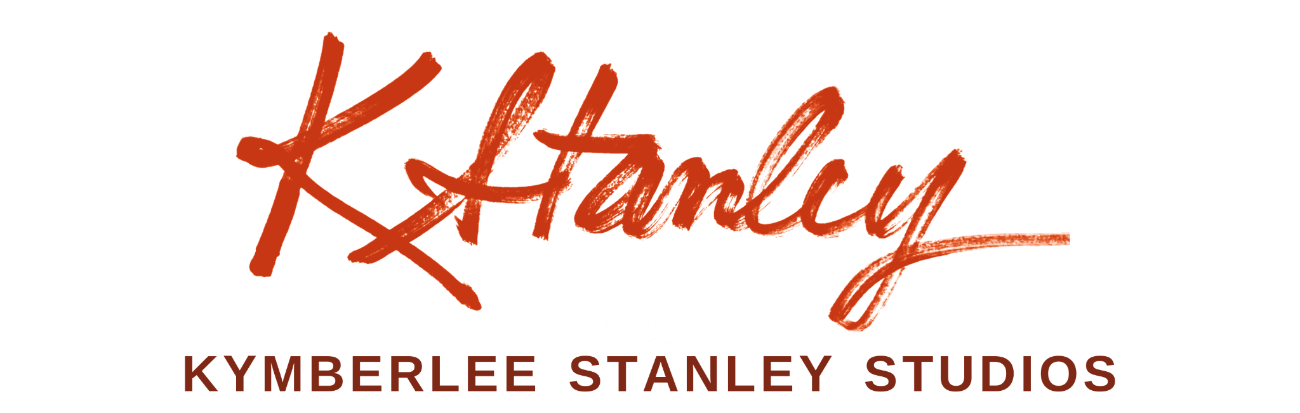
Contemporary Impressionism
kymberleestanley.com
SOLO EXHIBITIONS
2026 Nashville International Airport, BNA Arts — “Flying Solo Exhibition,” Concourse D, Nashville, TN
2024–2025 Avalon City Hall — “Island Impressions” (5 oil paintings on exhibit), Catalina Island, CA
2022–2025 Kymberlee Stanley Studios — West Nashville Art Crawl, Nashville, TN
2014 The Living Room Gallery, The Village Chapel Church — “Rediscovering Home,” Nashville, TN
GROUP & JURIED EXHIBITIONS
2026 Periscope Showcase Exhibiting Artist — Metro Arts and Business Council, Oz Arts, Nashville, TN
2026 Sounding Stone Gallery — “Southern Landscapes,” Nashville Painters Salon, Sewanee, TN
2026 Arcade Arts; Between the Avenues- “Slow Burn,” Nashville Painters' Salon, Nashville, TN
2026 Quick Draw Paint Out Competition — SOCALPAPA, Muth Interpretive Center, Newport Beach, CA
2026 Artist Circle of Nashville Group Show — Beam Gallery, Nashville, TN
2025 Arcade Arts Art Crawl — Nashville Painters' Salon, Nashville, TN
2021–2025 Catalina Island Art Festival — Exhibitor, Catalina Island, CA
2024 Galerie Tangerine — “Sunshine and Shadows,” Chestnut Plein Air Group, Nashville, TN
2024 So Cal Plein Air Association — Quick Draw Competition, Muth Interpretive Center, Newport Beach, CA
2019–2024 Catalina Art Association Gallery — Ongoing Exhibitor, Avalon, CA
2023 Ashton Gallery, Oceanside Museum of Art — “Beach Party,” San Diego, CA
2022 Laguna Beach Plein Air Association — “From Dusk to Dawn,” Long Beach Promenade, Laguna Beach, CA
2022 Oceanside Museum of Art, Artist Alliance — Front Porch Gallery, “Renewal,” Oceanside, CA
2022 Oceanside Museum of Art, Artist Alliance — Ashton Gallery, “Beneath the Surface,” San Diego, CA
2019–2020 The Parthenon Museum — “Both Sides Now,” two-artist exhibition (18 paintings), Nashville, TN
2019 Laguna Beach Festival of the Arts — Digital Jury Finalist, Laguna Beach, CA
2018 Crystal Cove Conservancy Invitational — Crystal Cove State Beach, CA
2017 Forest and Ocean Gallery — “Hot August Nights,” LPAPA Show, Laguna Beach, CA
AWARDS & HONORS
2025 Best of Show — “Casino Light Magic,” Catalina Art Association Art Festival, Avalon, CA
2024 Betty Schmidt Memorial Scholarship — Emerging Artist Recipient, Oil Painters of America
2024 Featured Artist / Poster Winner — Catalina Island Art Association, Avalon, CA
2024 Best Island Scene — “Green Pier,” Catalina Art Association Art Festival, Avalon, CA
2024 Third Place — “Back Bay Eye Candy,” SCALPAPA, Muth Interpretive Center, Newport Beach, CA
2023 Honorable Mention — “Sailing On,” Ashton Gallery, Oceanside Museum of Art, San Diego, CA
2022 Second Place — “Garibaldi Underwater Divepark,” Catalina Art Association Art Festival, Avalon, CA
2021 Featured Artist / Poster Winner — Catalina Island Art Association, Catalina Island, CA
PRESS
2026 Catalina Islander — “Pizza Box Plein Air Painting on Catalina"
2026 Catalina Islander — "A Little Catalina in Nashville"
2025 Oil Painters of America — "An Artist's Journey Is Only Beginning: Plein Air Painting in Normandy, Paris"
2025 The Nashville Scene — Highlighted as “Top Emerging Artist”
2025 Canvas Rebel — "Meet Kymberlee"
2024 American Art Collector — "Highlighted Artist"
2024 Catalina Islander — "Catching Up with Artist Kymberlee Stanley"
2021 The Catalina Islander — "Life, Art Led Stanley Back to Catalina"
GALLERY REPRESENTATION
- Garibaldi Studios-Kymberlee Stanley Fine Art — Nashville, TN
- The Steamer Trunk Boutique — Avalon, Catalina Island, CA
- Catalina Art Association Gallery — Avalon, Catalina Island, CA
EDUCATION & PROFESSIONAL EXPERIENCE
2021–Present Oil Painting Teacher — Private and Group Classes, Nashville, TN and Catalina Island, CA
2018–Present Expressive Arts CEU Workshops Teacher — Nashville, TN
2015–Present Psychotherapist; Owner; Expressive Arts Private Practice – Nashville, TN
2018–2019 Art Therapist Volunteer — Next Door Ministries, Nashville, TN
2018–2019 Oil Painting Teacher — Little Art House Nashville, Nashville, TN
1990 Art Credential / Supplemental — California State University, Long Beach, CA
1987 Art Curriculum Creator / Volunteer — “Art in Schools,” CSULB Art Gallery, Long Beach, CA
1985 Art Scholarship — Biola University, La Mirada, CA
COMMUNITY CONTRIBUTIONS
2026 Plein Air Painter, Nashville Painters' Salon — Monthly live painting at the Nashville Symphony
2026 Selected Artist — Periscope Program, Arts and Business Council, Nashville, TN
2026 Artist Member — Nashville Artist Circle
2024–Present Founder, Artist Member — Nashville Painters Salon, Exhibitions, Events, Education, Community
2022–Present Founding Group Member — West Nashville Art Crawl, Nashville, TN
PROFESSIONAL AFFILIATIONS & MEMBERSHIPS
Oil Painters of America · California Art Club · Laguna Beach Plein Air Painters Association · Southern California Plein Air Association · Catalina Art Association · The Chestnut Group · Nashville Painters Salon · Artist Circle Nashville · Arts Council of Williamson County

