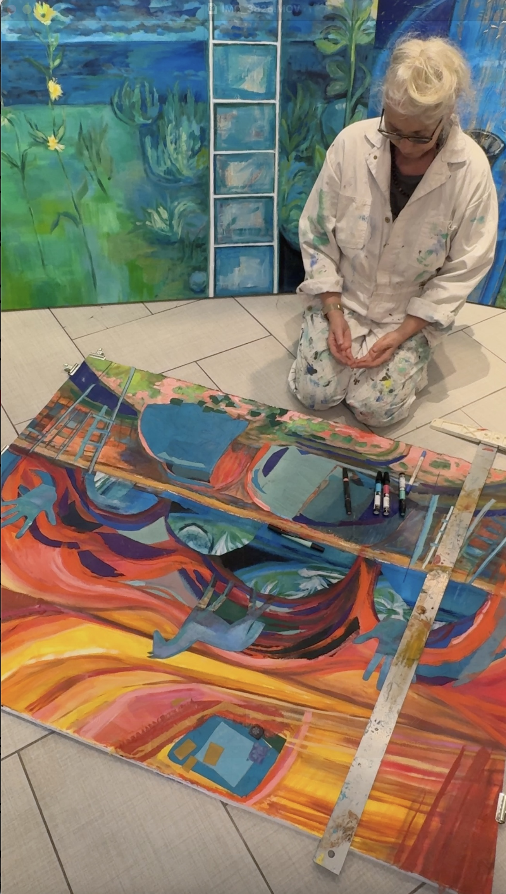
DENITA BENYSHEK

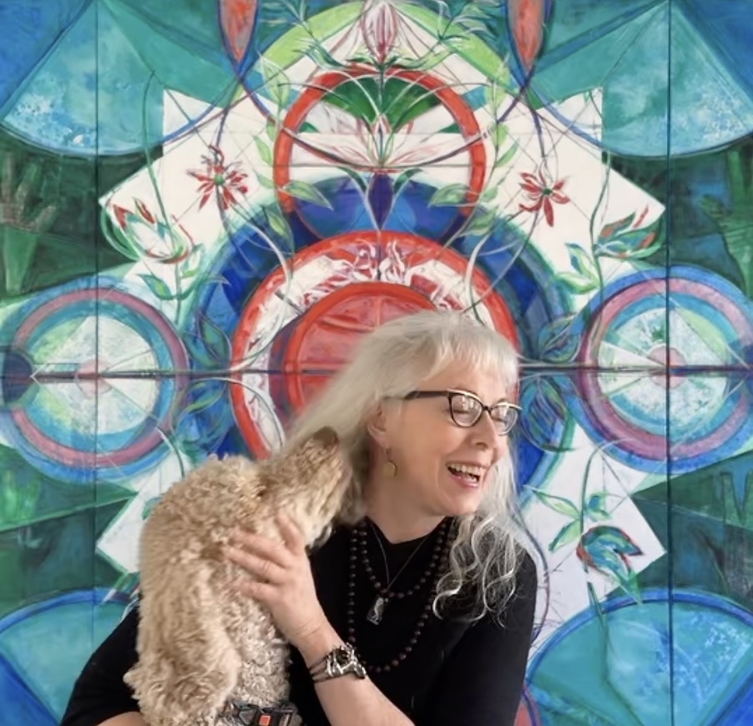
Represented by Artio Gallery

https://www.artiogallery.com/denita-benyshek

https://www.womeninartbiennale.com/denita-benyshek

Art

http://www.denitabenyshek.com

https://www.artworkarchive.com/profile/denita-benyshek

https://www.instagram.com/denitabenyshek/

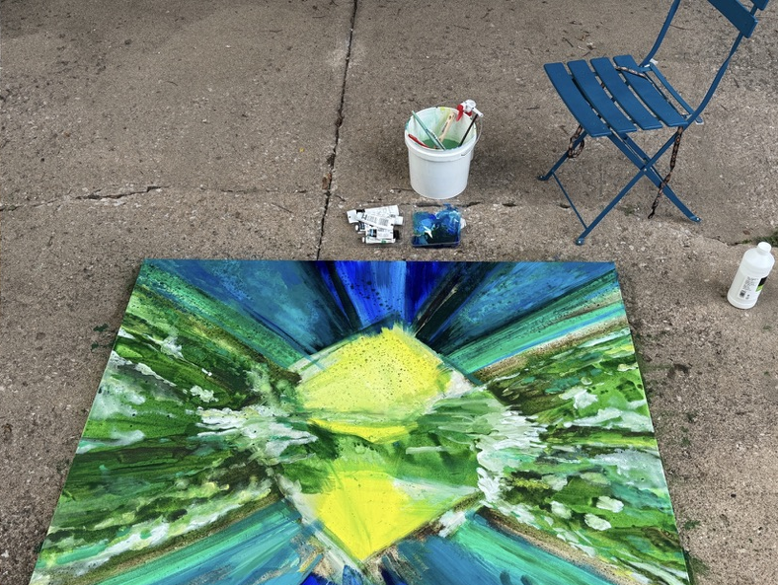
Publications

https://saybrook.academia.edu/DenitaBenyshekPhDMFA

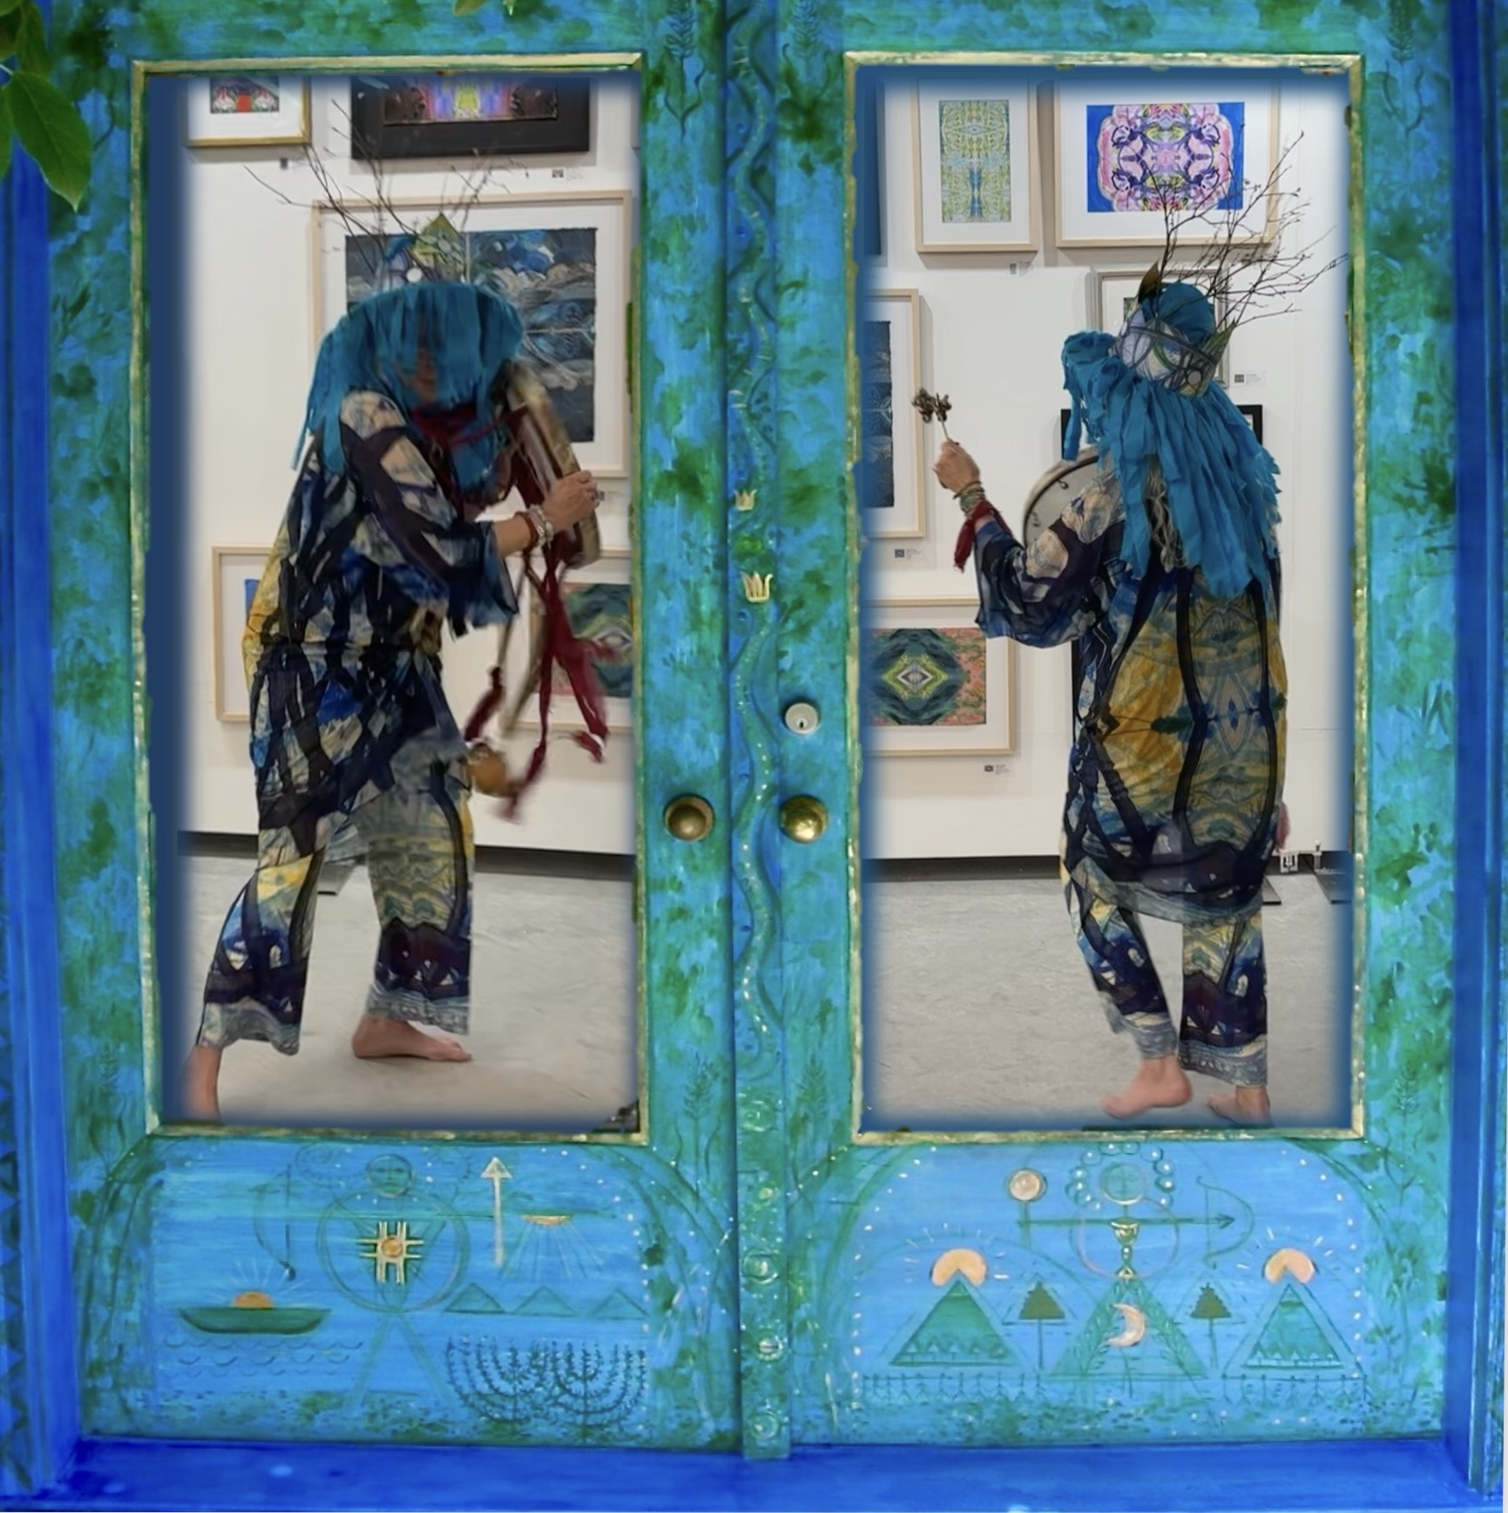

Statement

I make art as an act of service. In 2018, a South Korean shaman, master of one thousand spirits, led me through a traditional initiation ritual. When creating, I invite nature spirits to guide me. My published research focuses on contemporary artists as shamans and research methods inform my studio practice.

While writing a chapter, I asked how to physically represent, in art, my experience of inspirited nature, the vast cosmos, and the great sweep of time. I integrate traditional and contemporary art media, in an iterative process that circles through love, gardening, painting, photography, printmaking, ritual garment design, and drawing.

Inspired by my farming Czech ancestors, physics, life sciences, folk art, animism, and transpersonal psychology, my work provides the viewer with access to nonlinear time, reverie-provoking discontinuous space, intuitive combinations, heightened color, and ecstatic visionary experiences.

Biography

In early childhood, Dr. Benyshek lived in a farmhouse without running water, amidst a Czech immigrant community in Kansas. She earned a BFA (Wichita State University), an MFA (University of Washington), and later completed an MA and PhD in humanistic and transpersonal psychology (Saybrook University, San Francisco). Benyshek attended Pilchuck Glass School on a full scholarship, and she was selected as an artist-in-residence by the Ucross Foundation.

For 15 years, she taught visual arts and dance in the Native villages of the Alaskan bush. Far from the contemporary art scene, she discovered her unique artistic voice. When she returned to Seattle, she worked as a runway model for I. Magnin’s, Nordstrom’s, and independent designers.

Dr. Benyshek’s research focuses on contemporary artists as shamans, with publications in the US, Europe, and China. Her artworks were included in group exhibits at the Bellevue Museum of Art, Whatcom Museum of History and Art, Yakima Valley Art Museum, Coos Bay Museum, Museum of Northwest Art, and the Daum Museum of Contemporary Art, with solo exhibits in Seattle, WA, Portland, OR, Sun Valley, ID, Santa Fe, NM, Ann Arbor, MI, Anchorage, AK, and Wichita, KS.

For 25 years, Benyshek lived in the Cascade Mountains. She recently returned to Kansas with her son. She is currently preparing for a major solo exhibit at MARK Arts.

DENITA BENYSHEK

C V

American, b. 1955

Represented by Artio Gallery, https://www.artiogallery.com/denita-benyshek

2018 Shamanic initiation, traditional Naerim Gut, with South Korean manshins (masters of
one thousand spirits) Kim Junghee and Sung Mi Lee, with mudang Jung Kyung Nam

EDUCATION

2013 PhD humanistic and transpersonal psychology, Saybrook University, San Francisco, CA
2010 Graduate Certificate, psychology of creativity, Saybrook University
2004 MA Psychology, Saybrook Graduate School
1995 MFA in painting, University of Washington, Seattle, WA
1994 Pilchuck Glass School, Stanwood, WA
1979 BFA in painting, Wichita State University, Wichita, KS, Magna cum Laude with
Departmental Honors
Additional training in dance (modern, Martha Graham technique, Bella Lewitsky
technique, jazz, ballet) and jazz and blues vocals.

AWARDS

2026 Project grant, Arts Council, Wichita, KS
WEAD (Women’s Eco Art Dialog) Andrée Singer Thompson Scholarship
2025 Artist Access Grant, Wichita Cultural Arts, KS
WEAD (Women’s Eco Art Dialog) Andrée Singer Thompson Scholarship
2024 Koch Cultural Trust Enabling Grant
2022 OpenStudios Artist in Residence grant at Botanica Gardens, Wichita, KS
2019 Mary Lou Panter Scholarship, Creativity & Madness Conference, Santa Fe, NM
2012 Nominated for Dissertation with Distinction Award, Saybrook University
2011-12 Doctoral candidate research grant, Saybrook University
2011 Professional Conference Honorarium.
2010-11 Alumni Scholarship, Saybrook University
2008 Society for Shamanic Practitioners, Santa Fe Conference Scholarship, Olivenhain, CA
2007 Rudy Melone Presidential Scholarship, Saybrook
2007 USA Funds Access to Education Scholarship, Indianapolis, IN
2006 The Alfred G. and Elma M. Milotte Art Scholarship, Atlanta, GA
2006-09 Seclef-Hoetzel Scholars Merit Award, Council of Higher Education Scholarship
Program for Students of Czech, Slovak, or Rusyn Descent, Chicago, IL
2006 Finalist, Eileen J. Garrett Research Library Fellowship, Parapsychology Foundation
New York
2006-09 Tuition Grants, Saybrook
2006 USA Funds Access to Education Scholarship, Indianapolis, IN
2005 Tuition Grant, Saybrook Graduate School
1995 Liquitex Paint Product Grant, Binney & Smith, Inc., Easton, PA
1995 W.W. Stout Fellowship, The Graduate School, University of Washington
1994 Full Scholarship, Pilchuck Glass School, Stanwood, WA
1994 Special Project Grant, School of Art, University of Washington
1994 W.W. Stout Fellowship, The Graduate School, University of Washington
1994 Liquitex Paint Product Grant, Binney & Smith, Inc., Easton, PA
1993 Support Grant, Gary Smith, Ross, CA
1988 Emerging Artist Grant, 200+1 Corporation, Seattle, WA
1984 Artist-in-Residence, The Ucross Foundation, Ucross, WY
1975-79 Miller Art Scholarship, Wichita State University
1973-78 Kansas State Board of Regents Scholarships, Wichita State University
1973-77 Art Scholarships, City of Wichita, KS
1963 Art Scholarship to Wichita Art Association (now MARK Arts), Wichita Board of
Education

SELECTED SOLO EXHIBITS

2027
Cosmos: Flower to Stars, Larksfield Place, Wichita, KS (5/1/27 - 7/31/27)

2026
The Sanctuary, MARK Arts, Wichita, KS (11/20/26 – 1/29/27)

2025
Mandalandscapes, Main Gallery, University of Michigan Medical Center, Ann Arbor, MI
Into the Garden, Reuben Saunders Gallery, Wichita, KS (4/4/25 – 4/26/25)
Cosmic Spirits, Commerce Club at The National, Wichita, KS (2/7/25 – 4/26/25)

2000
Denita Benyshek, Hope Collection, Canyon Road, Santa Fe, NM

1999
The Return of White Horse, Gallery Oscar, Sun Valley, ID

1997
In the Red Year, Anderson Glover Gallery, Kirkland, WA

1996
The Still Lake of Revery, Childhood’s End Gallery, Olympia, WA

1995
Artist’s Collection, Pilchuck Glass School Open Studio Tour, Seattle, WA
Windows to the Past, Continuous Spectrum Gallery, Tacoma, WA

1991
Glimpses of Soul, Olympia Art Walk, Olympia, WA
My Soul The World, Bell Gallery, Seattle, WA
Benyshek Solo, Littman Gallery, Portland State University, Portland, OR

1990
Visionary Paintings, University of Alaska – Anchorage, National Competition

1989
New City Theatre, Seattle, WA

1988
New Work, Bruskin Gallery, Pt. Townsend, WA
Solo Benyshek, Broadway Performance Hall, Seattle, WA

1987
I Tell Stories, Bruskin Gallery, Pt. Townsend, WA
Of Two, with photographer Corwin Fergus, University Unitarian Gallery, Seattle, WA
Letters, St. Mary’s College, Notre Dame, IN

1985
From My Garden, Century II Gallery, Wichita, KS

1984
Paintings from Wyoming, Big Red Gallery, The Ucross Foundation, WY

1983
Components of Multi-Media Performance, Duerkson Fine Arts Center, Wichita, KS

1981
Inscapes, Century II Gallery, Wichita, KS

1977
Recent Work, McFarland Gallery, Wichita State University, Wichita, KS

SELECTED GROUP EXHIBITS

2026

Women in Art Biennale London, Chelsea Old Town Hall, Artio Gallery, UK
Contemporary Visions of the West, Daum Museum of Contemporary Art, Sedalia, MO
Lotus and Lion: Contemporary Buddhist and Hindu Art 2, Shoshoni Retreat, CO
HERstory, Viridian Artists, New York City, NY
Tell Me What You Think of Me, Part 2, Ann Resnick, lead artist, and Ksenya Gurshstein,
curator, Salina Art Center, KS

2025

Invoke, WomensWork.Art at Cunneen-Hacket Art Center, Poughkeepsie, NY
Rituals, Millepiani Gallery, Rome, Italy,
Coalesce, 4-person show, @art_up_stairs with Health Hub Gallery, New York City, NY
Lotus and Lion: Contemporary Buddhist and Hindu Art, Shoshoni Retreat, CO
Clio Art Fair, New York City, NY
MMX: Positive Disintegration, Mixed-Media Group Show, Harvester Arts, Wichita, KS, Co-curated with Jo Reinert
Prairie Art Exhibit, Symphony of the Flint Hills, Cottonwood Falls, KS
HerStory: The Battle Continues, Viridian Artists, New York City, NY
Versus, School of Creativity Gallery, MARK Arts, Wichita, KS
Creative Labor: The Art of Gestation (online)

2024

Winter Salon in Saffron, Cerbera Gallery, Kansas City, MO
cOLD Times, Viridian Artists, New York City, NY
Art of the View, Sunnyview Hospital Foundation, Schenectady, NY
Horizons, Midwest Center for Photography, Wichita, KS
Prairie Art Exhibit, Symphony in the Flint Hills Gallery, Cottonwood Falls, KS
Voices of the Midwest, Kavanagh Gallery, Fine Line Creative Arts Center,
St. Charles, IL
Portfolio Platform, Midwest Center for Photography, Wichita, KS

2001

Alumni Exhibit, Ulrich Museum of Art, Wichita State University, Wichita, KS

2000

Wyndy Morehead Fine Arts, New Orleans, LA
Vitrum Gallerie, Ashland, NC
Masters of Drawing, Invitational, Shoreline Community College Gallery, Seattle, WA
Northwest Women in Glass, Rebecca Meloy Gallery, Bellingham, WA

1999

Northwest Women in Glass, American Art Gallery, Tacoma, WA in conjunction with
International Glass Museum
Work on Paper, West Coast Paper Company, Seattle Center, Seattle, WA (juried)

1998-9

The View from Here: 100 Artists Mark the Centennial of Mt. Rainier National Park
(Invitational, Peggy Weiss, Curator) Exhibit Tour:
Yakima Valley Museum of Art, Yakima, WA
Museum of Northwest Art, La Conner, WA
Whatcom Museum of History and Art, Bellingham, WA
Seattle-Tacoma Airport
Citizens Cultural Center, Fujinomiya, Japan (Mt. Rainier/Mt. Fuji Sister Mountains)
Seafirst Bank Art Gallery, Seattle, WA
Reviewed:
Howe Verhovek, S. (1998, December 23). Arts in America: The Mountain as Muse,
Glacial, Menacing Or Not So, The New York Times
Glowen, R. (1999, January 8). Rainier Centennial, The Herald, Everett, WA
Berger, D. (1998, November 12). 100 Views of the Mountain, Seattle Times

1998

Best of 1998, Bainbridge Arts, Bainbridge Island, WA (Invitational)
Northwest Expression of Landscape, Coos Bay Museum, Coos Bay, OR

University of Washington Medical Center Collection Highlights, Washington Convention

& Trade Center, Seattle, WA. (Curator: Sharon Ducey)

1997

The Glass Gallery, Bethesda, MD
The Healing Arts, Washington Center, Olympia, WA (Juried)
Glass Invitational, Pratt Fine Arts Center, Seattle, WA
Human Figure, Center on Contemporary Art, Seattle, WA

1996

Pacific Northwest Annual, Bellevue Art Museum, Bellevue, WA
16th International Northwest Art Competition, Whatcom Museum of History and Art,
Bellingham, WA

1995

Glass Invitational, Owens Gallery, Arts Commission of Toledo, OH
Paint & Glass: The Expressive Connection, Philabaum Gallery, Tucson, AZ
(International Invitational, Curator: Robert Carlson, President, Glass Art Society), participating artists included: Erwin Eisch, Tom Farbanish, Italo Scanga, Ulrica Hydman-Wallien, Walter Lieberman, Therman Statom

Seattle Community College Art Faculty Exhibit, North Seattle Community College
Pratt Fine Arts Center Faculty Exhibit, Center on Contemporary Art, Seattle, WA
1004 Gallery, Pt. Townsend, WA

University of Washington MFA Thesis Exhibit, Center on Contemporary Art, Seattle

1994

Interpretation of Human Form, Childhood’s End Gallery, Olympia, WA
Works on Paper, Jacob Lawrence Gallery, University of Washington, Seattle
(Juror: Diane Douglas, Director, Bellevue Art Museum)

1993

The Elements, Washington Center, Olympia, WA (Juried)

1992

Spirituality in Art, Washington Center, Olympia, WA
Summer Faculty Exhibit, University of Alaska, Fairbanks, AK

1990

Women Artists, Matrix Gallery Satellite Exhibit, Sacramento, CA (Juried)

1989

9th Annual Competition, Phinney Center Gallery, Seattle, WA
6th Alcoa/Gallery ’76 Juried Exhibit, Wenatchee, WA
Redefining Visionary Art, Doma Gallery, New York, NY. (Juror: Suzi Gablik)

1988

In Her Image, Seattle Women’s Caucus for Art, Seattle, WA (Juried)
Dreams, Fantasy, Visions, Greeley, CO (Juried, 1st Place Award)
Summer Faculty Exhibit, University of Alaska, Fairbanks, AK

1987

4th Alcoa/Gallery ’76 Juried Exhibit, Wenatchee, WA
3rd Annual Salute to the Arts, Seattle, WA. (Jurors: LaMar Harrington, Director, Bellevue
Arts Museum, and Glenn Weiss, Director, 911 Media Arts Center, Seattle)
Past Presence: A Circle of Women’s Visions, Corvallis Art Center, OR
Summer Faculty Art Exhibit, University of Alaska, Fairbanks, AK

1986

Brand XVI, Brand Library Art Galleries, Glendale, CA (Juried)
BirthArt Project, Saratoga, CA (Juror: Janet Isaacs Ashford, Editor)
Summer Faculty Art Exhibit, University of Alaska, Fairbanks, AK

1985

Community Art Action, 9th International Conference on the Future of Religion, Dubrovnik, Yugoslavia (Invitational, Diane Lincoln, Juror)
Women in the Arts, Phoenix Art Institute, Wichita, KS
Summer Faculty Art Exhibit, University of Alaska, Fairbanks, AK

1984

Intimate Images, Westin Crown Center, Kansas City, MO (Juror: Lynn Warren, Assistant Curator, Museum of Contemporary Art, Chicago, IL)
Kansas Four, Mulvane Art Center, Washburn University, Topeka, KS (Juror: William Struve, Frumkin & Struve Gallery, Chicago, IL)

Women’s Caucus for Art ’84 National Juried Exhibition, Wilson Gallery, Lehigh

University, Bethlehem, PA. (Jurors: Audrey Flack, Joyce Kozloff, Joan Marter)

1983

Womanart 6, Century II Gallery, Wichita, KS (Juried)
Aqueous ’83, Museum of Fine Arts, Owensboro, KY
7th National Watercolor Exhibit, Art Association, Springfield, IL (Juried)

1982

Exhibition: 1982 Kansas City Calendar, City of the Arts, Crown Center, Kansas City, MO

1981

3rd Annual Jurored Show for Kansas Artists, Salina Art Center, KS
Art, Inc. Juried Exhibitions, Great Bend, KS, Two Cash Awards

1980

Womanart 3, Century II Gallery, Wichita, KS (Juried)

1979

Aqueous ’79, Museum of Fine Arts, Owensboro, KY
Womanart 2, Century II Gallery, Wichita, KS (Juried: First Place Award)

1978

8th Greater New Orleans International Art Exhibit, New Orleans, LA

PUBLIC ART COLLECTIONS

Orientation Table, Snoqualmie Point Park, WA. Commissioned by Alpine Lakes
Wilderness Society (ALPS), Seattle, WA. Contributed to park receiving Award of
Excellence from the Federal Highway Administration and the Washington State Department of Transportation

Oberlin College, Oberlin, OH, Library Special Collections, Women’s Studies, The Seal Press Archives

The Fast Beach, engraved glass. Glasmuseet (Glass Museum), Ebeltoft, Denmark

A Tree in Winter Remembers Spring, Cultural Heritage Collection, King County, WA Arts Commission, Harborview Medical Center, Seattle
Crossing Over, acrylic painting triptych. St. Peters School, San Francisco, CA
Your Name Here, ceramic tile bench and patio with poetry and painting, Arts in Public
Places, baseball park, Olympia, WA. Deaccessioned due to vandalism

Wheatland Star, watercolor, gouache, ink on paper. University of Washington Medical
Center, Seattle, WA

SELECTED PUBLICATIONS
Benyshek, D. (work in process). My naerim-gut: Initiation of a Western shaman by Kim Junghee, Korean manshin.
Benyshek, D. (forthcoming). An Overview of Western Ideas regarding the Artist as Shaman (Wang, Trans.). In G. Shuyun, W. Weibo & Q. Fang (Eds.), Modern artists and shamanism (Vol. II of Encyclopedia of shamanism). Beijing: 商務印書館 (The Commercial Press).
Benyshek, D. (forthcoming). Art audience as shamanic community: How art meets psychological, social, and spiritual needs (Wang, Trans.). In G. Shuyun, W. Weibo & Q. Fang (Eds.), Modern artists and shamanism (Vol. II of Encyclopedia of shamanism). Beijing: 商務印書館 (The Commercial Press).

Benyshek, D. (2025). The artist holds the center: Kathleen Shanahan at the Wichita Art Museum,
The Shout,
https://www.shoutwichita.com/kathleen-shanahan-wichita-art-museum/

Benyshek, D. (2025). Invading the boys’ club, Ulrich Art Museum at 50: 1974-2024, T. Mott & V. Zavataro (Eds), Ulrich Museum of Art, Wichita, KS, p. 90.

Benyshek, D. (2024). The art audience as shamanic community. In Y. Owens (Ed.), Trans-Disciplinary Migrations: Science, the Sacred, and the Arts. London, UK: Cambridge Scholars.
https://www.academia.edu/121290249/ART_AUDIENCE_AS_SHAMANIC_COMMUNITY_HOW_ART_MEETS_PSYCHOLOGICAL_SOCIAL_AND_SPIRITUAL_NEEDS
Benyshek, D. (2020, October 09). Our Time of Coronavirus and Black Lives Matter. Coreopsis: A Journal of Myth and Theater, 8(2).
Benyshek, D. (2015). The contemporary artist as shaman: An artist-researcher perspective.
ReVision, a Journal of Consciousness and Transformation, 32(2-3), 54-60.
https://www.academia.edu/36891520/The_Contemporary_Artist_as_Shaman_An_Artist-Researcher_Perspective

https://revisionpublishing.org/the-contemporary-artist-as-shaman/

Benyshek, D. (2015). A historical and critical overview of the artist as shaman and recent research. In A. Czyżewski & E.E. Djaltchinova-Malets (Eds.), Shamanhood and its arts. Budapest, Hungary: Bibliotheca Shamanistica, Akademia Kiado, and The Polish Institute of the World Art Studies, Warsaw.
https://www.academia.edu/2066714/Artists_as_Shamans_Historical_Review_and_Recent_Theoretical_Model

Benyshek, D. (2013). An archival exploration comparing contemporary artists and shamans.
PhD, Saybrook University, San Francisco, CA.
https://www.academia.edu/25182315/Contemporary_Artists_as_Shamans_-_Archival_Exploration_full_text_and_references

Benyshek, D.M. (1982). Deerfield: A multimedia performance. Calyx: A Journal of Women’s Art
and Literature, 8 (1). https://www.calyxpress.org/product-category/journals/

PROFESSIONAL CONFERENCE PRESENTATIONS AND LECTURES

Benyshek, D. (2026, proposed). Initiation of a Western Shaman through a Traditional South
Korean Ritual, International Society for Academic Research on Shamanism, Sogang
University, Seoul, Republic of Korea.

Benyshek, D. (2026). The Sanctuary: Story and Process, MARK Arts, Wichita, KS.

Benyshek, D. (2025). Contemporary Artists as Shamans: in Wichita and Beyond.
Harvester Arts, Wichita, KS.

Benyshek, D. (2024). Contemporary Artists as Shamans. Creativity and Madness
Conference, Psychological Studies of Art and Artists, AIMED American Institute of Medical Education, Santa Fe, NM. https://www.creativityandmadness.com

Benyshek, D. (2018). My Initiation into Shamanism. Indigenous Wisdom & Shamanism: Within,
Between, and Beyond Worlds. The 34th International Conference on Shamanism, Healing, and Transformation. Sonoma State University, Rohnert Park, CA. http://www.indigenouswisdom.info/.

Benyshek, D. (2017). Disintegration and Reintegration Healing Processes: Seeing and Working
with Spirits. Protecting Earth, Water, Air, and Light, Honoring the Wisdom of our Ancestors for Future Generations: The 33rd International Conference on Shamanism, Healing, and Transformation. Santa Sabina Retreat Center, San Rafael, CA. http://shamanismconference.org/

Benyshek, D. (2014). Transliminality in artists, shamans, and art audiences. The 31st
International Conference on Shamanism, Healing and Transformation. Santa Sabina Retreat Center, San Rafael, CA. http://shamanismconference.org/recordings/highlights-31st/ .

Benyshek, D. (2013). Shamanistic arts benefit audience healing, growth, and social change.
R. Richards (Chair), Art as healer: Preschoolers to seniors to society at large. American Psychological Association Annual Conference, Division 32: Society for Humanistic Psychology, Honolulu, HI.

Benyshek, D. (2013). An archival exploration of contemporary artists as shamans. Humanistic
Psychology, Division 32, Hospitality Suite Poster Session, American Psychological Association Convention, Honolulu, HI.

Benyshek, D. (2011). Exploring Artists as Shamans: A Critical and Historical Overview and
Some Friendly Advice to Scholars. The 10th Conference of the International Society of
Shamanistic Research: Shamanism and its Arts. State Ethnographic Museum, Warsaw,
Poland.
Benyshek, D. (2011). Art Audience as a Shamanic Community. The 28th International Conference
on Shamanism, Healing and Transformation: The Shaman’s Gift to the Community. San
Rafael, CA.

Benyshek, D. (2010). A true story: The spontaneous shamanistic healing of a boy. The 27th
International Conference of the Society for the Study of Shamanism, Healing and
Transformation: Traditional Beliefs and Healing Systems in a Changing World, An
Interdisciplinary Approach. San Rafael, CA.

Benyshek, D. (2009). The Contemporary Artist as Shaman, The International Society for
Shamanistic Research, University of Alaska, Anchorage.

Benyshek, D. (2009). Artists and Shamanism, Creativity Studies Program, Residential Conference,
Saybrook Graduate School and Research Center, San Francisco, CA.

Benyshek, D. (2009). Artists as Shamans and Art Audience as Shamanic Society, Starwood
Festival, NY.

Benyshek, D. (2009). Artist as shaman: Academic performance art. Shamanism in the 21st
Century Conference, Shamanism and Alternate Modes of Healing, San Rafael, CA.

Benyshek, D. (2008). Creative Opportunity within Creative Block, Creativity Studies Department,
Saybrook Graduate School, Residential Conference, San Francisco, CA

Benyshek, D. (2007). Seer and Seen, Creativity Studies Department, Saybrook Residential
Conference.

Benyshek, D. (2004). Panel Member, Creativity Studies Dept., Saybrook Residential Conference.

Benyshek, D. (2003). Slide Lecture regarding artwork and creative process, Creativity Studies
Dept., Saybrook Residential Conference.

Benyshek, D. (1996). Northwest Women Artist Series, North Seattle College, Seattle, WA.

Benyshek, D. (1995). Public Art Panel – Guest Speaker, Olympia Arts Commission, Olympia, WA.
Exhibit Lecture, Continuous Spectrum Gallery, Tacoma, WA.

Benyshek, D. (1993). Influence of Folk Art on the Fine Arts of Eastern Europe and Cultural Roots
in the Paintings of Denita Benyshek, Collection Artist Series, University of Washington
Medical Center, Seattle, WA.

Benyshek, D. (1993). Denita Benyshek: Visiting Artist, College of Folk Arts & Culture, Pskov,
Russia.

Benyshek, D. (1993). Exhibition Lecture/Performance, Bell Gallery, Seattle, WA.

Benyshek, D. (1991). Exhibit Lecture, University of Alaska, Anchorage, AK.

Benyshek, D. (1989). Labore est Orare (To Work is To Pray), Carl Jung Society, Seattle, WA.

Benyshek, D. (1987). The Role of Visiting Artists in Native Villages, Young & Associates,
Artist in the Schools Conference, Anchorage, AK.

Benyshek, D. (1983). Denita Benyshek: Visiting Artist, Convocation Speaker Series, McPherson
College, KS.

Benyshek, D. (1983). Multi-Media Performance Art, Dance Dept., Wichita State University,
Wichita, KS.

COMMUNITY SERVICE (SELECTED)

2025 Co-curate MMX: Positive Disintegration, 8 women artists, multi-media group exhibit at
Harvester Arts, Wichita, KS

Wilderness Conservation, Oil Dependence, and Corporate Responsibility

- Orientation Table
  - Art commission from Alpine Lakes Wilderness Society for Snoqualmie Point Park, WA. Funded by Alpine Lakes Protection Society. Sponsored by Mountains to Sound Greenway and City of Snoqualmie

- Exxon Valdez Oil Spill in Prince William Sound, AK
  - Interviewed residents of Cordova, AK, bird and animal rescue workers on boats.
    - Published excerpts of interviews in anthology of writing about the spill.
    - Benyshek, D. (1990). Journey into the dead zone. In H. Frost (Ed.), Season of Dead Water (pp. 21-28). Portland, OR: Breitenbush Books
  - Assistant for Corwin Fergus’s film, Oil and Water, showing the death and destruction caused by the oil spill
  - What Do You Do with a Drunken Sailer? Elegy for Prince William Sound.
    - University of Alaska – Fairbanks
    - Multi-media performance/public grieving ritual, in collaboration with art students

Underrepresented and Disadvantaged Populations

- University of Alaska – Fairbanks
  - Persuaded art department to hire Native American instructor
  - Lobbied successfully for Native American students, working in traditional Aboriginal style, to receive art scholarships
  - Worked with village elders to fund scholarships for talented students to UAF

- North Seattle Community College
  - Women in the Arts Lecture Series
  - Organized to balance underrepresentation of women artists in art history texts and art history courses (85% of associate degree art students were female)
  - Coordinated with Women Studies Department
    - Obtained funding
    - Organized for credit class

- Seattle Arts Commission
  - Grant panel juror
    - Successfully lobbied for artists from Japan and Guatemala, working within their ethnic traditions, to receive funding

- Women in the Arts
  - Board of Directors
  - Initiated Midwest Radio Play Competition
    - Coordinated with Wichita Radio Reading Service for the Blind
    - Directed winning radio play, The Saga of Belle Starr

- Artists Unlimited, a nonprofit organization serving adults with severe disabilities.
  - Program Director (Exhibits, field trips, budget, hired/supervised faculty and volunteers)
  - Producer
    - Award winning multi-media performance video, Sometimes the Metro Doesn’t Stop for Me

ARTS EMPLOYMENT AND TEACHING EXPERIENCE

1979-Present Professional artist.
2015-21 Developmental editor, review editor, Coreopsis: Journal of Myth and
Theatre.
2015-19 Art editor, Revision: A Journal of Consciousness and Transformation.
1989-98 Art instructor, Pratt Fine Arts Center, Seattle, WA.
1997 Art instructor, Kirkland Arts Center, Kirkland, WA.
1995-97 Adjunct Instructor, North Seattle College, Seattle, WA.
Taught Prehistoric to Early Medieval Art History, Introduction to Art,
Drawing I, Watercolor Painting.
1993 Visiting Artist, Rimsky-Korsakov Pskov Regional College of Arts, Russia.
Mural painting instructor, Sun Valley Center for the Arts & Humanities,
Sun Valley, ID.
Washington State Arts Commission Artist in Residence: Washington
State Reformatory. Led interior mural project with life sentence
prisoners .
1992 Sitka Center for the Arts & Ecology, Otis, OR. Image Intensive/Creative Process.
Washington State Arts Commission Artist in Residence: Washington
State Reformatory. Led interior mural project with life sentence
prisoners.
1991 University of Alaska – Sitka, Summer Program.
1990 University of Alaska, Anchorage, AK. Workshop.
Artist in the Schools, Lincoln City, OR.
1989-90 Program Director, Artists Unlimited, Seattle, WA. Art education and
career development program for adult artists with severe disabilities.
1988 Workshop on Image Intensive/Creative Process. Homer Council on the
Arts, Homer, Alaska.
1987 Artist in the Schools, Long Creek, OR. Jazz dance and mural painting.
1986-89 Lectureship, University of Alaska – Fairbanks. Summer program.
Taught Drawing, Drawing the Human Figure, Acrylic Painting,
Performance Art, Mural Painting in Music Department Building.
1985-89 Scenic Artist in Seattle: Seattle Repertory Theatre, Empty Space Theatre,
Group Theatre, HBO Movie Productions. Master Scenic Artist, Intiman
Theatre.
1983-96 Artist in the Schools, Alaska, primarily remote Native American villages
in the Alaskan bush: Wainwright, Bettles Field, Chignik Lake, Chignik
Lagoon, Huslia, Delta Junction, Whales Pass, Kasaan, Aleknagik, Ft.
Greeley, Dillingham, Utquiagvik (Barrow), Pelikan, Yakutat, Tyonek.

