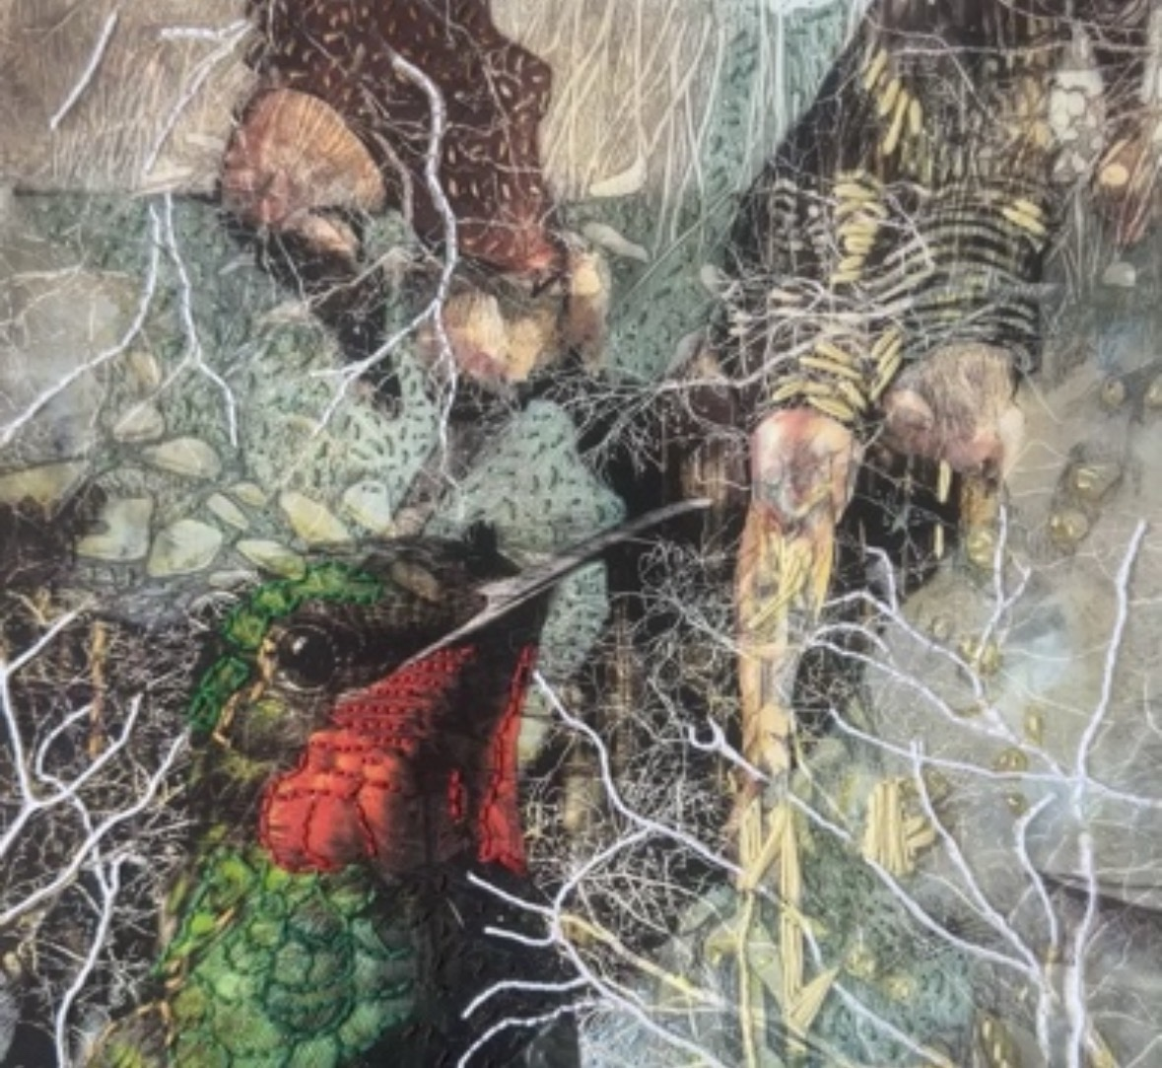
CHRISTINE NORTON
Mixed Media + Contemporary Embroidery + Photography
Diego Martin, Trinidad and Tobago | christine@christinenortoncraftedart.com | www.christinenortoncraftedart.com

PROFILE
Trinidad-based mixed media artist working across contemporary embroidery, photography, drawing, paint, and digital imagery. Her richly layered, image-based compositions explore memory, emotion, and place, inviting viewers into spaces where reality and quiet fantasy coexist.

SELECTED SOLO EXHIBITIONS
- 2026 — "Embroidered x Nature," A Space Inna Space Gallery at the FrameShop, Port-of-Spain, Trinidad
- 2024 — "The Island: Remember to Pray," Soft Box Gallery, Port-of-Spain, Trinidad
- 2022 — "Water & Spirit: Nurturing the Soul of India," Soft Box Gallery, St. Clair, Port-of-Spain, Trinidad
- 2019 — "After Basquiat: Fragmented Imagery | Mischievous Thoughts," 101 Gallery (self-managed)

SELECTED GROUP & TWO-PERSON EXHIBITIONS
- 2025 — "All Inclusive 2025," Loftt Gallery, Woodbrook, Port-of-Spain, Trinidad
- 2024 — Vueling OnBoArt In-Flight Exhibition, Contemporary Art Station (in-flight digital exhibition)
- 2021 — "Connections: The Art of Self Care," 24 Mucurapo Road, St. James, Trinidad
- 2020 — "False Narratives," two-person exhibition with Jonathan Creese, The Art Society of Trinidad and Tobago
- 2019 — "Anima Mundi: Consciousness," Palazzo Ca’ Zanardi, Venice, Italy
- 2018 — National Museum of Trinidad and Tobago, "Through My Lens – Trinidad and Tobago from Me," juried exhibition

SELECTED PRESS
- 2019 — World of Art Magazine, Venice Biennale issue — worldofartmagazine.com
- 2019 — Circle Arts Spotlight Magazine, Issue 16, p. 61 — circle-arts.com/spotlight-16
- 2018 — Press review of "Art of the Image" exhibition, Trinidad Express — trinidadexpress.com

