LINDA LEFTWICH – VISUAL ARTIST
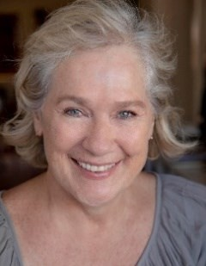
M: +61 (0) 411 22 33 99
E: lindaleftwich.art@gmail.com
I: www.instagram.com/lindaleftwichart/
L: www.linkedin.com/in/linda-leftwich-a041294/
W: www.artworkarchive.com/profile/linda-leftwich
Residence: Brisbane, QLD

EDUCATION
2023-2025 Bachelor of Creative Industries (Visual Arts) University of Canberra, South Bank, Brisbane
2023 Diploma of Visual Arts, South Bank Campus TAFE Queensland, Brisbane
2018 Academia del Giglio, Florence, Italy – Painting Summer Course
2017 Diploma of Interior Design & Decoration, CATC, Brisbane
2009 Buyers’ Agent Certificate, REINSW, Sydney
1978 Diploma of Theatrical Arts, 3 Arts, Sydney

WORKSHOPS
2016 Shirley Battrick, Gold Coast Potters – Raku workshop
2015 Anne Mossman, Gold Coast Potters – Nerikomi workshop
2013 Gold Coast Potters Association – weekly ceramics classes

SOLO EXHIBITION 2021 ELEMENTS One Arts Gallery, Gold Coast, QLD

SELECTED GROUP EXHIBITIONS
2026 RED GALLERY ART PRIZE – Fitzroy North, Melbourne VIC
2025 ART IN FOUR DIMENSIONS, Field Trip Gallery, Paddington, Brisbane QLD
2025 ABSTRACTED, Woolloongabba Art Gallery, Brisbane QLD
2024 DEEP LISTENING, Impress Gallery, Brisbane QLD
2023 DIPLOMA of VISUAL ART GRADSHOW South Bank TAFE Queensland, Brisbane QLD
2023 ABSTRACT, E Gallery, TAFE Queensland, South Bank, Brisbane QLD
2022 SUMMIT TO SHORES Aspire Gallery, Paddington QLD
2022 RQAS MEMBERS EXHIBITION RQAS, Petrie Terrace Gallery, Brisbane QLD
2015 – 2016 RQAS MONTHLY EXHIBITIONS, Gold Coast, QLD
2014–2020 DARCY DOYLE LANDSCAPE SHOW, Gold Coast QLD

EDITORIAL Artist Closeup Magazine #39 P68 September 2025

PROFESSIONAL LIFE
2025 Card-wizard POD and packs – in start up
2017-24-Holistic Home Store (Etsy) – art, ceramics and homewares
2017-2020 Art of Living Interiors (com.au) & Holistichome (Shopify) – art, ceramics and homewares
1998-2010 Typecast Management (Owner & Entertainment Manager) – multicultural actors’ agent 1980-2000 International Make-up Artist (Freelance) specialising editorial, beauty, advertising, celebrity portraits, music video and short films in Australia, Europe and USA.

ARTIST STATEMENT
My inspiration comes from the beauty of the natural world primarily painting land and seascapes from photographs I have taken of places that hold a deep connection for me. My aim is to reflect the richness of these vivid scenes and emphasize the shapes, colours, and forms that evoke feelings of memory, place and time. Another genre that I am exploring is portraiture; currently moving between representational and abstract which is an exciting new avenue. My research into Cubism is a catalyst for this study. I prefer working in oils and large format canvases. During my ceramic studies and trials with different clays, I have found pleasure in creating unique sculptural forms over functional ware. Being inspired by nature I find oxides and glazes are ideal for their natural properties, colours and finishes. My experience in photography, Adobe Photoshop and New Media has been a benefit in my experimentation of fantasy and sci-fi oriented digital media which is in complete contrast to my previous works.
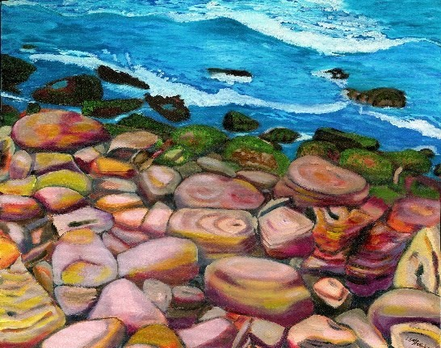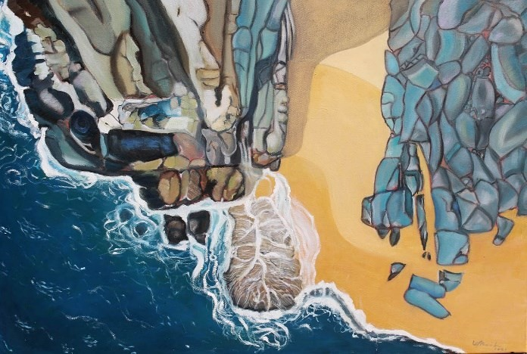

ABOUT ME
Beauty, colour and design are hallmarks of my former career as an international make-up artist working with some of the world’s best magazines, photographers and directors. My journey as an artist began in 1992 when I started painting in my leisure time whilst working in Los Angeles. On returning to Australia, my arts practice broadened to include ceramic classes with the Gold Coast Potters Association, which encouraged me to embark on formal art studies. After completing a
Diploma of Visual Art at TAFE Queensland I began studying for my Bachelor of Creative Industries
(Visual Arts) with the University of Canberra, where I am widening my range and developing my skills.
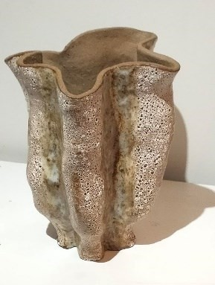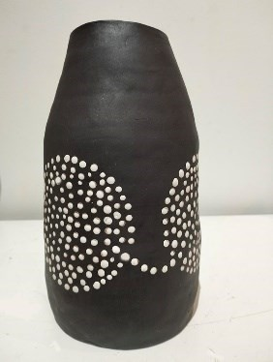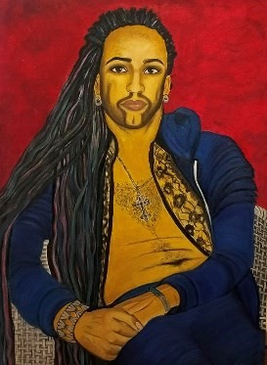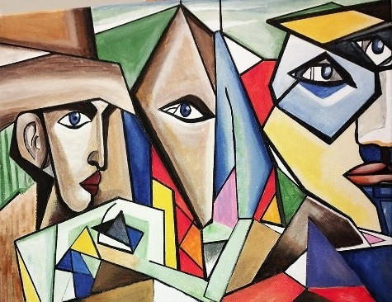

LINDA LEFTWICH CV ARTIST BIO 2026

