
KEITH ALLEN JONES
Artist | Storyteller | Former Corporate Executive
I didn’t leave corporate America. I walked away from it.

SUMMARY
Keith Allen Jones is a Colorado-based artist and former C-level executive who walked away from corporate leadership to build work rooted in truth, identity, and lived experience. His series Life After Life challenges conventional narratives by stripping away titles, status, and expectation—revealing what remains beneath. His work is juried, published, and actively exhibited across Colorado.
PUBLICATIONS & JURIED EXHIBITIONS
EXHIBITIONS
• Exhibiting Artist NEXT Gallery – Casa Bonita Murder Mystery (Juried Exhibition), Lakewood, CO
Casa Bonita Exhibition — Juried Show + Award Recognition
Exhibiting Artist NEXT Gallery – “Woke/Triggered (Juried Exhibition), Lakewood, CO
Exhibited Work
“Metamorphosis” and “Freewill

• Juried Selection, Breckenridge Summer Art Festival, Breckenridge, CO (2026)
• Juried Selection, Pearl Street Arts Fest — Boulder, CO (2026)
• Juried Selection, Golden Fine Arts Festival — Golden, CO (June 2026)
• Colorado Summer Art Festival Circuit (Multiple Juried Selections)

PUBLICATIONS
•Artistonish Magazine (February 2026) – Featured Artist
- Published Work: Red Rockin
MEGA 2026 – Biafarin
- Published Work: Browns Canyon
https://www.biafarin.com/p/mega2026.html?name=keith-jones

MEDIUM
Watercolor and ink on hot-pressed paper – precise, permanent, and intentionally unforgiving.
SERIES

Life After Life
Life After Life is a narrative-driven body of work centered on Skully Jones—a stripped-down human form that exists beyond identity, status, and social conditioning.
By removing race, title, and external markers, the work forces a single question: What remains?
Set inside real, recognizable environments—from Denver landmarks to intimate social spaces—the series contrasts familiar settings with existential clarity, exposing behavior, power dynamics, and human truth without distraction.
Each piece functions as both a standalone moment and part of a larger system—an evolving world where viewers are not just observers, but participants in interpretation.
BOOKS
• What Remains – A six-month private journey (Releasing April 2026)
• Lead or Get Out – A Letter to the CEOs Who Need to Hear It —
and the Leaders Who've Been Waiting for Someone to Say It (Releasing 2026)
- A direct, real-world account of leadership, power, and integrity inside corporate systems—exposing the gap between narrative and reality.

Media & Public Presence
Extensively media-trained with the ability to control narrative in live and recorded environments. Skilled in high-pressure interviews, message redirection, and reframing questions to drive engagement, challenge assumptions, and create impact.
Known for direct, provocative communication style that generates attention, conversation, and emotional response—both in-person and on camera.
CORPORATE LEADERSHIP BACKGROUND
Former Corporate Vice President of Human Resources, Risk, and Safety overseeing multi-state operations across 40+ properties and 2,600+ employees. Led a $300M brand transformation, built executive leadership pipelines, and drove measurable improvements in performance, culture, and operational efficiency.
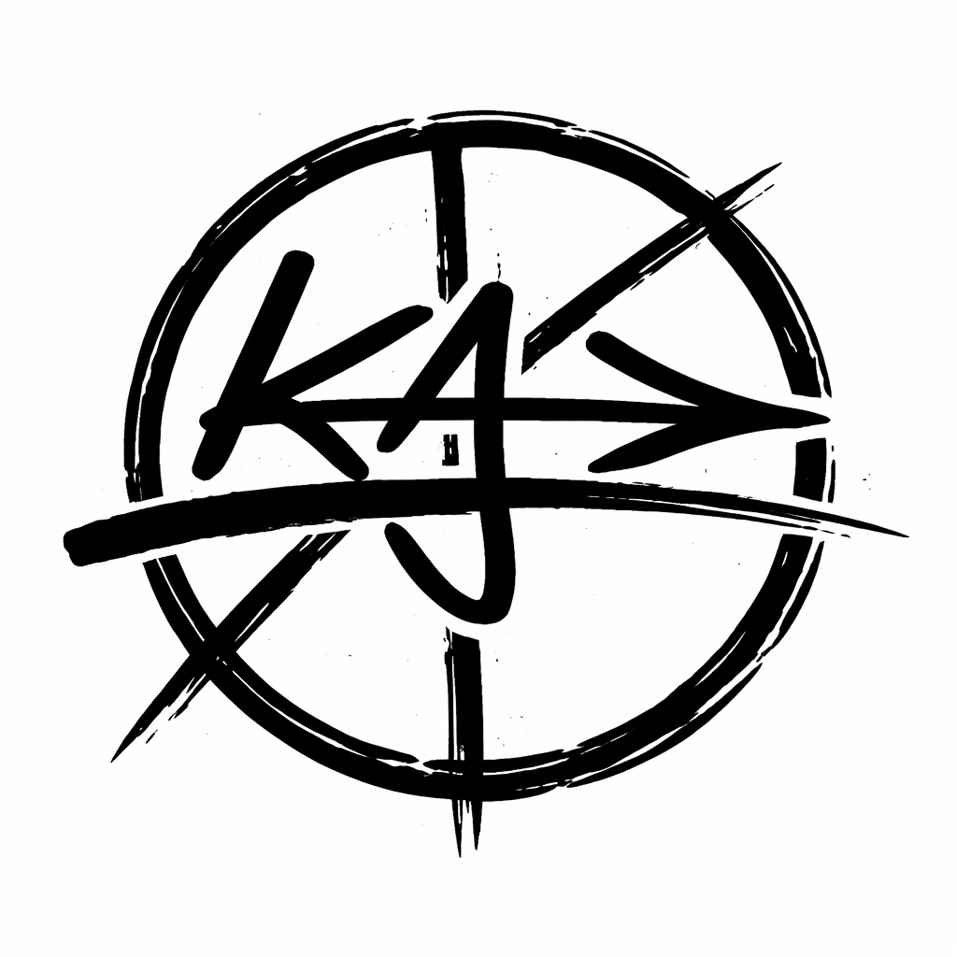
EDUCATION & SERVICE
• B.S. Marketing, Kansas State University
• U.S. Army

