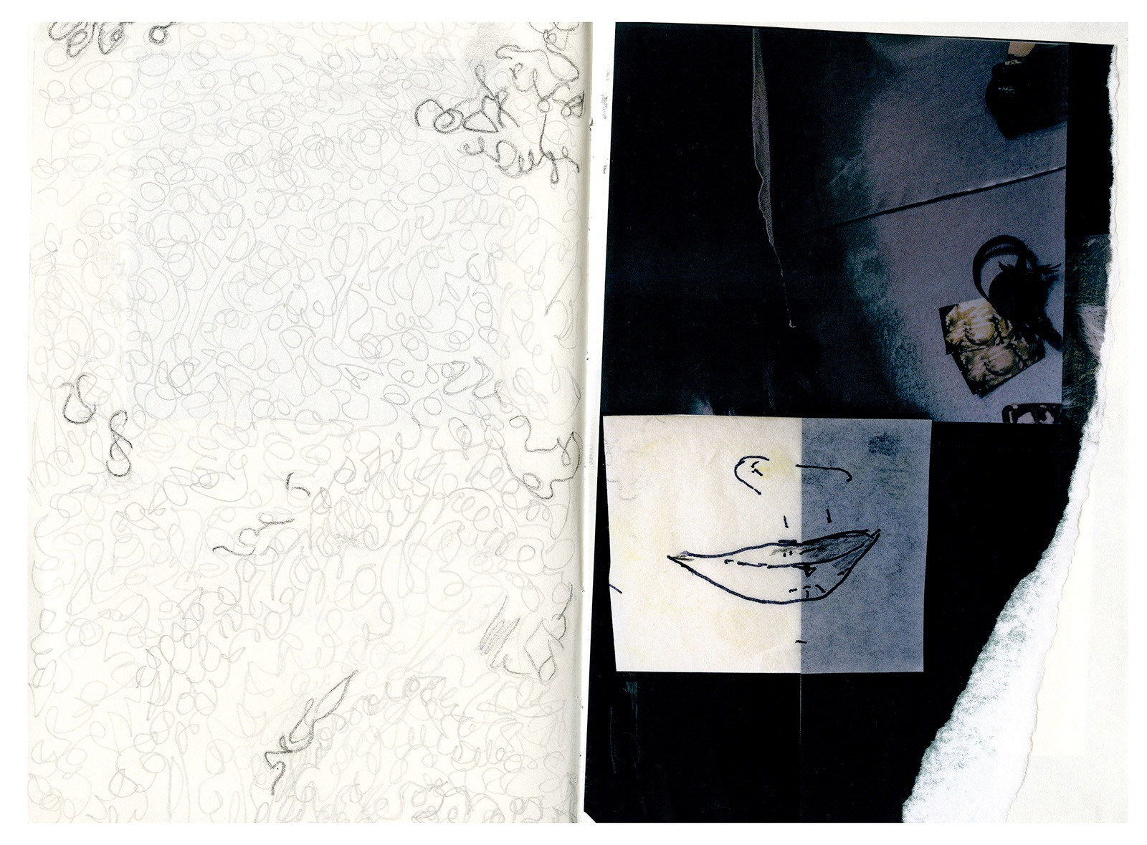ISIDORA GAJIC (1988)
Serbian–Brazilian visual artist working with photography, installation, and artist books.
SELECTED SOLO & TWO-PERSON EXHIBITIONS
2026 Sirenes — Galeria Paulo Darzé, Salvador, Brazil
2024 Sirenes — Galeria Silvia Cintra + Box 4, Rio de Janeiro, Brazil
2023 Sirenes — Laurel Parker, Paris, France
2022 Sirenes — Simone Klein Showroom Fotografie, Cologne, Germany
2020 Flutuações — Galeria Silvia Cintra + Box 4, Rio de Janeiro, Brazil
2019–20 Habaneras — with Miguel Rio Branco, SESC Quitandinha, Brazil
2016 Teias e Tramas — Gabriel Wickbold Gallery, São Paulo, Brazil
2015 Swann’s Way — with Miguel Rio Branco, Estúdio 321, São Paulo, Brazil
SELECTED GROUP EXHIBITIONS
2026 Sirenes — DOTS Gallery, Belgrade, Serbia
2023 Sirenes-Book— L’éditeur du dimanche, Les Rencontres d’Arles, France
2022 Pavilion of Arts Cvijeta Zuzorić, Belgrade, Serbia
2018 Ecume — book launch, Paris Photo, Grand Palais, Paris, France
Inspira Ocupa, Petrópolis, Brazil
2017 Galeria Mul.ti.plo, Rio de Janeiro, Brazil
Galeria Silvia Cintra + Box 4, Rio de Janeiro, Brazil
2016 Galeria A2 + Mul.ti.plo, Petrópolis, Brazil
Olhar Feminino — SESC Quitandinha, Petrópolis, Brazil
2015 Westergasfabriek, Amsterdam, The Netherlands
2014 Cultural Center Grad, Belgrade, Serbia
2013 Templo, Rio de Janeiro, Brazil
2012 The FotoFactory Show, Amsterdam, The Netherlands
ISSP Residency Exhibition, Kuldīga, Latvia
RESIDENCIES & AWARDS
2026 Mirante Xique-Xique Residency, Chapada Diamantina, Brazil
2016 Miguel Rio Branco Residency, Araras, Brazil
2012 ISSP Residency, Kuldīga, Latvia
2012 NEW Dutch Talent Award
EDUCATION
2020–2023 Artist Masterclass Program — Latela Curatorial, USA
2008–12 BFA Photography — The FotoFactory, Amsterdam, The Netherlands
2005–2007
Britannica International School, Budapest, Hungary
British international secondary education (AS Level certifications)
2004–2005
Ecole d’Humanité, Hasliberg, Switzerland
Boarding school founded by Paul Geheeb, rooted in Waldorf-inspired education

PROFESSIONAL EXPERIENCE
2013–20 Studio management, exhibition production, book design, image research, and archiving for Miguel Rio Branco
2012 World Press Photo — Image Research, Amsterdam, The Netherlands
2010 Internship focused on vintage black-and-white photography — Kahmann Gallery, Amsterdam, The Netherlands
www.isidoragajic.com • isidora.v.gajic@gmail.com • Rio de Janeiro / Araras, Brazil

