ARTIST CURRICULUM VITAE
Curtis Dickman MD Address: 6230 North 51st Place
Paradise Valley, AZ 85253 curtisdickman1@gmail.com
cell 602-524-5059
ART PORTFOLIO WEBSITE: https://www.CurtisDickmanArt.com
YOUTUBE SITE: https://www.youtube.com/@CurtisDickmanFineArt
INSTAGRAM: https://www.instagram.com/curtisdickman
FACEBOOK: https://www.facebook.com/profile.php?id=61554597107800&mibextid=LQQJ4d

ARTISTS STATEMENT:
My artwork invites viewers into an interactive and immersive experience. My passion is deeply rooted in a lifelong fascination with art, emotional expression, and the workings of the brain. I experiment freely across a diverse spectrum of styles and techniques, blending pop art, cubism, surrealism, and modern art to produce emotionally expressive, cathartic pieces that challenge and delight the viewer’s perception.
My art often explores the boundaries of visual perception through opticokinetic effects, reverse perspective, and dynamic transformations that change as the viewer’s perspective shifts. These optical illusions create a hallucinogenic-like experience without the use of drugs, teasing the brain and encouraging a deeper engagement with the work. I strive to merge painting and sculpture in ways that offer vivid 3D renderings of color, form, and light, producing crisp imagery that feels both modern and timeless.
Influenced by artistic masters such as Salvador Dali, M.C. Escher, Pablo Picasso, Yaacov Agam, Andy Warhol, and Vincent Van Gogh, I continuously push the limits of how art and perception intersect. My reverse perspective and opticokinetic pieces test the ways reality can be perceived and questioned, inviting viewers to explore new dimensions within the artwork.
I am honored to serve as the Artist in Residence for Paradise Valley from 2025 to 2026 and will present a continuous one-year exhibition at the town complex beginning in October 2025. My work has been showcased in galleries across the United States and acquired by private collectors, including notable figures such as Sir Elton John, Claire Holt, and Jewel Pilcher. Alongside my creative passion, I am committed to philanthropy; my artwork has been auctioned at charity events for over a decade, helping to raise more than $250,000 for various causes.
Through my art, I aim to engage, inspire, and transform the way people experience visual reality, offering a unique blend of emotional depth and perceptual innovation that captivates both the mind and the senses.
My artwork is best appreciated by viewing videos on my website and YouTube page.
https://www.CurtisDickmanArt.com
https://www.youtube.com/@CurtisDickmanFineArt

ART AWARDS & PUBLICATIONS:

- “CURTIS DICKMAN. “WHEN ART REFUSES TO STAND STILL”. FEATURED ARTIST. ANNUAL ART ISSUE. SCOTTSDALE FERRARI ART WEEK ISSUE. Scottsdale Life & Style Magazine. MARCH 19-22, 2026. Page 14-17. https://lifeplusstylemag.com/scottsdale/issues/annual-art-issue/
- “CURTIS DICKMAN IS OUR LATEST ART RESIN AWARD WINNER” /FEATURED ARTIST. ART RESIN BLOG. FEBRUARY 19, 2026. https://www.artresin.com/blogs/artresin/curtis-dickman-is-our-latest-artresin-winner?utm_source=GRID%20%26%20PIXEL%2090-Day%20Engaged%20Email%20Subscribers&utm_medium=email&utm_campaign=AR%20Winner%20Curtis%20Dickman%20%2801KHS1KG3SZJ4FSN6F2RZNH7J5%29&utm_klaviyo_id=HgMJjV&_kx=4saTmYbu9-BD4Gt6KLDldno9FeSLHRN056lRaGE-VwRTUiZkHLUb_IPt9D2UUnFt.QthgSQ
- Artist in Residence. Town of Paradise Valley. Solo exhibition of 35 works “WELCOME TO PARADISE”. Juried selection process. October 2025-September 2026. https://www.paradisevalleyaz.gov/88/PV-Arts-Board
- ARTIST PROFILE: CURTIS DICKMAN. “OFFICIAL ARTIST IN RESIDENCE. CURTIS DICKMAN”. TRENDS MAGAZINE. October 2025, Volume 43, No. 6, Page 40 https://www.artworkarchive.com/profile/curtis-dickman/news/town-of-paradise-valley-artist-in-residence-2025-2026
- CHILDHELP INTERVIEW. https://www.childhelp.org/interview-with-dr-curtis-dickman/
- “LIVING WITH EDWIN”. CURTIS DICKMAN / MVHL PRESS. 2022 ISBN:979-8-88581-021-0
- CURTIS DICKMAN OPTICOKINETIC POP ART. Book published October 2018. Edition One publishers. 98 pages.

- 2005 Calendar for the North American Spine Society. “The Matador” & “Cruzito”. Acrylic on canvas paintings

- “The Spine Surgeon” An original acrylic painting. Spine. Imagery section. Volume 38, Issue 23, November 1, 2013.

- Artist.com News Events. http://artist.com/news-events/view/muhammad-ali-inspiration-lives-on/51/

- Artist.com Art Recognition and Education. http://artist.com/art-recognition-and-education/world- renowned-neurosurgeon-artist-dr-curtis-dickman-donates-major-gift-muhammad-ali-painting-to- humanity-and-recognized-by-www.artist.com

ART EXHIBITIONS & AUCTIONS:
Jones-Gordon Foundation Gala. March 6, 2026 . Mountain Shadows Resort. Donated Portrait of Henry Winkler “OH HENRY!”

Desert Ridge Marriott Hotel. Phoenix, AZ. Exhibition at Spine Summit Meeting.
February 26-March 1, 2026.

Camelback Mountain Art Studio Tour. November 8-9, 2025. South Scottsdale Art Alliance.

Artist in Residence. Town of Paradise Valley, Arizona. October 2025- September 2026.
“Miracles in Miami” April 9, 2022. Auction of “Multiple Marilyns”.
Derubeis Fine Art Gallery. Scottsdale AZ. Dec 13-15, 2018
Hospice of the Valley AAHA Art Auction: March 15, 2014. “Coils 44”
Barrow Neurological Institute: Symposium Exhibition. April 2014. Phoenix, Arizona
Barrow Beyond Art Reception: September 2014, Biltmore Estates. Phoenix, AZ
Art Showcase: December 1, 2014-March 1, 2015. Temple Solel, Paradise Valley AZ.
Art Exhibition: Temple Solel 50th Anniversary Art Show. April 17, 2016
Hospice of the Valley AAHA Art Auction: March 2018. “Pablo Estuvio Aqui”
PROFESSIONAL ART ORGANIZATION MEMBERSHIPS:
ARIZONA ART ALLIANCE
SOUTH SCOTTSDALE ART ALLIANCE
SCOTTSDALE ARTISTS LEAGUE
CHARITABLE DONATIONS & AUCTION RESULTS
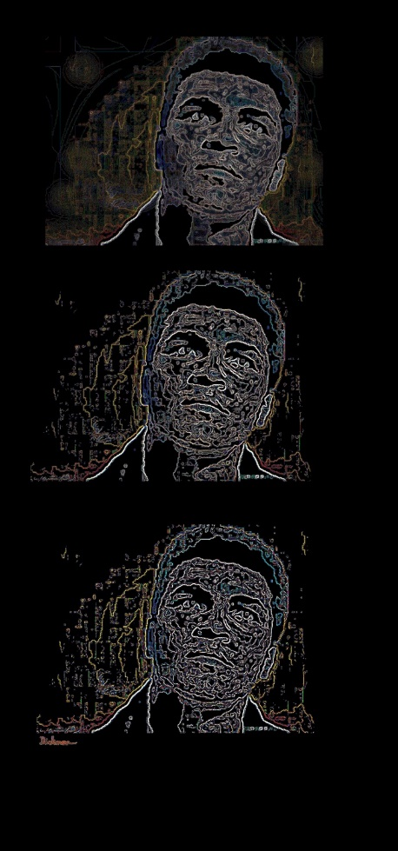
CHILDHELP Drive the Dream: January 2015. Dr. Dickman’s mixed media canvases of boxing legend Muhammad Ali, entitled “3 Faces of the Naked Soul of Muhammad Ali,” sold as two packages at auction for $57,000 apiece. This auction benefited the charity CHILDHELP, which is dedicated to the recovery of victims of child abuse
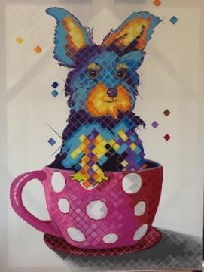
CHILDHELP Drive the Dream: January 2017. Dr. Dickman’s 36” x 48” painting of a Teacup Yorkshire Terrier entitled “Coffee, Tea or Me?” sold as an auction package for $20,000.

CHILDHELP Drive the Dream: January 2018. Dr. Dickman’s 36” x 36” commissioned 3D opticokinetic portrait of Grammy award nominated singer Jewel, entitled “Jewel Metamorphosis” sold as a live auction package for $23,000. The painting was signed by both Jewel and Curtis.
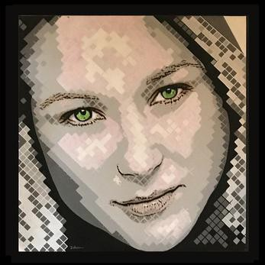
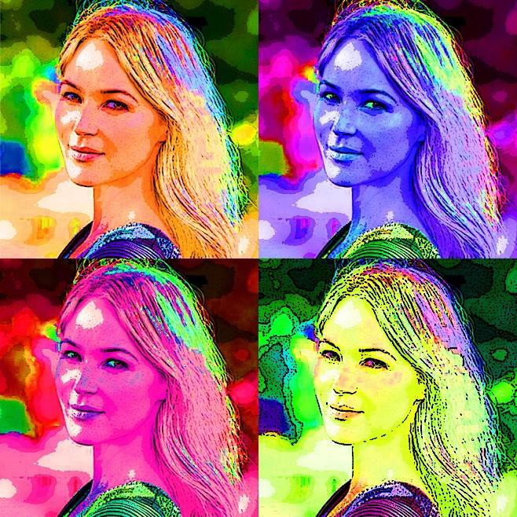
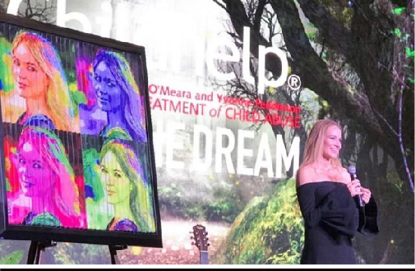
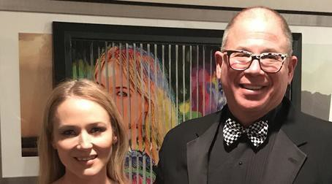
Video https://youtu.be/elI_BqPawGE

CHILDHELP 60TH anniversary Drive the Dream: February 2, 2019. Dr. Dickman was commissioned to create a unique painted piano sculpture featuring opticokinetic portraits of rock icon Sir Elton John. The artwork entitled “Goodbye Yellow Brick Road” sold as a live auction package for $50,000. Video: https://youtu.be/F0JXEEodcvI
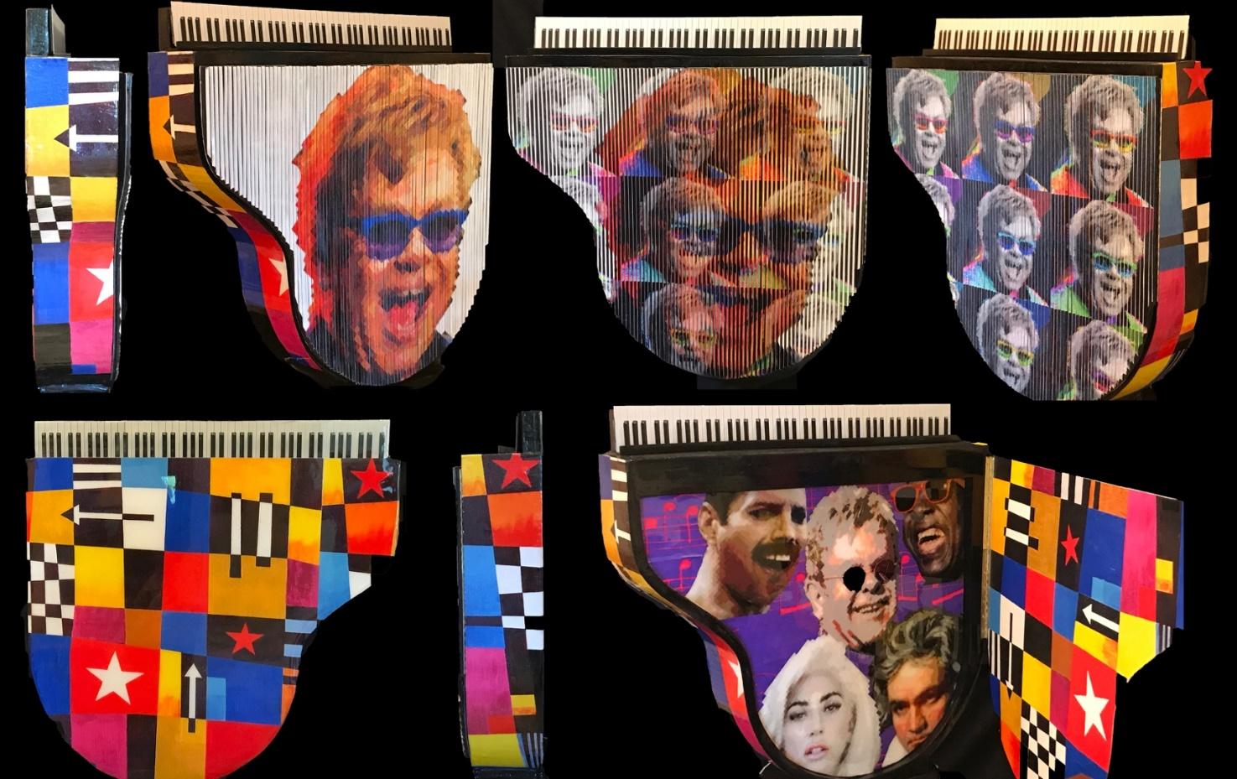

CHILDHELP Drive the Dream: May 15, 2021. Dr. Dickman donated a giant painted guitar sculpture entitled “THE SKULLCASTER”; a tribute to Keith Richards and the Rolling Stones. The artwork sold at live auction for $20,000. Videos https://youtube.com/shorts/-nPVw2KpIlE?feature=share
https://youtube.com/shorts/MgboyaXxGXc?feature=share

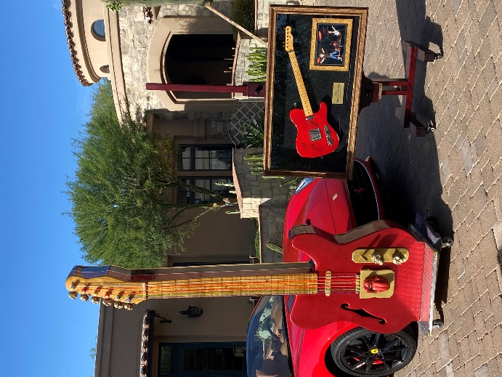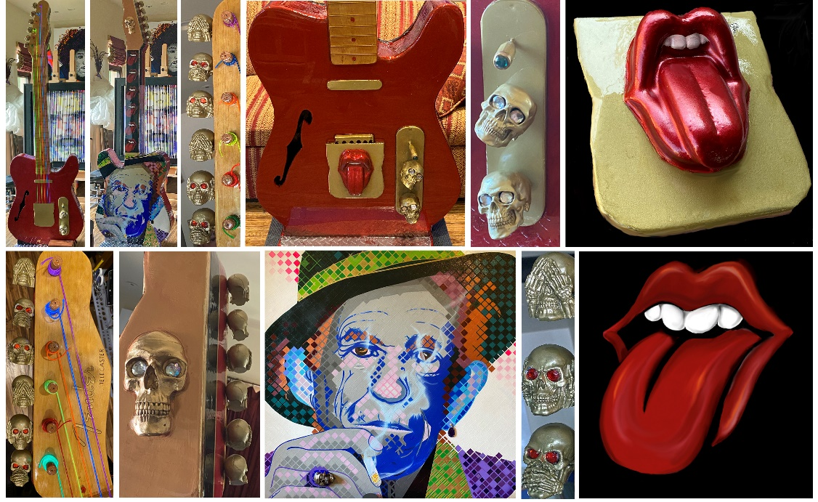
CHILDHELP MIRACLES IN MIAMI: April 9, 2022. Dr. Dickman donated a unique artist proof Opticokinetic artwork entitled “MULTIPLE MARILYN’S” which sold at live auction for $25,000.
Video: https://youtu.be/aHHhXQghkFY

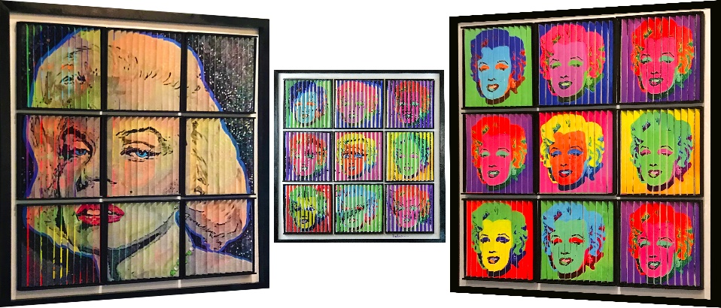

CHILDHELP WINGS Fashion Show: April 2023. Donated lenticular photocollage artwork. “BUBBLY MISS MARILYN”. Live Auction sales price $21,000.

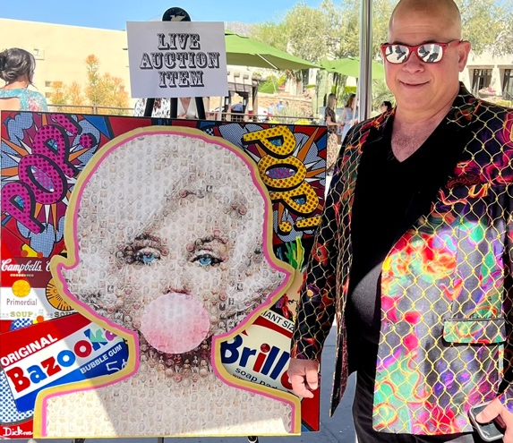 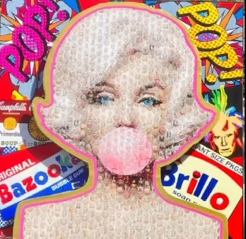 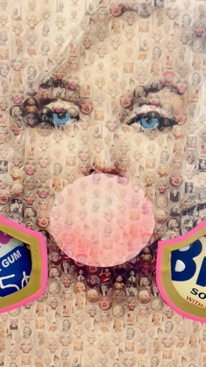______________________________________________________________________

Gordon Jones Foundation: Commissioned painting of Henry Winkler “OH HENRY” Donated for Live Auction. Signed by artist & Henry Winkler.

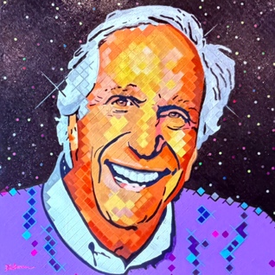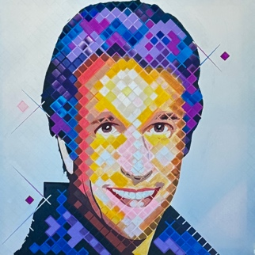

PRIVATE COLLECTIONS/REFERENCES UPON REQUEST:
Tommaso & Debra Mauro. Kewlona, BC Canada. Acquired fourteen of my original paintings and sculptures.
Mr. James Hebets: Acquired “Tears from Heaven” for permanent display at the headquarters of the Hebets Company. Phoenix, Arizona.
Permanent Installation in the Muhammad Ali Parkinson’s Center at the Barrow Neurological Institute, Phoenix, AZ: Paintings entitled “The Naked Soul of Muhammad Ali,”
Sara O’Meara & Yvonne Fedderson. Commissioned opticokinetic portrait of the founders of Childhelp, 36” x 36”, entitled “All who enter here shall find love”. 2019. Installed at Childhelp headquarters in Scottsdale AZ.

Sir Elton John & David Furnish. Custom painted piano sculpture with opticokinetic portraits of Elton John’s children & family. Entitled “Elton John & Sons”. Video https://youtu.be/KM-7gsU8XNY 2019.

Dr. James Greenspon: “9 Flavors of Primordial Soup” A multimedia tribute to Andy Warhol.

Ms. Sandra Wilkin. “Andy Warhol’s Broken Heart” Sculpture.

Warren (Budd) and Laurie Florkowiecz. “The Skullcaster” Giant Guitar Sculpture.

Claire Holt and Andrew Joblon. “Multiple Marilyns”. Opticokinetic artwork

Leah Langerman. Cowboys and Indians . Opticokinetic artwork

Paul and Kate Conn: Commissioned three paintings in 2022. Neon Andy Warhol, Lakota Indian Chief & Chief Red Cloud

Jacqueline and Dale Laniuk. February 2025. Commissioned 2 reverse perspective artworks. Canadian Rockies Winter Doorways & Canadian Rockies Summer Doorways.

Ivy & Joey Ciolli. Purchased “Bubbly Miss Marilyn” at Childhelp Wings auction. April 2023.

Brian & Tiffany Page. Purchased “We Will Rock You”. Opticokinetic Art . 2025

Michelle & Peter Kalina. Purchased “Double Bubble Triple Trouble”, Opticokinetic Art. January 2026

Karen Robins & Jeff Olsen. Purchased painting “Chromatic Contours of Camelback Mountain”. January 2026.

LECTURES:

- Welcome To Paradise. Opening reception of year-long solo art exhibition,
Artist in Residence, Town of Paradise Valley, Arizona. October 14, 2025.

- Never Give Up/ the Art of Healing. A neurosurgeon’s spiritual and emotional journey
of healing….reflected in art. St Vincent De Paul. Phoenix AZ. December 11, 2013.

- The Art of Healing. A neurosurgeon’s spiritual and emotional journey of
healing….reflected in art. Temple Solel. Paradise Valley AZ. January 25, 2015.

