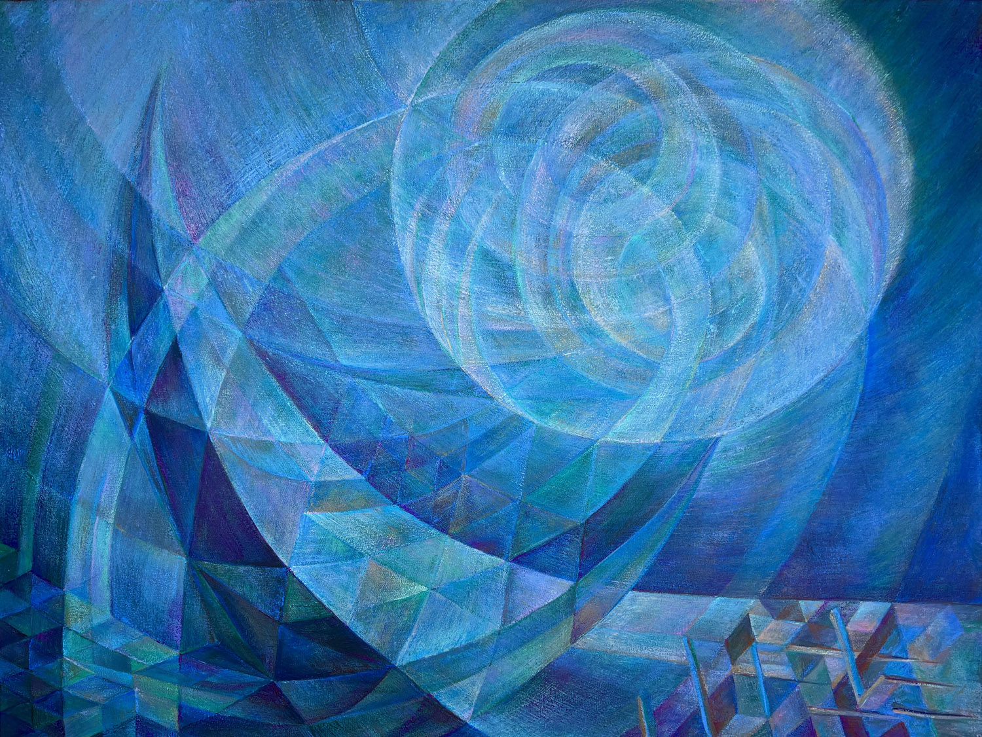

Pearl Moon
oil on canvas
30” x 40”
April/May 2023

Starting with dimensional lines in a color scheme of purple and green that turns a peacock blue. In the beginning phases I turn the canvas to follow its linear structures. The all-over cloud awaits. As the forms assert themselves, the composition confirms where the darks and lights are. Warm colors balance the blues, enriching the palette. Painting in multiple orientations allows concentration on the composition, outside of potential meaning. Ultimately, it is wresting with and exploring a cloud of unknowing.

The first lines and overall form progress very quickly into an all-over composition. Looking into this abstract void to divine a structure was described as “Orphic” by Guillaume Apollinaire, as Orpheus delved into the underworld to pursue his passion. At this stage, printouts are made to draw into the shapes and delineate possible outcomes. Many hours are dedicated to looking and planning as the individual elements and areas of the canvas develop. The last sessions appear to progress slowly as much work is dedicated to fine-tuning, sharpening lines, smoothing passages and deepening color relationships.

Background and foreground weave together, making the moon at once far away and then linked to the earth. The linear structure connects the circular and cubic forms, flowing through the geometry. These space-plays introduce an element of time, animating the composition.

The working title for much of the painting's progression was, ‘The Cloud of Unknowing,’ after a 14C manuscript of Christian mysticism that suggested we not try to define God, but surrender the mind and ego to the realm of “unknowing" in hopes of glimpsing insight into the nature of the divine.
As the Moon became more pronounced, the title became clear. Pearls begin as a rock, inert as the moon, and coated with layers and layers of nacre. Grit is the core, given light from without, to glow as if from within.

