CERTIFICATE OF AUTHENTICITY
This certifies that the artwork described below is an authentic work
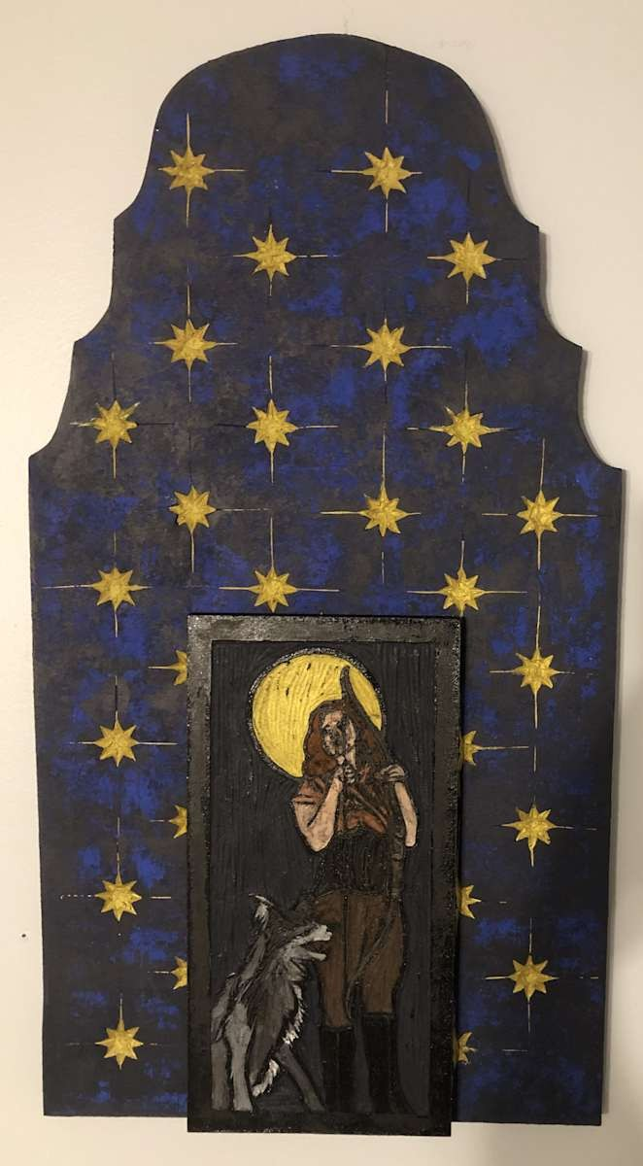
FRANCES BYRD
Diana Beneath a Starry Sky
Date:
January 30, 2026
Medium:
Wood Carving
Dimensions:
24
x 13 x 1 in
This portrait is the first piece in a new body of work that combines the craftsmanship and design elements of printmaking with the more painterly approach that I have been using in my portraits of empowered women. I utilized one of my printmaking blocks as the central element of this assemblage piece, drawing on art historic inspiration for the narrative.
On a trip to Italy several years ago, I was fascinated by the architectural features in Florence that incorporated sculpture and handmade tile in alcoves on the exterior of several buildings. The starry sky in this piece pays homage to that inspiration as a backdrop to the goddess Diana. She is primarily considered a patroness of the countryside and nature, hunters, wildlife, childbirth, crossroads, the night, and the Moon.
The structural material for this piece is an MDF panel that has been cut to shape and carved by hand with woodworking tools. I used printmaking ink to color the blocks, further tying into the techniques and... Inventory: MM.2026.DIANABASS
This artwork is a one-of-a-kind original piece, derived from my own observation, imagination, sketch or photograph. All copyrights and reproduction rights are retained by Frances Byrd. This artwork may not be reproduced by any process or medium without the express written permission of the artist.

NAME DATE
SIGNATURE
Frances Byrd
16789234999 birdlady@francesbyrd.art

