CERTIFICATE OF AUTHENTICITY
This certifies that the artwork described below is an authentic work
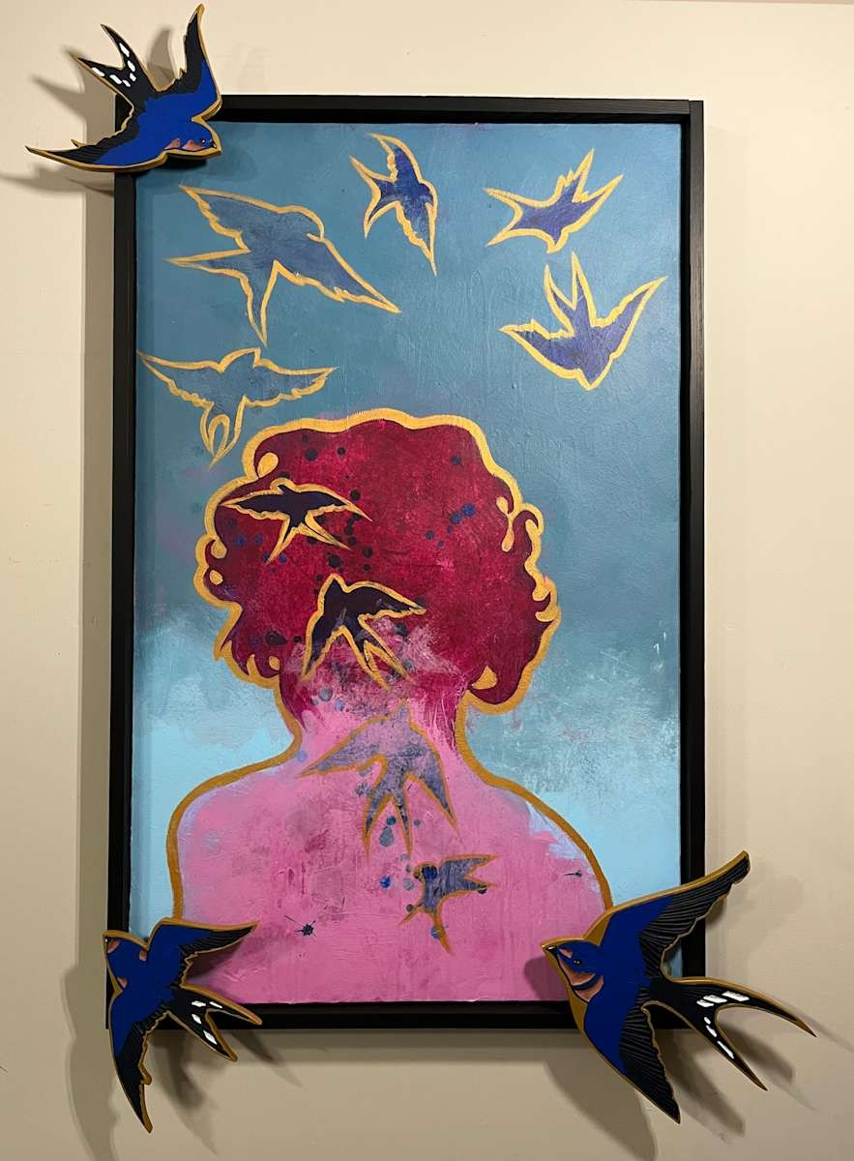
FRANCES BYRD
Taking Flight
Date:
March 26, 2026
Medium:
Acrylic On Canvas, Hand Carved MDF
Dimensions:
48
x 30 x 2 in
This portrait is an exploration of the personal freedom that comes from letting go – of other people’s expectations and preferences, of crippling self-imposed perfectionism, and a turning away from the negativity so prevalent in our culture. Birds are a recurring theme in much of my work because I have always felt a strong attraction to them. Whether they are wild, domesticated, songbird, scavenger, or bird of prey makes no difference to me. I love them all!
I have long felt that birds are the perfect symbol for freedom and creative expression. To be able to fly and spread joy through song makes them a perfect accompaniment to my portraits of empowered women.
In Taking Flight, I used barn swallows because historically they have been used to symbolize luck and good omens. In some cultures, they are believed to carry souls into the sky. In this portrait, they are juxtaposed with bright colors and strong shapes. The figure’s hair mimics their flight, as well as sharing their golden...
Inventory: 3DP.2026.TF
Framed: 60 x 41 x 0.5 in
This artwork is a one-of-a-kind original piece, derived from my own observation, imagination, sketch or photograph. All copyrights and reproduction rights are retained by Frances Byrd. This artwork may not be reproduced by any process or medium without the express written permission of the artist.

NAME DATE
SIGNATURE
Frances Byrd 16789234999 birdlady@francesbyrd.art http://www.francesbyrd.art

