Short resume Martin Spillmann
I was born on 27 June 1961. At Christmas I received pencils. As a toddler, I won a drawing competition in a major magazine, which I was proud to pick up in Aarau. I was able to buy a whole Märklin Model Railway with it.

As a seven-year-old, I gave this drawing to my first school friend. Her mother must have kept it, because after she died many years later, the bird was found again! The picture found its way back to me in a roundabout way.

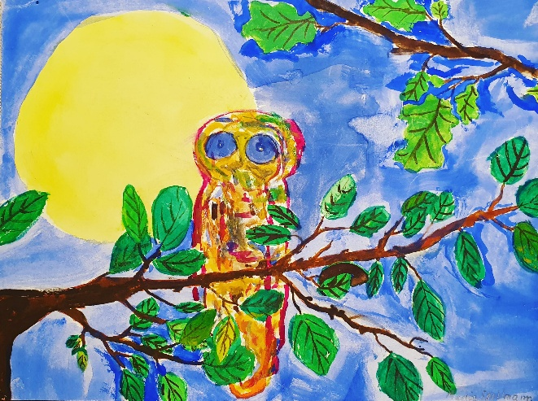

After school, I worked in the banking industry for 20 years, and another ten years as a finance professor. In 2017, I attended an urban sketching course. My enthusiasm for drawing was immediately back! I am particularly fascinated by drawing outside in public space. A day a sketch.

Publications
- Zug Sketches 2021-22, glued, self-published (out of print)
- "Not for eternity", Zuger Zeitung, 10.3.2022
- The Pointed Nose Fox, children's book (illustration), self-published 2024
- Bridge to the World, art contribution in the Brugger Neujahrsblätter 2026

Exhibitions
- January 2025: KunstKubus in Cham
- April 2025: Lakeside Gallery in Zug
- August 2025: Gluri Sutter Huus in Wettingen
- May 2026: Brugg City Museum

