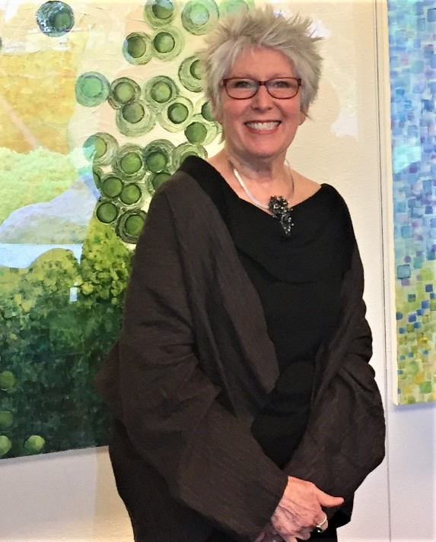
A lifelong passion for art and education has shaped Kathleen Kane-Murrell’s three-decade career. After earning a marketing degree from San Diego State University, she worked as a corporate trainer and manager before translating those skills into Fine Artists™, an award-winning children’s art program. Since 1990, Fine Artists™ has trained thousands of volunteers and students across San Diego. During COVID-19, she developed an online platform to continue Fine Artists™. She currently serves as resident artist for Ellen Browning Scripps Elementary, where she trains more than 100 volunteer docents supporting 800 students.
Kane-Murrell’s professional art career began in 2007. She has exhibited throughout Southern California and Tijuana, Mexico. Group and solo exhibitions include the Oceanside Museum of Art, the Japanese Friendship Garden Museum, the San Diego Art Institute, and the La Jolla Athenaeum. Her work is held in private collections in the United States, Japan, and Singapore. She is represented by Sparks Gallery in San Diego.

Exhibition History

Solo Shows
2025 – Solo Exhibition “Chasing Shadows” ∣ Sparks Gallery, San Diego, CA
2024 – Solo Exhibition “Dog Smiles and Curious Cats” ∣ Rancho San Diego Library, San Diego, CA
2023 – Solo Exhibition “Wayfinding In Suspended Times” ∣ Sparks Gallery, San Diego, CA
2022 – Solo Exhibition Historic Wegeforth House ∣ San Diego, CA
2020 – Solo Exhibition “Addressing Her Story” ∣ Sophie’s Kensington Gallery, San Diego, CA
2019 – Solo Exhibition “First Sight Kyoto, Ichigo Ichie” ∣ Japanese Garden Museum ∣ Balboa Park, CA
2018 – Solo Exhibition “Coming to Light” | Sophie’s Kensington Art Gallery ∣ San Diego, CA
2017 – Solo Exhibition “Made and Remade” | Ray Street Gallery, San Diego, CA
2017 – Solo Exhibition “The Secret Life of Paper” | Liberty Station Martha Pace Swift Gallery, San Diego, CA

Public Art Projects Fine Artist’s™ Program

2020 – Kumeyaay Elementary Children’s Mural “Swimmable Fishable” ∣ San Diego Water Board
Administration ∣ San Diego, CA
Scope of Project: Designed project and taught adult volunteers and children to create

mural for the permanent collection of the San Diego Water Board Authority, San Diego, CA

2010 – Kumeyaay Elementary Children’s Mural “Le Grande Jatte” ∣ Office of County Education ∣
San Diego, CA
Scope of Project: Designed mural project and taught adult volunteers and children to create a mural.
Permanent collection San Diego County Office of Education, Linda Vista

2007 – Kumeyaay Elementary Children’s Mural “Mulholland Drive” ∣ San Diego International Airport,
San Diego, CA
Scope of Project: Designed mural project and implemented instruction of volunteers and children to create a public mural for the permanent collection of San Diego International Airport, Terminal 2

Publications/Awards
2020 Creative Leadership Award, San Diego County Office of Education
2020 “How One Dress Inspired a World of Possibilities” feature article by Karla Peterson, San Diego Union
Tribune
2015 San Diego Museum of Art Artists Guild, featured artist for “Borders” exhibit
2015 Short Listed for California Art Educators Association, “Exemplary Art Program”
2013 Museum of the Living Artist Juror’s Choice Award
2012 Gallery 4311 First Place Viewer’s Choice Award
2011 “Artissimo Outstanding Educator” awarded by the San Diego County Office of Education
2003 “Creating A Masterpiece” feature article by James Steinberg, San Diego Union-Tribune

Selected Exhibition Record

2025
- November 10, 2025 – December 16, 2025 – “Reimagining La Linea” ∣ Group Exhibition ∣Mesa College Art Gallery, San Diego, CA
- October 6, 2025– November 11, 2025 – “No Hard Edges” ∣ Group Exhibition ∣Woodward Contemporary Gallery, San Diego, CA
- May 10, 2025 – July 6, 2025 – “Chasing Shadows” ∣ Solo Exhibition ∣Sparks Gallery, San Diego, CA

2024
- November 1, 2024 – November 30, 2024 – “Kathleen Kane-Murrell & Alex Arshansky” ∣ Duo International Exhibition ∣ Angulo Galeria-Sparks Gallery, Tijuana, Mexico
- October 13, 2024 – December 1, 2024 – “Face: Off Portraits and Masks” ∣ Selected Exhibition ∣ Phes Gallery, Carlsbad Village, CA
- May 9, 2024 – September 5, 2024 – “Eurythmy, Dance of Colors” ∣ Selected Exhibition ∣ Sparks Gallery installation at Encinitas Community Center, Encinitas, CA
- April 17, 2024 – May 1, 2024 – “Dog Smiles” ∣ Solo Exhibition ∣ Rancho San Diego Library, Rancho San Diego, CA
- April 10, 2024 – May 17, 2024 – “Radiant” ∣ Juried Group Exhibition ∣ Oceanside Museum of Art, SIP Gallery, San Marcos, CA

2023
- May 7, 2023 – July 7, 2023 – “Wayfinding in Suspended Times” ∣ Solo Exhibition ∣Sparks Gallery, San Diego, CA

2022
- October 1, 2022 – February 19, 2023 – “Legacy: 25 Years of Art and Community” ∣ Danielle Deery, Juror ∣ Oceanside Museum of Art, Oceanside, CA
- April 30 – July 3, 2022 – “Dreams and Daylight: Artists Alliance at Sparks Gallery” ∣ Sonya Sparks, Juror ∣ Sparks Gallery, San Diego, CA
- February 5 – March 18, 2022 – “Your True Colors – California’s Best Authentic Work” ∣ Nicholas Wilton, Juror ∣ Escondido Arts Partnership, Escondido CA
- December 18 – May 1, 2022 – “2022 Artist Alliance Biennial” ∣ Alessandra Moctezuma, Juror ∣ Oceanside Museum of Art ∣ Oceanside, CA

2021
- September 11 – October 9, 2021 – “Seven Women Artists” ∣ Rebecca Molayem Gallery & Studio ∣ Los Angeles, CA
- March 13 – August 1, 2021 – “Twenty Women Artists: NOW” ∣ Oceanside Museum of Art ∣ Oceanside, CA

2020
- Mesa College Drive Thru Art Exhibition | San Diego, CA
- Group Exhibition/Invitational ∣ “Abstract Show” ∣ Sparks Gallery, San Diego
- Group Exhibition ∣ “20/20: Twenty Women of Vision” ∣ Fresh Paint Gallery, La Jolla, CA
- Oceanside Museum of Art (OMA) ∣ Biennial ∣ Jurors Robert Pincus and Maria Mingalone, Oceanside, CA

2019
- San Diego Museum of Art Artists ∣ Horton Plaza, ∣ San Diego, CA. Juror: Sonya Sparks, Sparks Gallery
- Group Exhibition ∣ “Craft Revolution” ∣ Orange County Center for Contemporary Art ∣ Juror: Staci Steinberger, Los Angeles County Museum of Art
- Juried Biennial ∣ William D. Cannon Art Gallery | Jurors: Robert Pincus and Maria Mingalone, Carlsbad, CA

2018
- Duo Exhibition “Glaze” ∣ Conversations in Clay and Paint , Studio Door Gallery ∣ San Diego, CA
- Group Exhibition “Growing Community Roots Art” | North County LGBTQ Resource Center, Encinitas, CA
- Group Exhibition “Prom Dress: Seventeen on Being 17” | William D. Cannon Art Gallery, Carlsbad, CA
- Group Exhibition “Art Alliance at University Club” | Oceanside Museum of Art, San Diego, CA

2017
- Group Exhibition “Over the Rainbow” | Juror: Larry Baza, Ashton Art Gallery, San Diego, CA

2016
- Group Exhibition “MAS Attack” |Torrance Art Museum, Torrance, CA
- Group Exhibition “Oceanside Museum of Art Alliance” at NCRT: Cocktails and Laughter” | Solana Beach, CA

2015
- Group Exhibition “Centennial Balboa Park” | San Diego Museum of Art Guild, Gallery 21, San Diego, CA
- Group Exhibition “Borders” ∣ San Diego Museum of Art Guild, San Diego, CA
- Group Exhibition “Celebrate San Diego” ∣ La Jolla Art Association, La Jolla, CA
- Group Exhibition “What Remains: Debris and Detritus” | San Diego Art Institute, San Diego, CA
- Group Exhibition “San Diego Keeps Her Promise” | San Diego Art Institute, San Diego, CA

2014
- Group Exhibition “So/Cal/Baja” | San Diego Art Institute, San Diego, CA

2013
- Group Exhibition “Athenaeum 22nd Juried Exhibition” | Athenaeum Music and Art Library, La Jolla, CA
- Group Exhibition “Cannon Gallery Biennial” | William D. Cannon Art Gallery, Carlsbad, CA

2012
- Group Exhibition “San Diego Hospice” | San Diego, CA
- Group Exhibition “Museum of the Living Artist” |San Diego Art Institute, San Diego, CA

2011
- Group Exhibition “Outstanding Visual Artists” | San Diego Art Institute, San Diego, CA

2010
- Group Exhibition “San Diego Hospice” | Gallery 4311, San Diego, CA

2007-8
- Group Exhibition “Empowered Women” | Patrick Moore Gallery, San Diego, CA

