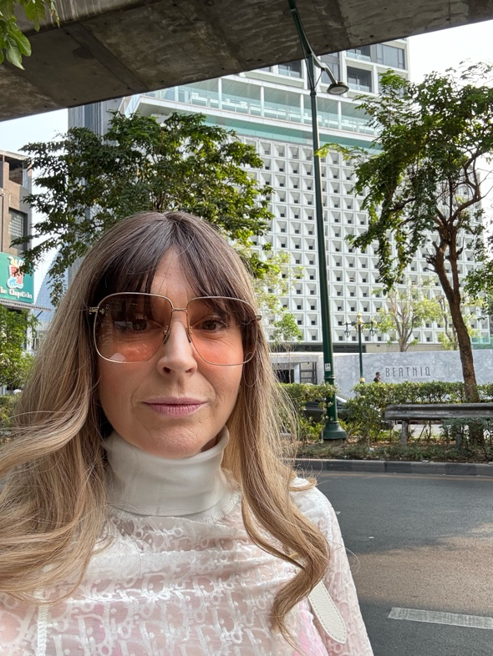 |  |  | Rosemary Anne Marcell
 |  |  | Painter and Skytographer
contact  rosemary1@yandex.com  www.sableciel.com |  |  | Seattle University Whittier Law  Seattle, WA 2003 Costa Mesa, CA 2007  BA Liberal Arts, Juris Doctor  majors: Summer Study:  Universite Tolouse de Droit Philosophy of Linguistics;  Fine Arts (painting); and  minor :  French

