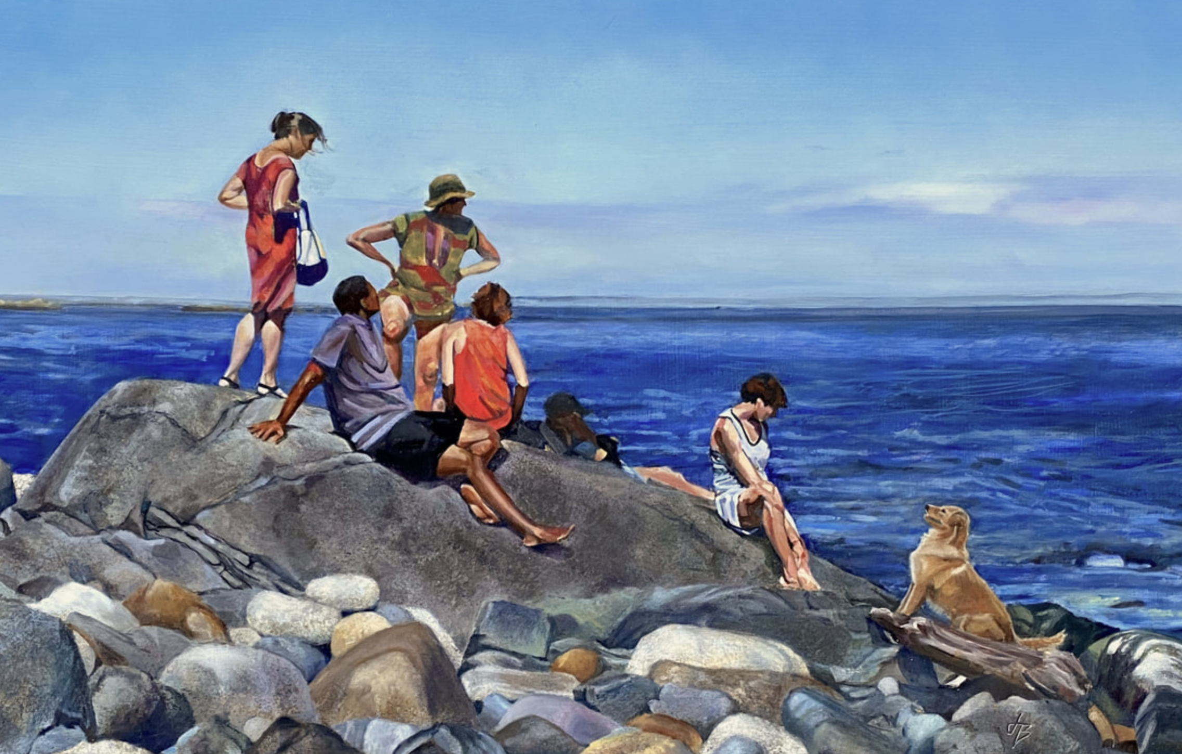
Joan Brady, O.P.A.
www.joanbradystudios.com

Curriculum Vitae
Joan Brady is a classically trained artist working in oils, often including 23k gold leaf. After having lived for seven years on an island twelve nautical miles off the coast of Maine, Brady returned to Annapolis, MD in 2022.
Brady’s paintings are found in the form of murals, trompe l’oeil, framed paintings, and ceramics. Clients include The Henry DuPont Winterthur Museum, Delaware, The Hotel Hershey, Pennsylvania, and the Mohegan Island Inn, Mohegan, ME.
Awards, Honors, and Miscellany
- O.P.A. Oil Painters of America, Associate Member, 2024-present.
- Artist In Residence, Maryland Hall for the Creative Arts, Annapolis, MD. 2023-2024.
- Paint Annapolis, Juried Plein Air event, June 2024.
- Grant winner, Island Institute, Rockland, ME. 2019.
- Summer Residential Artist Fellowship at Skidmore College in Saratoga Springs, NY.
- Monhegan Brewing Company “Rusticator” Beer label design.
- La Nef Chocolate "Brady Bar" artwork for package design.
- Winner, Maryland Wine Festival Poster competition.

Education:
- Mount Holyoke College, South Hadley, Massachusetts
  - Bachelors of Art degree
  - Phi Beta Kappa Prize in Art.
- Notre Dame of Maryland University, Baltimore, MD.
  - Master of Arts degree in Leadership in Teaching.
- Schuler School of Fine Arts, Baltimore, Maryland.
- Zoll Studio School of Fine Arts, Baltimore, Maryland.
- Baltimore Clayworks, Baltimore, Maryland.
- Koo Schadler, New Hampshire, Egg tempera 2019, 2021.
- Timothy Horn Plein Air workshop, Monhegan, ME. 2022.
Exhibits

Gallery 57 West, Annapolis, Guest artist, July-September, 2025

Submerged: Sea Life and Aquatic, Juried Group Exhibition at Annmarie Sculpture Garden & Arts Center, Solomons, MD, June-August 2025

Artist’s Melange, Circle Gallery, Annapolis, MD, March 2025
- Lowe House, Anne Arundel County Government building, Annapolis.juried exhibit through Maryland Federation of Art, January 4-present, 2025.
- Maryland Hall for the Creative Arts, Annapolis, MD, Solo exhibit, January 3- May 6, 2025.
- Hospice of the Chesapeake, Joan Brady and Aysha Akhtar at Hospice of the Chesapeake May-July, 2024
- Maryland Federation of Art, Member and Juried Group Shows, 2023
- Maryland Hall for the Creative Arts, Annapolis, MD, June 2022
- Monhegan Island Inn, Solo Artist, Monhegan, ME, May-October 2022
- Lupine Gallery, Monhegan Island, Monhegan, ME, 2017-2022
- Archipelago, Island Institute, Rockland, ME, 2018-19
- Winter Works, Monhegan, ME, 2016-2019
- Mitchell Gallery, St. Johns College, Annapolis, MD. Less is More; Small Works in a Great Space 2012.
- Annapolis Maritime Museum, Annapolis, MD. Annapolis Arts Alliance Juried show. 2012
- Maryland Hall for the Creative Arts, Annapolis, MD, 2011, 2012.
- Maryland Federation of Art, Circle Gallery, Annapolis, MD, 2012 Photography juried show.
- Paint Annapolis Quick Draw Competition. Maryland Hall for the Creative Arts. Maryland Association of Plein Air Painters show, 2010`.
- Maryland Hall for the Creative Arts, Annapolis, MD, 2010. Two Person show.
- Howard Community College, Two Person Show, 2009.
Other
- Painting and Workshop Teacher, 1990 to present at the following (partial list):
  - Providence Pottery and Arts Studio, Arnold, MD
  - Maryland Hall for the Creative Arts, Annapolis, MD
  - Sarah Webb, Art and Yoga retreat, Monhegan, ME
  - Monhegan Brewing Co, Paint With Pints, Monhegan, ME
  - Monhegan Wellness, Creativity Retreat, Monhegan, ME
  - Maryland Hall for the Creative Arts, Annapolis, MD
  - Rehoboth Art League, Rehoboth, DE
  - The Three Arts Club, Baltimore, MD
  - Baltimore Charcoal Club, Baltimore, MD
  - Owen J Roberts School District, Pottstown, PA
  - Mount Holyoke Club of Philadelphia, PA
- Lifetime Television “Our Home”; NY, NY, Guest Appearance.
- Better Homes and Gardens,” Window and Wall Ideas”; (Work published in three issues).
- Channel 8 Lancaster, PA, Two guest appearances.
- Guest lecturer, The History of Oil Painting. Monhegan Museum, Monhegan Island, ME.
- Materials Consultant, James Fitzgerald Studio, Monhegan Island, ME, 2011.
- Art Educator
  - Maine Connections Academy 2016-2020. Virtual Art teacher.
  - Sevenstar Academy, 2014-2018 Virtual Art History teacher.
  - St. Mary’s High School, Department Chair 2005-2015.

