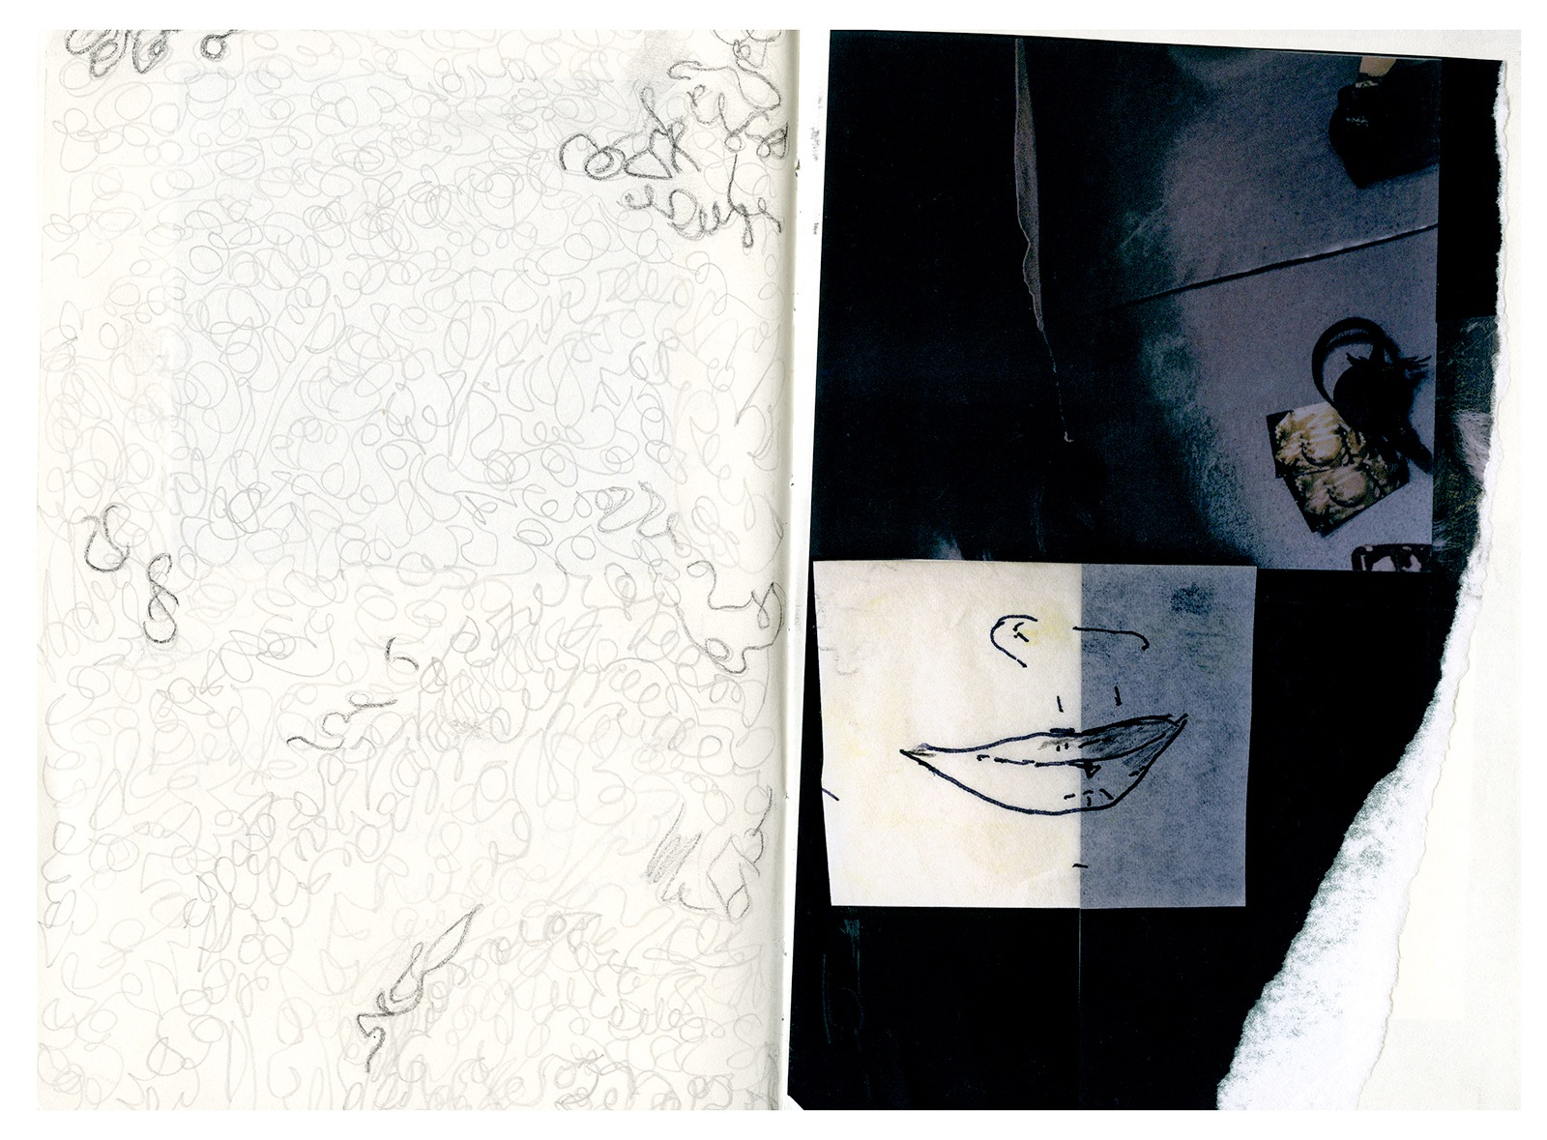 **Isidora Gajic**

**SELECTED SOLO AND TWO PERSON EXHIBITIONS**

2024  Sereias – sedas, Galeria Silvia Cintra Box 4, Rio de Janeiro, Brazil

2023 Sirenes book lounge and exhibition at Laurel Parker, Paris, France

2022 Sirenes, - Silk prints, Simone Klein Showroom Fotografie, Cologne, Germany

2020 Flutuações, Galeria Silvia Cintra Box 4, Rio de Janeiro, Brazil

2019-20 Dual show with Miguel Rio Branco, Habaneras, SESC, Quitandinha, Brazil

2016 Teias e Tramas, Gabriel Wickbold Gallery, São Paulo, Brazil

2015 Dual show with Miguel Rio Branco; Swann’s Way, Estudio 321, São Paulo, Brazil

**SELECTED GROUP EXHIBITIONS**

2020 Autumn show, Pavillon des arts Cvijeta Zuzoric, Belgrade, Serbia

2018 Ecume book presentation- Grand Palais-Paris Photo, France

2nd Inspira Ocupa, Petropolis, Brazil

2017 Inspira Ocupa, Petropolis, Brazil

Galeria Mul.ti.plo; Solar. Rio de Janeiro, Brazil

Galeria Silvia Cintra Box 4: De Acervo. Rio de Janeiro, Brazil

2016 Galeria A2 + Mul.ti.plo, Petropolis, Brazil

Olhar Feminino; SESC Quitandinha, Petropolis, Brazil

2015 Westergasfabriek, Amsterdam, The Netherlands

2014 Cultural Center “Grad”, Belgrade, Serbia

2013 Templo, Gavea, Rio de Janeiro, Brazil

2012 The FotoFactrory show, Amsterdam, The Netherlands

ISSP Residency show, Kuldiga, Latvia

**Residency**

2016 Miguel Rio Branco residency, Araras, Brazil

2012 ISSP, Kuldiga, Latvia

**Award**

2012 NEW Dutch Talent

**Publications**

Ela-Globo, Rio de Janeiro, 2024

Ela-Globo, Rio de Janeiro, 2020

Kurir International, September issue 2017

GUP Magazine, Brazil issue, 2014

FC Magazine - Natural issue pp.88-95. 2013

NEW Dutch Talent book, 2012

SHUTR Fotomagazine, 2012

NRC NEXT, 2012

GUP Magazine, 2012

**Work Experience**

2019 - Alessa cloths design with photographs of Isidora. Collection: Arte para vestir.

2013-2020 working with Miguel Rio Branco; Book designing, Image research and archiving, preparation of exhibitions, managing the studio.

2013 Creative assistant to Paul Blanka, Amsterdam, The Netherlands

2012 World Press Photo; Image research, Amsterdam, The Netherlands

2010 Kahmann Gallery, Amterdam, The Netherlands

**Education**

2008-2012 Bachelor of Fine Arts in Photography, The FotoFactory, Amsterdam, The Netherlands

2005-2007 Britannica International School (graduated; Advanced Supplementary (AS) certifications) Budapest, Hungary

2004-2005 Ecole d’Humanite, Boarding school, (secondary Waldorf education) Hasliberg, Switzerland

[www.isidoragajic.com](http://www.isidoragajic.com) e-mail : [isidora.v.gajic@gmail.com](mailto:isidora.v.gajic@gmail.com) Phone +55 24 999050530, Rio de Janeiro/ Araras, Brazil