Lyn
Laver-Ahmat

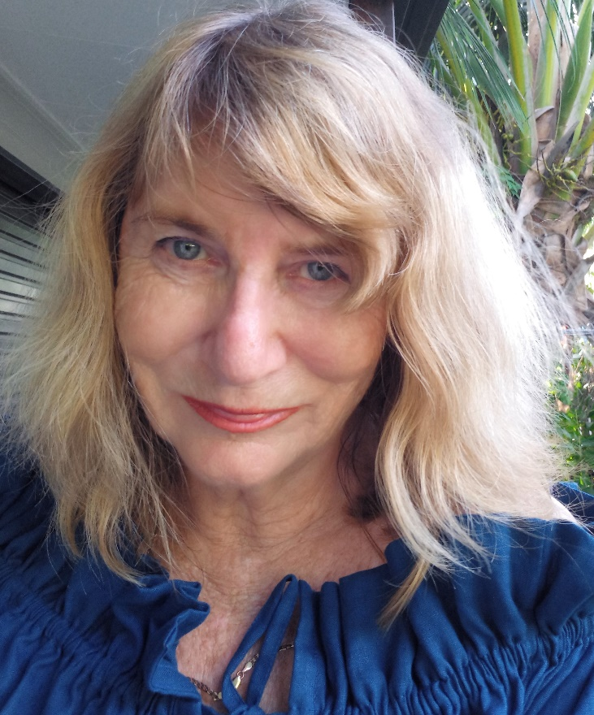

ABN No. 59223295673
- Slade Point, Q. 4740, Australia
M. 0438190951
E. lahmatau@yahoo.com.au
F. https://www.facebook.com/lynlaverahmatartist
I. https://www.instagram.com/lynlaver_ahmat/
L. www.linkedin.com/in/lyn-laver-ahmat
W. https://www.artworkarchive.com/profile/lyn-laver-ahmat

Lyn Laver-Ahmat ____________________________________________________
Selected Grants, Awards, Commissions

2023 Winner – “Best in Show” Artists and Art, Annual Art Comp. Mackay, Qld.
2022 Winner – 2D Award– Whitsunday Arts Festival, Qld.
2022 Winner – Easel painting award, Central Highlands, Emerald, Qld.
2021 Regional Arts Development Fund, Grant recipient, Mackay, Qld

2021 Winner – John Villiers Outback Art Prize, Winton, Qld.

2021 Selected Finalist – Queensland Regional Art Awards, Flying Arts Inc.

2021 Selected Finalist – Lethbridge Landscape Prize, Brisbane, Qld.

2021 Winner – Art on Show, Mackay, Works on Paper

2021 Selected Finalist – Whitsunday Arts Festival

2019 Winner – Art on Show, Mackay, Works on Paper

2019 Selected Finalist – Pro Hart Broken Hill Outback Art Prize, N.S.W.

2019 Winner – Oil Painting, Bowen Art Society

2018 Selected Finalist – Moreton Bay Art Awards, Pine Rivers, Qld.

2018 Selected Finalist - Percival Portrait Painting Prize, Townsville. Qld.

2018 Winner – Acrylic Painting, Mackay Art Society

2017 Winner – Paxton’s Portrait Painting Prize, Mackay, Qld.

2016 Selected Finalist - Pro Hart Broken Hill Outback Art Prize
2016 Selected Finalist Moreton Bay Art Awards, Pine Rivers
2015 Selected Finalist - Broken Hill Outback Art Prize
2015 Winner – Oil Painting, Mackay Art Society
2015 Open H.C. Mackay Art Society
2015 H.C. – Works on Paper, Sarina Art Extravaganza

2011 Winner – Landscape prize, Sarina Art Extravaganza
2010 Regional Arts Development Fund, Grant recipient, Mackay, Qld

2009 Commended - Airlie Beach Marine Art Show)
2007 Commended - Sarina Scope Art on Show
1996 Marian Mill Award – Pioneer Valley
1995 Acquisitive Award – Pioneer Valley
1994 Acquisitive Award – Pioneer Valley

1992 Winner – Pioneer Valley
1994 Winner Group Mural – Mackay Airport
1992 Open Encouragement Award - Rockhampton
1991 Winner – Sarina Art Society
1991 Open runner up, Gladstone
1990 Winner Contemporary – Pioneer Valley
1989 Winner Oil and watercolour, - Blackwater
1988 Artist considered most promise – Barrier Reef Art Awards, Mackay
1987 Winner Open – Pioneer Valley

Solo Exhibitions

2024,2023 Artist Inc. Open Studios, July
2022 Central Regional Queensland Art Gallery, Emerald – “Light on Landscape”
RADF funded.
2022 Coalface Gallery, Moranbah. – “Light on Landscape” – RADF funded.

2021 Bauhinia Bicentennial Art Gallery, Springsure, Dec – January

“Light on Landscape” RADF funded
2021 Cedar Gallery, April – August, Eungella
2020 Mackay Artspace Regional Gallery, December – February 2021
“Light on Landscape”
2018 Milton House Gallery, Mackay, Queensland
2017 Pilgrim Uniting Church, Adelaide – “Dreamscapes”
2017 Mackay Golf Course, Mackay
2016 Mackay Golf Course, Mackay
2013 Paxton’s Gallery, Mackay
2011 Botanical Gardens, Mackay – “Where the Shore Meets the Sea”
2010 Gargett Gallery – “Paperbarks to Pebble Beach”
2010 Botanical Gardens, Mackay – “Mackay Landscapes”
2005 Beenleigh Cultural Centre, Brisbane
2005 Satchmo’s, West End, Brisbane

Selected Group Exhibitions

2023 “Passion for Plein Air” Botanical Gardens, Mackay

2023 “Launch of Artist Studios” Gallery 31, C.Q.U. Campus, Mackay

2022 Provoking Change – (re)action states of change 7 – 28th July,

2022 RADF showcase of recipients, 2021 – 2022 Jubilee Centre, Mackay

2022/1 “Art on the Hill” Mackay

2021 Mackay Cedar Gallery, Eungella

2019 “Foundations in Drawing” Mackay Art Space Regional Gallery

2019 - 2023 Hamilton Island Art Gallery

2018 Moreton Bay Art Finalist Awards

2018 Percival Portrait Painting Finalist Prize

2017 “Beautiful one Day, Fruit Salad the Next” A Flying Arts Alliance Initiative, Judith Wright Centre for Contemporary Arts, Brisbane

2017 Mackay Art on Show

2016 Mackay Art on Show, Mackay Art Society

2015 Sarina Extravangza, Mackay Art on Show

2013 Paxton’s Gallery, Mackay

2012 Paxton’s Gallery, Mackay

2011 Sarina Scope, Mackay Art on Show, Printbank

2010 Printbank - Artspace Mackay; Art on Show, Mackay, Sarina Scope, Gargett Gallery – “Festival Fever”

2009 Gargett Drawing Prize, Sarina Scope, Art on Show, Mackay

2009 Artspace Mackay Postcard Exhibition
2008 Sarina Scope; Art on Show, Mackay,
2007 Gargett Gallery – “Faces and Places”
2007 Circle Gallery, West End - “Expressions of Interest”
2007 Gold Coast Convention Centre – “Art Expo”
2006 Leif’s Art Space, West End.
2006 Gargett Gallery, -“Press-less Painters”
2004 Gargett Gallery Inaugural Exhibition
2000,1998 Adelaide Fringe Festival - “Australian Spirituality”
2000 Brisbane, Fortitude Valley -“We Mean Women”
1998 Q.U.T. student exhibition, Brisbane - “Interval”
1997 Q.U.T. student exhibition, Brisbane.
1996 Walter Reid Centre, Rockhampton.- Mountains of Colour”
1996 - 87 Mackay City Library - Forbes Contemporary Art Group
1995 Qld. Arts Council (RADF funded) - “Colour and Collage”
1993 Mackay City Library - “Fertile Ground”
1992 North Eton Pottery Gallery - “Summer Quartet”
1991 Aust. Flying Arts School, Brisbane - “20th Anniversary”
1990 Aust. Flying Arts, School, Brisbane - “Beyond the Boundaries”

Public Art

2019 “Plastic Boutique”, Mackay

2019 5th Lane Street Art Project

2010 “Piano with Attitude” Gargett Gallery RADF funded

2006 Collaboration Mural Project Sunnybank Community Park, Sunnybank

2002 Mural Project– Aspley State School
1995 Mural Project– Slade Point State School
1995 Winner - Mural - Mackay Airport

Professional Development

2022 Makers’ shopfront – A 2 day Exhibition Development Bootcanp
2021 RASN Creative Business Champions Mentoree
2020 Provoking Change Project Retreat, Seaforth. A 2 day intensive art making, linking technology and art collaboration
2018 “Where to Next” A Career Management Intensive for Mid-Career Artists. An initiative of NAVA and Flying Arts Inc., Toowoomba, Qld.
2018 Artiz Innovation at The Edge, (Qld State Library) for Educators, Flying Arts Inc.
2000 Bachelor Arts and Bachelor Education, Q.U.T., Brisbane. Majored in sculpture. Completed, painting, printmaking, and sculpting workshops with nationally acclaimed tutors.
Art teacher in public schools and private classes for children and adults.

Employment

2019 - 2024 Residency Hamilton Island

2018 - 2024 Artist and Teacher Relief

2011 – 2017 Education Qld, Mackay North High School

2010 Education Qld., Teacher Relief, Primary and High School
2000 – 2008 Education Qld. -Sunnybank State High School, Brisbane

Gallery Representation

Cedar Gallery, Eungella.

Hamilton Island Gallery

Milton House Gallery, Mackay

Community Involvement/Residencies

2023 Inaugural Artist Trail Mackay Committee Member

2023 Tutor for “Responding to the River” 1 day workshop

2023, Tutor and Artist talk for 1 day workshop, Clermont, Qld.

2023, 2022 Artist Residency – Bimblebox Nature Reserve, Qld. 4 – 11 Sept.

2023, 2022 Tutor for Master Class Plein Air Workshops, St Lawrence Wetlands Weekend

2022 Workshops, Yeppoon, Emerald, Moranbah as part of RADF funded project
2019 5th Lane Project, Mackay
2019 “Plastic Boutique” Mackay
2017 “Paddles with Pizzazz” Dragons Abreast, Mackay
2012 Tutor, Paxton’s Creative Space and Upstairs Gallery
2012 2011 Volunteer Mackay Art Space, Q.A.T.A. member
2010 Artist in Residence workshop for children – Gargett Gallery RADF funded
2010 Hays Inlet Festival, Pine Rivers, Qld.
2007 Workshop for children– Gargett Gallery
2005 Community Mural – Sunnybank, Brisbane
2000 Workshop for children’s mural - “Our Place”, Stafford, Brisbane
2000 Workshop for children’s workshop mural – Aspley State Primary School, Brisbane.
2000 Adult classes – Stafford, Brisbane
1999 Volunteer for Children’s Global Vision World Congress, International Society for Education through Art (InSEA)
1996 Mural for Arts Festival - Mackay City Library, Qld.
1994 - 1996 stage props, Murals and collaboration in commemoration of the “Year of Indigenous People- Slade Point Primary School, Mackay, Qld.
1995 Regional Rep - Flying Arts Inc
Collections and Acquisitions

The John Villiers Outback Prize, Winton
Confa Dental, Sarina
Mackay Port Authority
T.A.F.E. College Mackay
Mackay Art Society
Sarina Shire Council
The Daily Mercury - Mackay
Broken River Mountain Retreat
Private Collections

Travels

2021 Cape York
2019 Daintree
2018 Scotland, Ireland
2017 Outback Australia, East McDonald Ranges, Lake Eyre, Kings Canyon.
2016 France, Spain, Portugal
2014 France, Belgium, Paris, England, Wales
2012 Hinchinbrook Island, ThornsburneTrail
2007 Thailand
2006 Outback Australia, Canning Stock Route, Simpson Desert, Kimberleys
2005 China
1999 New Zealand, Solomon Islands.

