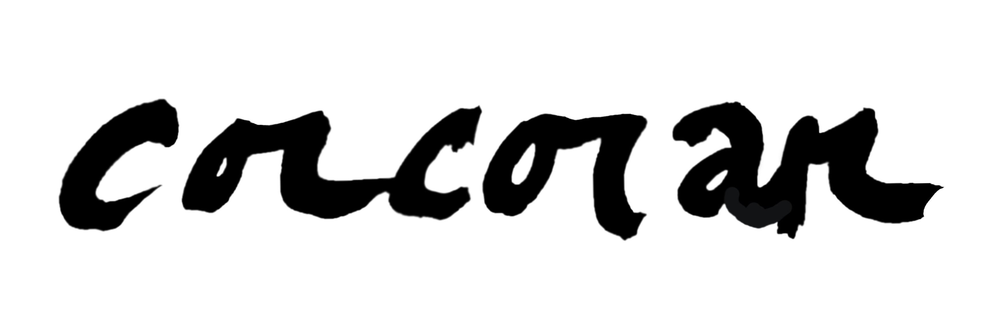
Education
1987-91 Savannah College of Art & Design; Savannah,GA
BFA in Illustration
1983-87 Lassiter High School; Marietta,GA
1969 Born in Detroit, Michigan
Exhibitions
2022 Inkberry Books; Niwot,CO
The Art of Corcoran featured Artist for the month of May
2021 Abbott and Wallace Distillery; Longmont,CO
Exhibited work from the Corcoran Art Studio (Oct.-Dec.)
in the Lounge Room at the Distillery
Lonetree Arts Center; Lonetree,CO
Commissioner’s Choice exhibition: Into the Rearview Mirror: A Look Back at 2020
“Another Roadside Distraction” painting accepted
2018 Why Not Niwot exhibition: Niwot, CO
“Spirit of Niwot” painting submitted
2015 The Pavillions Building; Longmont,CO
Exhibited the Landscapes & Galaxies series
2009 Caffe Luna; Longmont,CO
Exhibited “The Way of the Earth” all new work of mixed-media constructions and paintings
2008 30x30: 30 Years at SCAD (a Commemorative exhibition); Savannah,GA
One of 30 artists chosen to paint a 30x30” canvas for the exhibit celebrating the college’s 30th Anniversary
2007 Longmont Artwalk; Longmont,CO
Exhibited “the Mythological Landscape” series @ the French Quarter Art Gallery
2004 Longmont Artwalk; Longmont,CO
Exhibited 50 artworks from “the CORCORAN collection” @ Serendipity Antiques Gallery
2000 Gallery 978; Atlanta,GA
Exhibited “the CORCORAN collection: the first decade”
1999 the STUDIO; Flagstaff,AZ
Exhibition of the “PARADOX” series
1997 “Arts on the River” 18th Annual Juried Arts Competition; Savannah,GA
“Oceana” painting accepted by juror, Lisa Philips, curator of the 1997 Whitney Biennial
Art Mob Gallery; Decatur,GA
Solo Exhibition of the “PASTURE” series at this artist-run gallery.
1994 The Sacred Bean Coffeehouse; Marietta,GA
Displayed two paintings and three woodcuts
The Sinai Room; Transfiguration Catholic Church; Marietta,GA
Exhibited “EUROPA” ~ sketches & watercolours from my trip abroad
1992 19th International Dogwood Arts Exhibition; Atlanta,GA
‘FRAGMENTS’ painting accepted
The 3590 Downing St. Pop-Up Gallery; Marietta,GA
First showing of paintings

1989 “Arts on the River” Juried Arts Competition; Savannah,GA
Honorable Mention award for my first amateur student painting;
‘Leviathans’

Group Shows
2023 Three Artists: Corcoran, Gallegos & Colbert @8Z Realty; Longmont,CO
2016-18 The Left Hand Auction Group show
Donated a painting & sold for three consecutive years for this annual fundraiser
2011 Sizzle & Bang Gallery; Denver,CO
“the Fantastic Figures” a group exhibition featuring “A&E” and “Figure in Azul”
2009 SCAD-Atlanta Gala Fundraiser; Atlanta,GA
Donated a painting “the Aesthetics of a Landscape” for scholarship fundraiser.
2006 Denver Classic; Denver,CO
Donated “Dixon’s Horse”for the 19th Annual Polo Auction for the Denver Active 20-30 Children’s Foundation
1997 BOA Gallery; Atlanta,GA
Exhibited 2 new paintings and etchings in a group show
1994 The Red Light December Show; Atlanta,GA
Coordinated and exhibited new work in a multi-artist show at the Red Light Coffeehouse & Gallery
1993 Habitat for Humanity Silent Birdhouse Auction & Fundraiser

Happenings
2024 Firehouse Art Center; Longmont,CO
Joined the Firehouse as an Art Member
2023 Deb’s Magic Bus Mural: Longmont,CO
Commissioned to paint her double door garage at her house in Longmont.
2022 Inkberry Books; Niwot,CO
Limited edition print and artist signing of “The Flagstaff Ponderosa Tree”
2021 CAVE 30th Anniversary Colorado Winefest; Palisade,CO
Annual poster contest
2019 21st Longmont Jazz Festival
“Kind of Blue” painting featured on the festival poster
2017 The Hidden Gallery; Boulder,CO
A Winter Vintage Art & Objects Happening
Longmont Jazz Association
Elected as a board member
2015. Joined the Left Hand Artist’s Group {LHAG}
2014 January Artist of the Month: Art demo on the” Art of Collage
2012 Elected Secretary of the LAG
2011 Joined the Longmont Artist’s Guild {LAG}
2007 The Birch Tree Studio Exhibit; Longmont,CO
Studio open house of new work “the Mythological Landscape” and the “Man & Woman” series
2001-2 Moved to Taos, NM
Celebrated the birth of our son. Settled into Longmont,CO the following year
1999 Married J.L. Lohmeier @ Flagstaff Courthouse

1998 Flagstaff Historic Foundation; Flagstaff,AZ
Designed signs for the annual “Route 66”celebration
The Friends of Dry Lake Coalition; Flagstaff,AZ
Commissioned and designed two banners for the 4th of July parade
Moved to Flagstaff, AZ
1997 Central American Travel
Went to Mexico & Guatemala for 2 months w/my fiancée before moving out west
1996-7 Segakuin Atlanta International School; Atlanta, GA
Hired to teach the art curriculum for the elementary Japanese private school
1995 HORIZON Theatre Company; Atlanta,GA
Designed table backdrops and signs for the auction displays for the 5th Annual Academy Awards Party & Auction Fundraiser
1994 Schoolcraft College of Art; Livonia,MI
Presented a lecture at the college about my experience working on the “Christo Umbrellas Project”
1992-95 Rocky Mountain Elementary; Marietta,GA
Artist for the Day
Did an art demonstration for the K-5 class for three consecutive years
Transfiguration Men’s Club; Marietta,GA
Designed & coordinated the set design for the Annual New Year’s Eve gala
at Transfiguration Church for three consecutive years
1992 European Travel
For six months (April - October) I studied & travelled throughout Europe to visit the museums & culture of the Old World
ZOO Atlanta; Atlanta,GA
Donated ‘Civilized: Monkeys’ a mixed/media collage painting for the Annual Silent Auction Fundraiser
1991 the Christo Umbrellas Project/USA-Japan: Gorman,CA
After graduation from art school travelled west with some college grads to California to work as a representatives for the artist, Christo, on the Christo Umbrellas Project for six weeks
1989 St. Patrick’s Day Parade Design; Savannah,GA
Designed parade float with fellow art school comrades for the annual St.Patrick’s Day parade which was commissioned by the Census Bureau of Savannah
United Way Chapter of Savannah
Designed cover illustration for the Volunteer Awards Banquet for two consecutive years

