SUSY BOYER

Illustrator. Painter. Writer.
Educator. Presenter. Speaker.

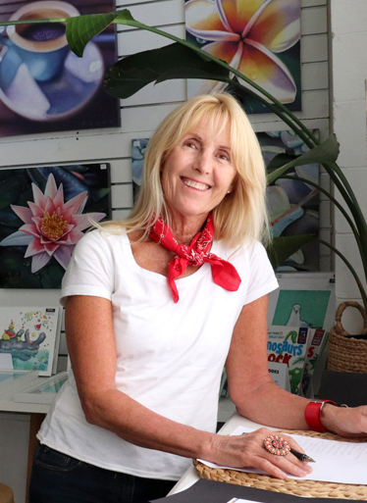
Contact Details:

Phone: 0413 134 426
Address: PO Box 222 Brunswick Heads. NSW

Email: susy@susyboyerart.com
Web: http://susyboyer.com/
Instagram: @SUSYBOYERART

Skills Summary:

Illustration: Children’s Book and Magazine illustration.
Fine Art: Botanical. Landscape. Portraits.
Writing: Children’s Fiction - Picture Books and Young Readers.
Art Educator: Teaching Studio - Drawing classes for students 6 -17yrs.
Presenter: Art and Illustration Workshops in schools and local community.
Speaker: Illustration Talks in schools.

Formal Education & Courses:

2023: Find Your Creative Voice: The Good Ship Illustration - UK.

2022: Writing Picture Books Masterclass. The Australian Writers Centre - Melbourne.

2021: Writing Picture Books. The Australian Writers Centre - Melbourne.

2019: Creative Business Planning & Marketing. The Design Trust - London.

2008: Photoshop & Advanced Photoshop. TAFE - Gold Coast.

2006: Keyboard skills. TAFE - Gold Coast.

2005: Biz Art Makers: Art Business Incubator Program. Metro Arts - Brisbane.

2001: Certificate IV Small Business Management. TAFE - Gold Coast.

1978-80: Diploma of Visual Communication – (Graphic Design & Illustration Major)
The Qld College of Art - Brisbane.

1973-77: Year 12 Certificate. Aspley State High School – Brisbane. Qld.

WORK HISTORY:

Present (since 1985)

Small business owner/operator of art practice - Susy Boyer Art.
Producing original fine art and prints.
Producing illustrations for book publishers, magazines and design agencies.
(Specialising in Children’s Books)

Skills:
Strong drawing skills and creative illustration techniques.
Imagination and creativity.
Focus and self-drive.
Communication with art directors, editors and clients.
Following art briefs.
Planning.
Meeting deadlines.
Invoicing and bookwork.
Self-promotion and marketing

Present (since 2011)

Small business owner/operator of art academy - The Art Room Drawing Academy.
Teaching drawing techniques and skills to students aged between 6-17yrs.

Skills:
Planning and teaching art lessons.
Communicating with students and parents.
Care of student’s safety and well-being.
Teaching workshops in schools.
Ordering art supplies.
Systems and inventory.
Invoicing and bookwork.
Self-promotion and Marketing.

2006 - 2016

Voluntary community work:
Beach Marshall and Public Relations Officer. Gold Coast Bodyboarding Club.

2008 – 2010

Freelance Photography assignments:
Photographing events for GCCC Active & Healthy Program marketing.

Skills:
Communicating with activity co-ordinator.
Photography of GCCC events on location.
Communicating with members of the public.
Editing and delivery of photographs.

2007 - 2009

Speaker, Presenter and Workshop facilitator:

Visiting 60 schools & public libraries in Qld and NSW.

(Agents: Show & Tell Promotions & Speaker's Ink)

Skills:
Preparation and planning of Illustrator talks and Art workshops.
Communicating with Librarian or Teacher regarding session requirements.
Presentation of talk or workshop to students or teachers (groups of up to 100 people)

Voluntary Community work:
Toogoolawa School, Coomera. Gold Coast.

Providing art workshops for emotionally damaged teen boys.

1994
Part-time Graphic Designer and Illustrator:
Warner Brothers Movie World. Gold Coast. Qld

Skills:
Illustration and design of Warner Bros characters for merchandising products.
Following briefs from Art Director and Marketing department.

1989
Graphic Designer:
Practical Parenting magazine (IPC Magazines - London, UK)

Skills:
Layout and design of magazine pages.

1982 - 1984
Assistant Art Director:
The Australian Women’s Weekly magazine (ACP Magazines - Sydney)

Skills:
Layout and design of magazine pages.
Preparation of Finished Art for printer.
Supervision of layout artists.
Overseeing photo shoots.
Checking print proofs.
Commissioning work to illustrators and hiring of freelancers.

1981 - 1982
Graphic Designer:
The Australian Women’s Weekly magazine (ACP Magazines - Sydney)

Skills:
Layout and design of magazine pages.
Preparation of Finished Art for printer.

Interests:

Art, Photography, Film, Architecture. Literature, History, Psychology. Fitness, Health and Nutrition.
Yoga and Meditation. Nature and Environment.

Additional Information:

- Current Working with Children Blue Card (Qld)
- Current Working with Children Check (NSW)
- Open Drivers licence
- Public Liability Insurance

Referees:

SAMANTHA HUGHES
Senior Active Parks Officer
Gold Coast City Council
Ph: (07) 55815233 or 0402 327 207
Email: shughes@goldcoast.qld.gov.au

PHIL NAPPER
Previous Creative Director of The Australian Women’s Weekly.
Ph: 0412 851 993
Email: md.studios@bigpond.com

DENISE CUMMINS
Writer. Journalist. Teacher.
Ph: 0438 721 581
Email: peteden@bigpond.net.au

