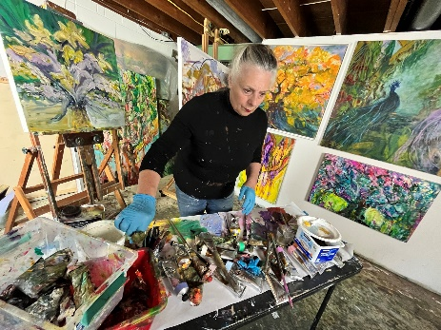
Gay P. Cox
Resume
Education  School of the Museum of Fine Arts, Boston, MA; Diploma, 1988  Coursework, Mass. College of Art, Boston, MA; 1984  Leeds Beckett University, Yorkshire, England, graduate  Art and Education 1968. |  | Solo Shows - Selections  Landscapes of the Heart, April 2023, Red Raven Art Gallery, Lancaster PA  Transvision LCAA Srasbourg PA  Tabernacle of Psalms, Preston Cutler Gallery, South Hamilton MA.  Transcendental Songs, St. Peter’s Hall, Beverly, MA.  Transcendental Songs, Zach’s Field Drum Studio, Newburyport, MA.  Small Mysteries, Liquorice and Sloe, Newburyport, MA.  Faith and Glory, Preston Cutler Gallery, Hamilton MA.  Fun, Fun, Fun, An Tua Nua, Beacon St. Boston MA.  Transcendental Songs, Diversity Gallery, Tufts MC, Watertown MA.  Small Works, New Horizons Gallery, Woburn MA.  Transformations, West Side Lounge, Cambridge MA.  Celebration, Provident Bank, Amesbury, MA.  New Paintings, Preston Cutler Gallery, South Hamilton, MA.  New Paintings and "The Way," Rensselaer Newman Foundation,  The Gallery-Chapel and Cultural Center, Troy, NY.  Spiritual Realities, Goddard Library, GCTS, Wenham, MA.  The Way, St. John’s Hall, West Newbury, MA.  Spiritual Realities, Preston Cutler Gallery, South Hamilton, MA.
Contact  110 E Charlotte Street.  Millersville PA 17551  978 504-9493  gaypcox@gpcox.com |  | Group Shows - Selections  Skies Colors of Humanity Gallery, PA  Award winner at 4 LCAA (Lancaster PA) Shows  Bloom. Gallery 115, Frederick MD. (2021)  3 Shows - Fall Season, Garden and Nature, Paula Estey Gallery, Newburyport MA.  Violence Transformed, Marran Gallery, Lesley College, Cambridge MA. (Curated)  Boston Biennial Project, Digital Travelling Show (Curated)  Newburyport Art Association, Winter Juried Show, honorable mention .  8x8 Holiday Show, MBA Dallas, TX. (Invitation only)  Make a Joyful Noise, (Invitation) Congregation Shirat Hayam, Swampscott MA.  10th Anniversary Show, Provident Bank, Amesbury MA.  Group Show, Canaan Gallery, Littleton CO.  Arts Council Show, (Juried), Amesbury, MA.  Groundworks, (Juried) Worcester Center for Crafts, Worcester, MA.  Summer House, Foxhall Gallery, Washington, D.C.  Past and Present, (Juried), M. Louise Aughinbaugh Art Gallery,  Messiah College, Grantham, PA.  Annual Art Exhibit, (Juried 1st Place), Ipswich Art Council, Ipswich, MA.  New Rituals, (Juried) Boston Center for the Arts, Boston, MA  15th Annual Cyclorama, (Juried) Boston Center for the Arts MA.  Prints and Drawings Exhibition, (Juried) Museum School Gallery, Boston, MA.
Articles and Publications  Lancaster County Newspapers 2 articles April 2023  The Lynn Item, 2013  The Herald Fall River 2012  Beverly Times 2012  Newburyport News, Andover Times and Lawrence Eagle Tribune March 2011  SMFA Magazine  Fall 2003 Eve Rising  Lenten Journey 2003: Sorrows, Small Crucifixion.  Boston Magazine 2002 Restaurant section,  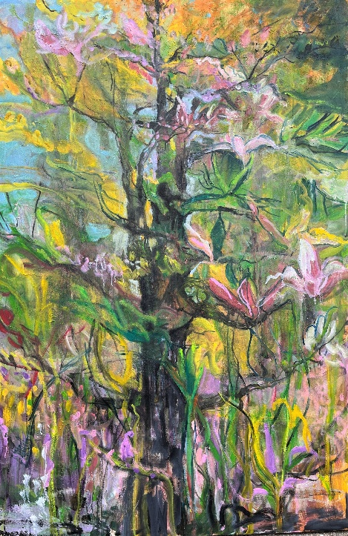 |  | Collections - Selections  Michael and Deborah McClelland, Groveland MA.  Elizabeth and Mark Retallack, Beverly MA.  Kim Thoman, El Cerrito, XCA.  Hal Stewart, N Easton MA.  William and Patricia Corson, Hampton Falls NH.  Reverend Brian Raiche, Newburyport MA.  Dr. John and the Reverend Susan Skillen, Newburyport MA.  Phillip and Susan Sheesley, East Kingston NH.  John and Carolyn Eurdolian, Belmont MA.  Jerry and Karen Adams, Wayne PA.  Gideon and Laura Adams-Cox, King of Prussia PA.  Sisters of St. Anne, Arlington MA.  Ann Smith, Ipswich MA.  Thomas and Patti Champion, Amesbury MA.  Richard and Suzie Brown, Newbury MA.  Paul and Linda Aganski, West Newbury MA.  Timothy and Linda Cox, Mechanicsville, VA.  Reverend Peter Jeffrey, Tewksbury, MA.  Cameron Wicker, Beverly, MA.  Jim Chapman, Amesbury, MA.  Roger and Marcie Lier, Andover, MA.  John and Jessamine Robinson, Alexandria, VA.  Barbara Gilbert, Grand Haven, MI.  Lovelace, Howard, Peabody, MA.  Martha and Lawrence Learned, Atkinson NH.  Timothy and Christine Sherratt, Rowley, MA.  Eugene and Linda Bullis, Hampton Falls NH.  Alan and Cindy Carter, Amesbury, MA.  Kay Weiner, Amesbury, MA.  Dr. Lorraine Rollo, Lebanon, PA  Roger and Kirsten Cramer, Amesbury MA.  Gloria Amalfitano, San Diego CA.  Peter and Gina Sheesley, Boise IO.  Karen Kudia, Ocala FL.  Karen Mcnamara, Haverhill MA.  Camilla Gruen, Newburyport MA.  Connie Woodberry, Bentonville, AR.  Carla Brewington, Altadena CA.  Private collections in U.S.A, Canada, England

