Creating an Artist
In my earlier years Dad always gave me the opportunity to try the things I found interesting, like having a typewriter as a 4 year old. He would Find these things for me “As long as you can make it work then you can Play with it” I fixed 4 typewriters, built my own bike after my new one was stolen, laces & all. This childhood hanging out made me strong and generous, independent & forever curious. Life is what you make it and how you View it, what you tell the Universe … She listens and I am grateful. Thank you Dad for making me the Woman Artist I am today and Mom for putting up with us.

Abstracts were strong for 2022 and the beginning of 2023 has already given 4 exceptional pieces, my new favorite: Fairy Glass Castle, a soft abstract with cool colors / acrylic on canvas 36x24. and December Rain (Sold) This bold modern skyline fit My View of the end of 2022 & has been a guide for other works
Techniques evolve, will flow differently depending on weather & this View.
2023 you will see the brush strokes again in my work as small detail is taking hold of my thoughts, don’t worry the credit card pallet is never far away. New Warm hues are finding themselves in the mix and I am stoked to see whats next

As the year moves along take time for yourself and to view and enjoy Art!

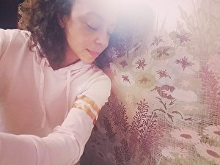
Irene Bee Kain
www.irenebeekain.com
Events page has current Exhibits

-Patioworld Showroom, Walnut Creek 2021-2023
-Richmond Arts Center, Art of the African Diaspora 2020-2023
Exhibitor, Curator and Committee Member 2021-2023
-ART House NYC Exhibitor 2020-2023
-Bridge Storage & Art Space Exhibitor 2021-2023
-Bioneers Exhibitor & Curator 2022 (Palace of Fine Art) + April 2023 (Berkeley)
-Concord Arts Association Exhibitor 2021-2023
-San Francisco Women Artist Gallery
Exhibitor, Curator and Board Member 2019-2022
-San Francisco Hearts Foundation 2020 Artist

