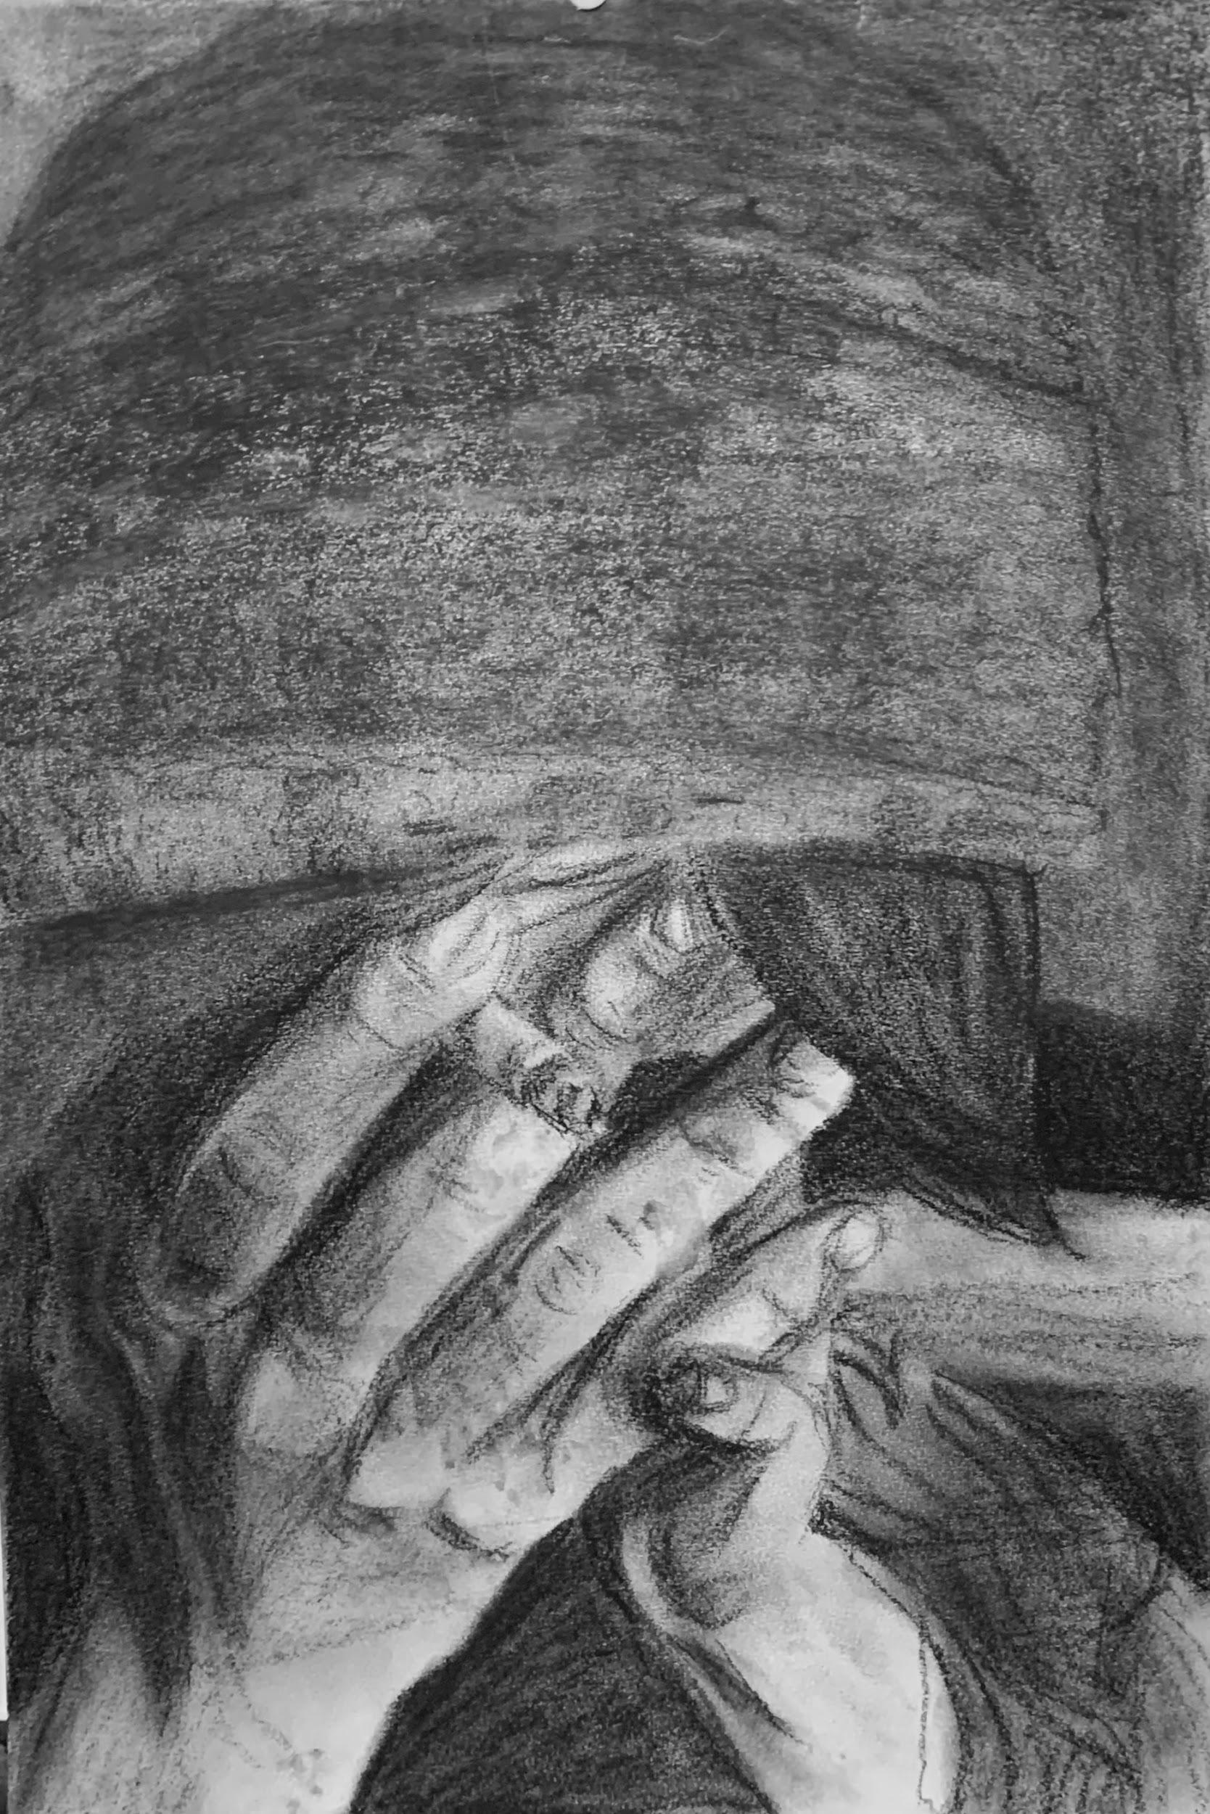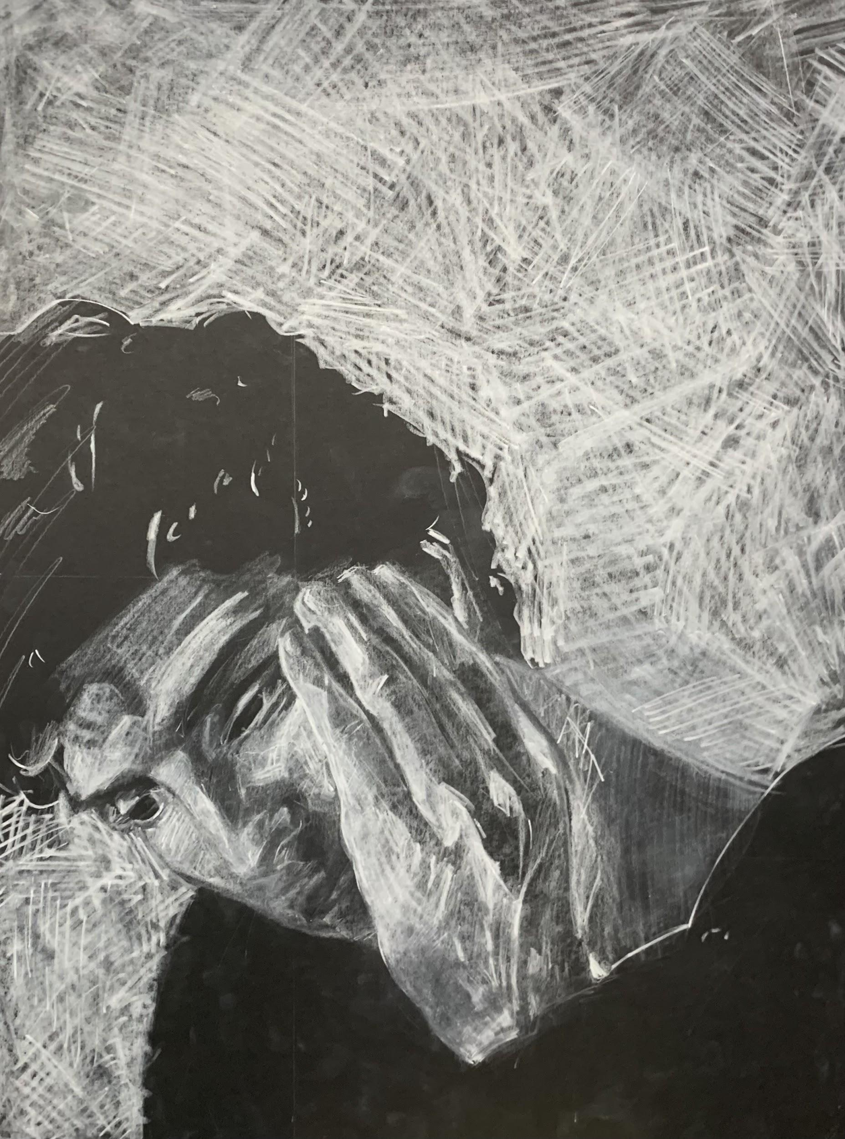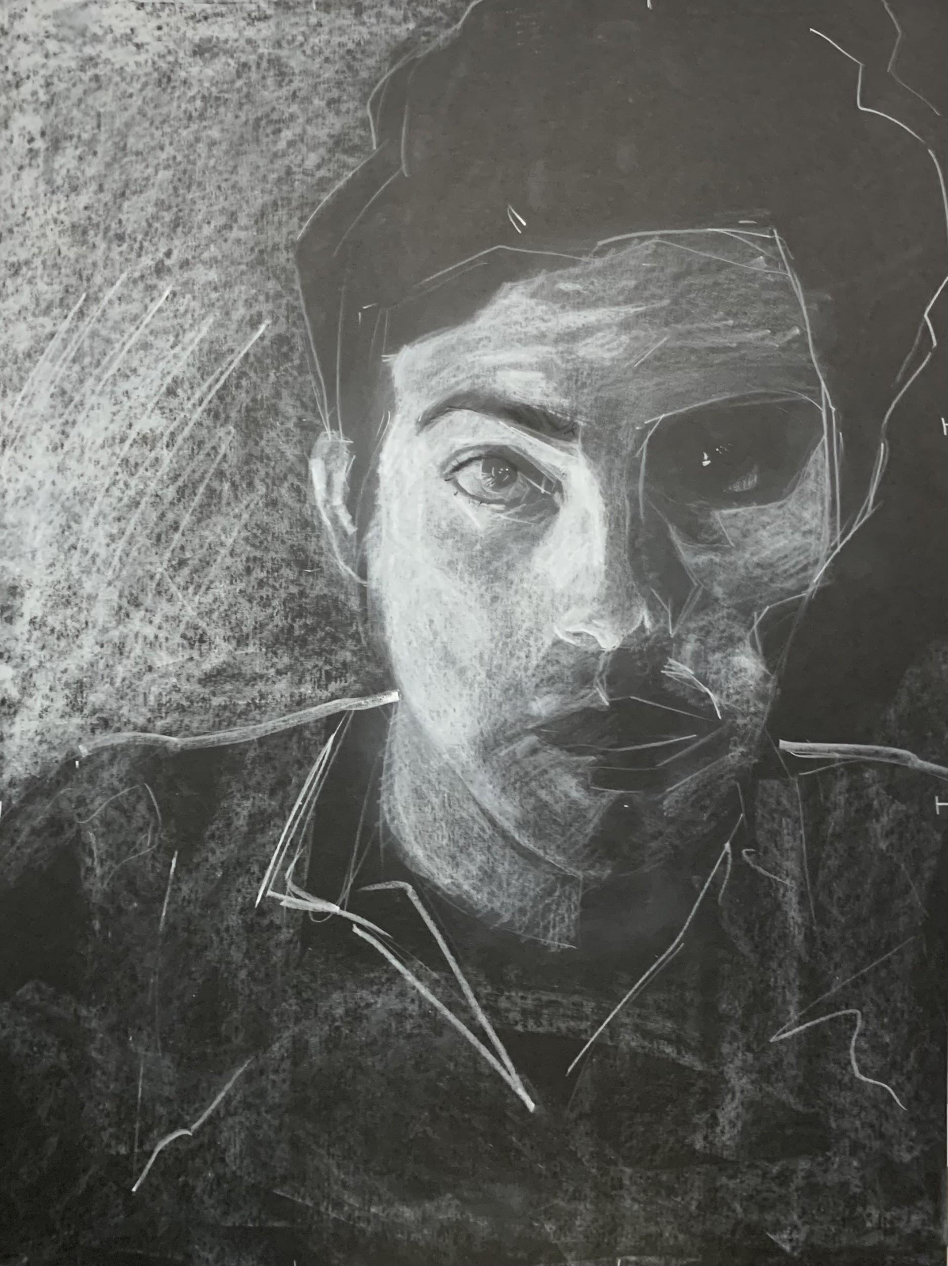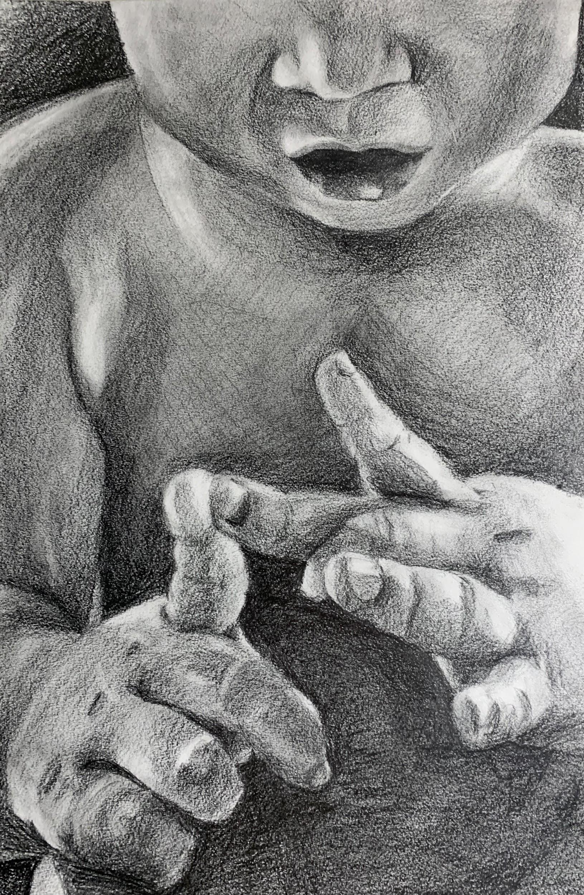

Rebekah  Wilson  Contact  501-413-2155  rebekahllwilson@gmail.com  IG: bekahwilsonart | Awards  - 2022, The Judith Wrappe Award, University of Arkansas at Little Rock, Little Rock, AR  - 2021, Windgate Scholarship for Art and Design, University of Arkansas at Little Rock, Little Rock, AR  - 2019, Windgate Scholarship for Art and Design, University of Arkansas at Little Rock, Little Rock AR  Juried Shows  - 2022, Student Competitive, Brad Cushman Gallery, Little Rock, AR  - 2021, Student Competitive, Brad Cushman Gallery, Little Rock, AR  Academic Speaking  - 2022, 32nd Annual Arkansas College Art History Symposium, Hendrix College, Conway, AR  Education  - 2023, BFA in studio art with an emphasis in drawing, University of Arkansas at Little Rock, Little Rock, AR

