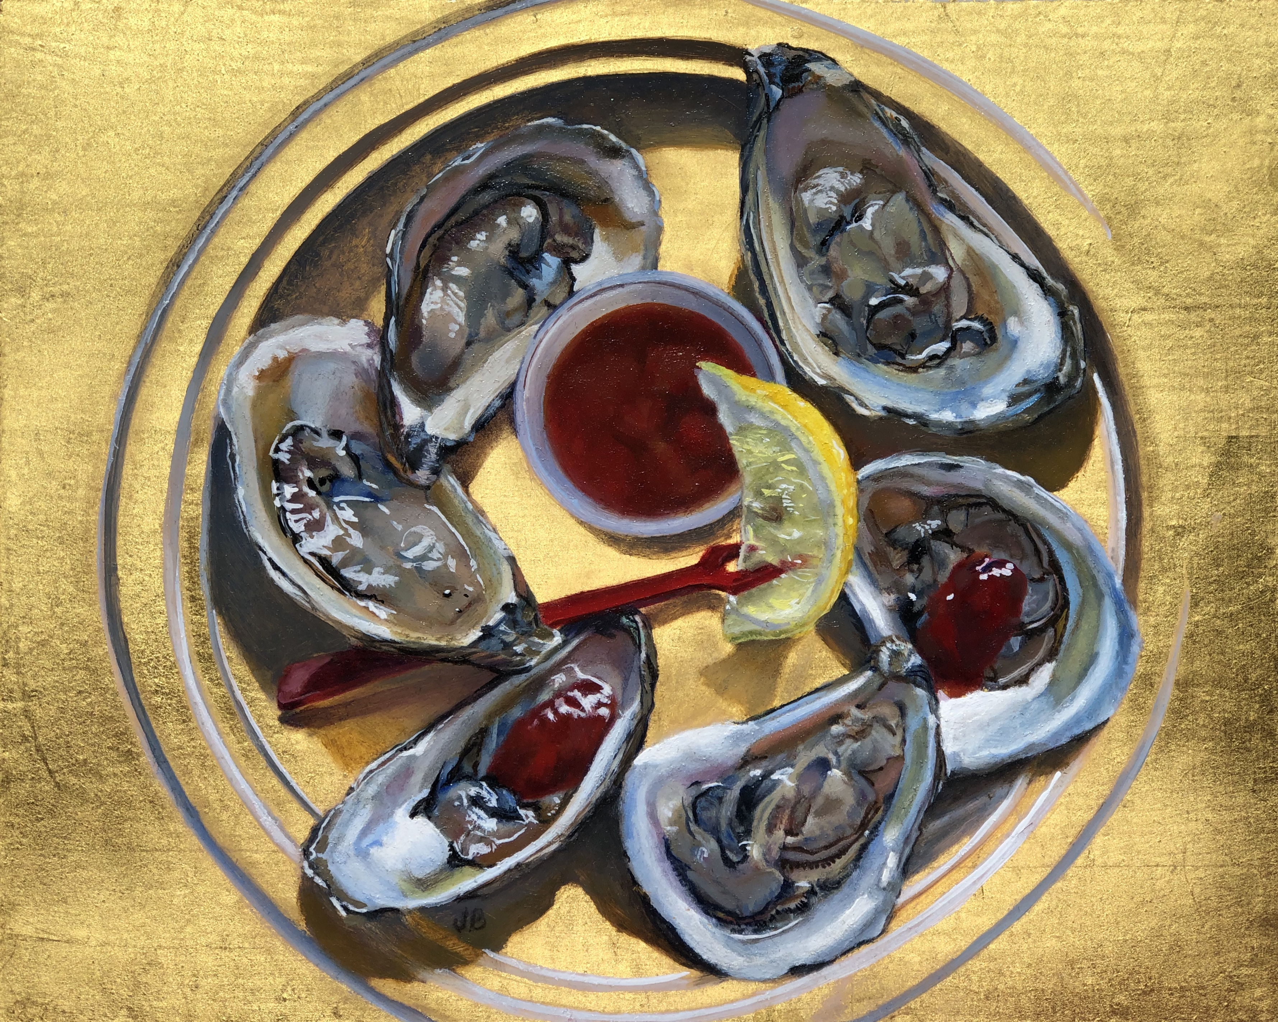
Joan Brady, Artist
www.joanbradystudios.com

Curriculum Vitae
Joan Brady is a classically trained artist working in oils, often including 23k gold leaf. Having lived for seven years on a tiny, rugged island twelve nautical miles off the coast of Maine for seven years, Brady now resides in Annapolis, MD.
Brady’s paintings are found in the form of murals, trompe l’oeil, and framed works. Clients include The Henry DuPont Winterthur Museum, Delaware, The Hotel Hershey, Pennsylvania, and the Mohegan Island Inn, Mohegan, ME.
Awards, Honors, and Miscellany
- Grant winner, Island Institute, Rockland, ME, 2019.
- Winner, Maryland Wine Festival Poster competition.
- Summer Residential Artist Fellowship at Skidmore College in Saratoga Springs, NY.
- Monhegan Brewing Company “Rusticator” Doppelbock Beer label Design.
- La Nef Chocolate "Brady Bar" artwork design.
Education:
- Mount Holyoke College, South Hadley, Massachusetts
  - Bachelors of Art degree
  - Phi Beta Kappa Prize in Art.
- Notre Dame of Maryland University, Baltimore, MD.
  - Master of Arts degree in Leadership in Teaching.
- Schuler School of Fine Arts, Baltimore, Maryland
- Zoll Studio School of Fine Arts, Baltimore, Maryland.
- Baltimore Clayworks, Baltimore, Maryland
- Koo Schadler, New Hampshire, Egg tempera 2019, virtual workshop 2021.
Exhibits
- Monhegan Island Inn, Solo Artist, 2022 Season
- Lupine Gallery, Monhegan Island, ME 2017-2022
- Archipelago, Rockland, ME 2018-19
- Winter Works, Monhegan, ME 2016-2019
- Mitchell Gallery, St. Johns College, Annapolis, MD. Less is More; Small Works in a Great Space 2012.
- Annapolis Maritime Museum, Annapolis, MD. Annapolis Arts Alliance Juried show. 2012
- Maryland Hall for the Creative Arts, Annapolis, MD, 2011, 2012.
- Maryland Federation of Art, Circle Gallery, Annapolis, MD, 2012 Photography juried show.
- Paint Annapolis Quick Draw Competition. Maryland Hall for the Creative Arts. Maryland Association of Plein Air Painters show, 2010`.
- Maryland Hall for the Creative Arts, Annapolis, MD, 2010. Two person show.
- Howard Community College, Two Person Show, 2009.
Other
- Lifetime Television “Our Home”; NY, NY, Guest Appearance.
- Better Homes and Gardens,” Window and Wall Ideas”; (Work published in three issues).
- Channel 8 Lancaster, PA, Two guest appearances.
- Guest lecturer, The History of Oil Painting. Monhegan Museum, Monhegan Island, ME.
- Materials Consultant, James Fitzgerald Studio, Monhegan Island, ME, 2011.
- Painting and Workshop Teacher, 1990 to present at the following (partial list):
  - Art and Yoga retreat: When Women Were Birds with
  - Monhegan Brewing Co, Paint With Pints, Monhegan, ME
  - Monhegan Wellness, Creativity Retreat, Monhegan, ME
  - Maryland Hall for the Creative Arts, Annapolis, MD
  - Rehoboth Art League, Rehoboth, DE
  - The Three Arts Club, Baltimore, MD
  - Baltimore Charcoal Club, Baltimore, MD
  - Owen J Roberts School District, Pottstown, PA
  - Mount Holyoke Club of Philadelphia, PA
- Art Educator
  - Maine Connections Academy 2016-2020. Virtual Art teacher
  - Sevenstar Academy, 2014-2018 Virtual Art History teacher.
  - St. Mary’s High School, Department Chair 2005-2015

