FREE YOUR MIND

F
ree Your Mind is a public textile social justice art project aiming to collect, exhibit, embed and release personal narratives about Microaggressions in a textile art piece created by artist Theda Sandiford.
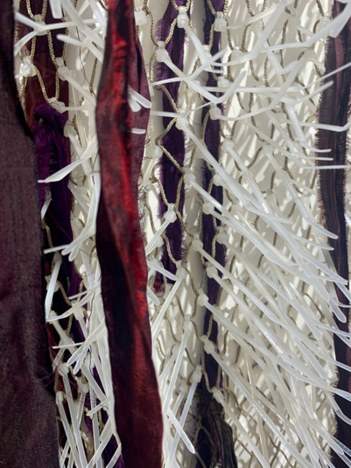
​
Microaggressions are subtle, intentional — and oftentimes unintentional — everyday
interactions or behaviors that communicate hostile, derogatory or negative racial
messages or assumptions toward historically marginalized groups. The weight of these daily interactions underpins very real consequences... stress, anger, frustration, self-doubt and ultimately feelings of powerlessness and invisibility.

This project intends to expose these interactions and provide a release for the participating individuals. Participants are invited to write a story about a microaggression they have experienced onto a ribbon and tie this ribbon onto a net to release this story from their personal narrative.

The story ribbons will ultimately be woven into a protective blanket, keeping a public record of these disempowering interactions that can later be exhibited and talked about.

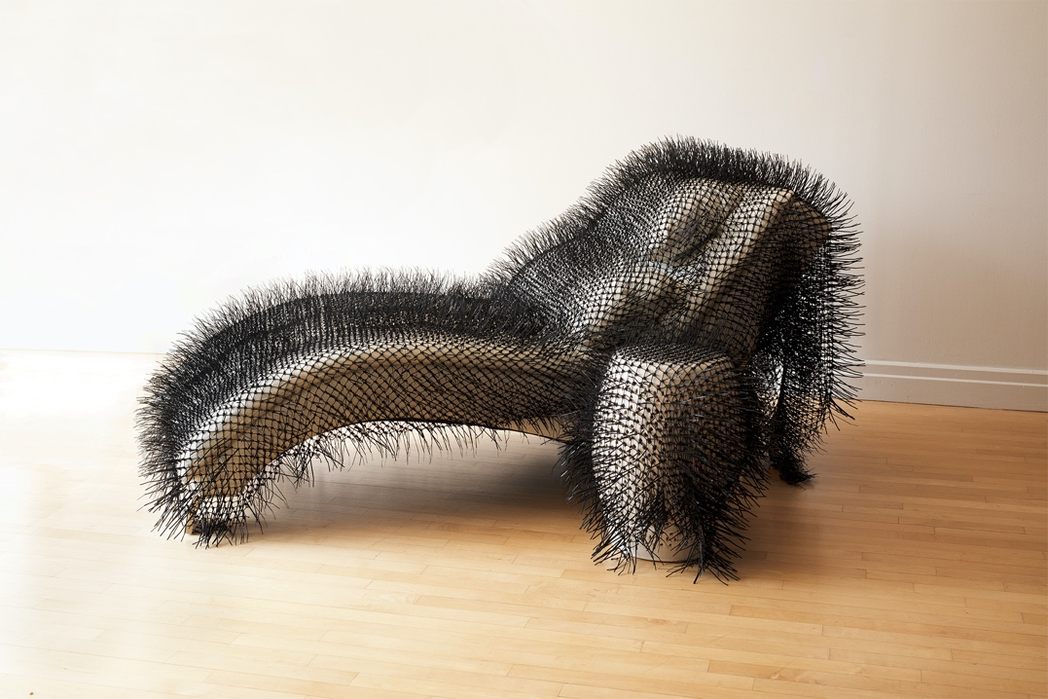

HOW TO PARTICIPATE
Interested individuals, institutions and businesses can sponsor the project by engaging themselves and/or communities they serve to collect stories. These stories and the textile artwork containing them will be shared on Instagram (@misstheda).
​

INFORMATION RELEASE FORM
Participating individuals will complete an information release form below consenting to the use of their written responses as part of the artist’s production and implementation of the Free Your Mind project.
​
THE ART(WORK) DESCRIPTION
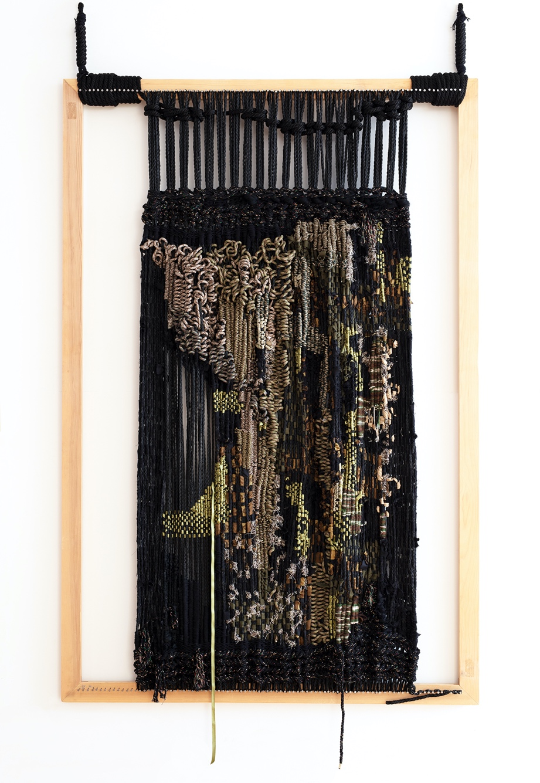
The artist will weave story ribbons of participating individuals into a protective blanket. ONLY the stories will be included, leaving the names of persons anonymous on the artworks. Should they wish, the names of participating individuals will be included in the description of the work and shared on Instagram.
​
TO PARTICIPATE >> SHARE YOUR STORY
Share a story about a microaggression you have experienced. How did it make you feel?
Using a Sharpie, in two sentences (100 words max.) write your story on a ribbon.
Complete the information release form and mail both items to:
Project Free Your Mind c/o Sky Garden Gallery, 150 Bay St. PH9 Jersey City NJ 07302

Follow @misstheda and @skygardengallery on Instagram to get updated on the project and see your story in the finished artwork.
​

“FREE YOUR MIND” INFORMATION RELEASE FORM

Guest (please enter full name) ______________________________________________

As a guest of the public textile social justice art project FREE YOUR MIND (herein “the Art Project”), I consent to the use of my story and ribbon in the Art Project. I further consent to the distribution and exhibition of my story ribbon, including any information and content I provide, by Theda Sandiford (“Artist”) in textile or any other art form without restriction. I further acknowledge and agree:

(1) I will receive no monetary compensation for my participation in the Art Project.

(2) I am granting the Artist a non-exclusive, royalty-free, perpetual, worldwide license to use and exhibit any content I supply as part of my written story to the Art Project.

(3) The Artist is the sole owner of all rights to the Art Project, including the artwork in which my written story appears. I further acknowledge and agree that the Artist has the right to edit the content of my participation and use, exhibit and/or publish the same in any media now and in the future without first obtaining my approval.

(4) I am releasing and discharging the Artist together with all the participating institutions and businesses from any and all liability arising out of or in connection with my participation on the Art Project.

AGREED & ACCEPTED

Date ____________________________________________________________________

Print name _______________________________________________________________

Signature ________________________________________________________________

NOTE: Written stories sent without the completed Information Release Form won’t be taken into consideration.

Mail ribbon and this consent form to:
Project Free Your Mind c/o Sky Garden Gallery 150 Bay Street, PH9, Jersey City NJ 07302

