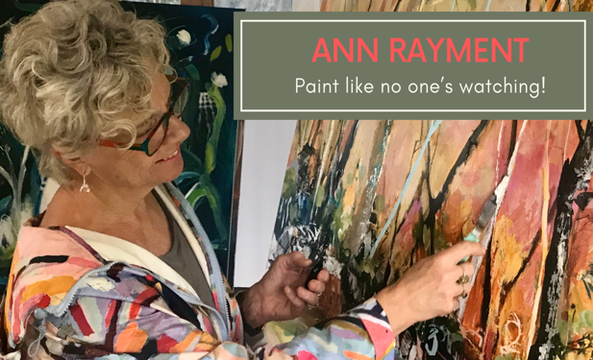
www.annrayment.com
www.instagram.com/artisann
www.facebook.com/annart2705

email : annray2705@gmail.com

Ann is a contemporary Australian Landscape artist from Dolphin Point NSW.
She grew up in Leeton ,NSW, lived for a number of years in Hobart and returned to Leeton in 2006.
Ann retired from a school teaching career of 35 years in 2015 and opened a gallery/studio where she taught classes and workshops for 4 years.
In 2019 she and her husband moved to the coast.

The Diversity of the Australian Landscape is Ann’s inspiration .
The sunlight, strong shadows and earthy colours are ever present in her work., The willowy eucalypts with long human- like limbs and textured bark, the rocks on the grassy hills, twigs amongst the forest floor, the movement of the ocean and the vastness of the horizons become a part of Ann’s source of imagery for her works.

Ann loves to paint ‘En plein air’ making a response to the landscape by painting with a paintbrush on a long stick.
The looseness and unpredictability of marks and experimenting with colour in layers is Ann’s style.
She layers printed collage papers with mediums such as ink, pastel, charcoal and acrylic to create her unique artworks

Exhibitions
Milton Work Hub _ Milton December 2019
Duke and Co- Milton - April 2019
Tallwoods Mollymook - April 2019
Wagga Art Gallery- Solo- February 2019
Wagga Art Gallery- Solo- February 2019
Cre8tiv art studios -St Leonards -December 2017
Beth Hulme Gallery -Still Life 2016
Solo exhibition- Artist Trail –Western Riverina Arts –Griffith Regional Theatre –October-December 2014
First solo exhibition in 2011 at the Roxy Art space, Leeton.

ANN RAYMENT, COASTAL FURY. INK, COLLAGE AND ACRYLIC PAINT, 52 X 52CM.

