Cindy Grisdela
Contemporary Art Quilts
Reston, VA

www.cindygrisdela.com 703-402-3116 cindy@cindygrisdela.com

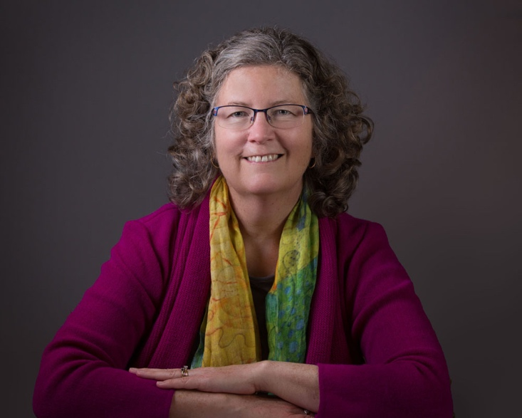
Cindy Grisdela is an award-winning fiber artist specializing in improvisational quilt designs and dense free motion quilting.

She is the author of Artful Improv: Explore Color Recipes, Building Blocks & Free Motion Quilting, published by C&T Publishing, and she travels extensively all over the country teaching and lecturing to guilds and groups.

Cindy began her quilting journey as a traditional quiltmaker over 30 years ago. Over time, she evolved into the contemporary style she is known for today. Her abstract art quilts are designed improvisationally without a preconceived pattern, a little bit like jazz music, where each decision about color and shape influences the next.

The color is the first step. Putting colors together intuitively, Cindy uses fabric the way a painter might use paint to create graphic compositions that engage the viewer from a distance, yet invite a closer look. The texture is the second step. The stitching lines provide contrast and dimension to the piece, integrating the different elements into a cohesive whole. She stitches on a sewing machine, but the stitches are entirely hand driven, without the use of a computer program or marking ahead of time.

Cindy’s formal education includes a BA in Fine Arts from the College of William and Mary and an MBA from George Washington University.

Her quilt designs have been published in numerous books and magazines, and she appeared in three episodes of Quilting Arts TV in 2018 and 2019.

Cindy’s work is represented by Artful Home, and can be found in a number of private collections all over the country. She is a member of the Fiberworks Studio at the Torpedo Factory in Alexandria, VA and a Juried Artist Member of Studio Art Quilt Associates.

For more information about Cindy’s work, please visit her website and blog at www.cindygrisdela.com or follow her on Facebook or Instagram @cindygrisdelaquilts

Select Juried Exhibitions:

May 13 – August 9, 2020 – Workhouse Arts Fiber National Exhibit, Lorton, VA
March 29 – May 2, 2020 – Art Quilt Elements, Wayne, PA
February 29 – April 19, 2020 – “Working with the Muse,” Strathmore Mansion, Bethesda, MD
February 26-29, 2020 – Mid-Atlantic Quilt Festival, Hampton, VA
February 20-23, 2020 – QuiltCon, Austin, TX

October 31 – November 3, 2019 – International Quilt Festival, Houston, TX
October 11-13, 2019 – International Quilt & Fiber Arts Festival, Everett, WA
October 2019 – Art League Open Exhibit, Alexandria, VA
July 18-28, 2019 – Sacred Threads, Herndon, VA
March 2019 – Art League Open Exhibit, Alexandria, VA
Feb 27 – March 1, 2019 – Mid-Atlantic Quilt Festival, Hampton, VA – Best Use of Color, Innovative

December 1-2, 2018 – Downtown Art Festival, Gainesville, FL FEATURED ARTIST, Award of Excellence
November 16-18, 2018 – Craft+Design Show, Richmond, VA
October 13-14, 2018 – International Quilt & Fiber Arts Festival, Everett, WA – Third Place Abstract
October 13-14, 2018 – Rittenhouse Fine Craft Show, Philadelphia, PA
August 22-September 21 – American Landscapes, Maryland Federation of Art, Annapolis, MD
August 9-12, 2018 - Fine Art Quilt Masters Exhibit, Festival of Quilts, Birmingham, England
February 23-25, 2018 – American Craft Council - Baltimore, Baltimore, MD
January 18-21, 2018 – Road to California Quilt Show, Ontario, CA
November 11-12, 2017, Downtown Art Festival, Gainesville, FL – AWARD OF EXCELLENCE
November 1-5, 2017, Houston International Quilt Festival, Houston, TX
October 6-8, 13-15, 2017 – Rio Grande Balloon Festival Shows, Albuquerque, NM
September 2-4, 2017 – Art in the Pearl, Portland, OR
August 25-27, 2017 Art in the High Desert, Bend, OR
July 29-30, 2017 – Chase on the Riverfront, Wilmington, DE
July 20-23, 2017 – Ann Arbor Street Art Fair – The Original, Ann Arbor, MI
May 20-21, 2017 - Northern Virginia Fine Arts Festival, Reston, VA
May 13-14, 2017 - Bethesda Fine Arts Festival, Bethesda, MD
May 6-7, 2017 - Morven in May, Princeton, NJ

December 1-4, 2016 - One-Of-A-Kind Show and Sale, Chicago, IL
November 3-6, 2016 - Artful Improv Special Exhibit, International Quilt Festival, Houston, TX
October 21-23, 2016 - American Fine Craft Show | Washington, Washington, DC
October 14-16, 2016 - Great Falls Studios 2016 Studio Tour, Great Falls, VA
September 23-25, 2016 - 70 Craftswomen, Princeton, NJ
September 10-11, 2016 - Workhouse Fine Arts Festival, Lorton, VA
July 21-24, 2016, Ann Arbor Street Art Fair - The Original, Ann Arbor, MI
June 11-12, 2016, Old Town Art Fair, Chicago, IL
May 21-22, 2016, Northern Virginia Fine Arts Festival, Reston, VA
April 8-10, 2016, American Fine Craft Show | Hartford, Hartford, CT
March 11-13, 2016, American Craft Council - Atlanta, Atlanta, GA
February 26-28, 2016, Palm Beach Fine Craft Show, Palm Beach, FL
February 19-21, 2016, American Craft Council - Baltimore, Baltimore, MD

