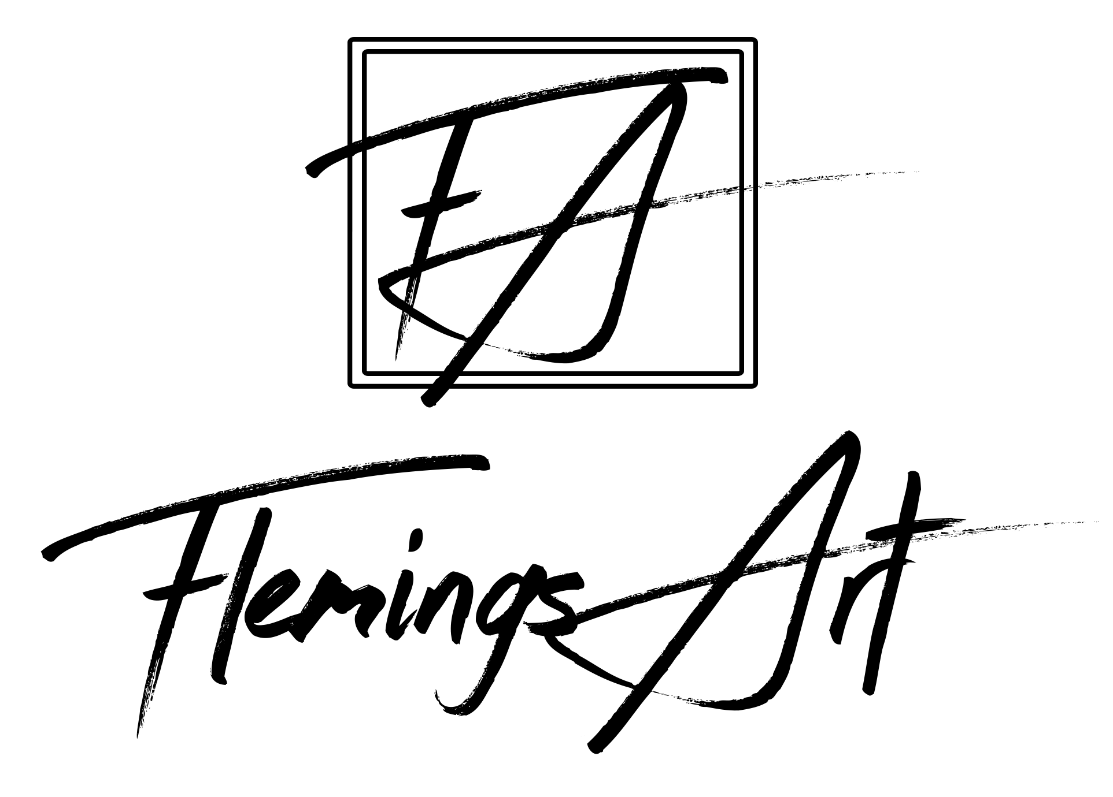

**Ann Flemings, Artist**

[Ann@FlemingsArt.com](mailto:Ann@FlemingsArt.com) | 512.963.0198 | 2804 Bridle Path, Austin, TX 78703 | FlemingsArt.com

**__________________________________________________________________________________________**

**Select Juried Exhibitions**

2018 September *Red Dot Art Spree*, Women and Their Work Gallery, Austin, TX

November *Femme Abstract Exhibition,* Curator Moya McIntyre, EAST Gallery Exhibition, Austin, TX

May *Summer Abstract Show*, Curator Melissa Kotzev, Austin Art & Frame, Austin, TX

2016 February *Imagine Exhibition,* Curator Eve Larson, Round Rock Arts Council at Texas State University, Round Rock, TX

2014 August *Juried Art Exhibition,* Barnstable County Fair, Falmouth, MA

2013 July *Member Show*, Curator Doug Rugh, Falmouth Artists Guild, Falmouth, MA

**Select Group Shows**

2019 May The Artworks Group WEST Austin Studio Tour, Artworks Gallery

2018 July Hyde Park Café Duval, With Mary Jo Kennard, Curator Anne Ducote, Austin, TX

2015 March *Color, Light and Movement*, Old Bakery Emporium; With Laura Sturtz, Austin, TX

September Hyde Park Westgate, With Jade Brady, Curator Anne Ducote, Austin, TX

2014 February *What Lies Below and Beneath,* Old Bakery Emporium, Austin, TX

**Select Solo Shows**

2019 May – June Bruegger’s Bagels and Spring Condos

May West Elm retail store

2018 December Soma Vida Gallery, Austin, TX

November EAST Austin Studio Tour #480, Soma Vida Gallery, Austin, TX

May WEST Austin Studio Tour #10, ArtSpace, Austin, TX

Jan Hyde Park Café Westgate, Curator Anne Ducote, Austin, TX

2017 November EAST Austin Studio Tour #161, Bolm Studios, Austin, TX

Feb Bruegger’s Bagels, Austin, TX

2015 Jan - April Blue Dahlia Café Westlake and Downtown, Curator Anne Ducote, Austin, TX

April - May Trianon Café, Austin, TX

2013 December “First Solo Show” Amplify Austin Credit Union, Creative Arts Society, Austin, TX

**Education**

BFA Graphic Design, Indiana University of Pennsylvania

MA Sociology/Counseling, Indiana University of Pennsylvania

**Continuing Education**

2018 Feb – May Masterclass Program with Gwen Fox, Taos, NM

2017 April Abstract Water Media workshop: Mark Mehaffey, Waterloo Watercolor Group, Austin, TX

2016 Jan-June Art Study Program with Elizabeth Locke, Austin, TX

July Process, Meaning, Making with Deborah Dancy, Castle Hill Art, Truro, MA

2014 Oct-Nov Artists INC Live, Mid-America Arts Alliance Partnership/City of Austin, Austin, TX

2013 July Abstract Art, Melissa Morris, Barnstable, MA

2011 July Reinventing Your Creative Process, Andrew Long, Austin, TX

**__________________________________________________________________________________________**

**Professional Associations**

Board Member Since 2013 Generous Art/Big Medium

Member Since 2018 Creative Standard

Since 2013 Austin Creative Alliance | Falmouth Artists Guild | Women and Their Work

Since 2011 Austin Visual Artists Association

**__________________________________________________________________________________________**