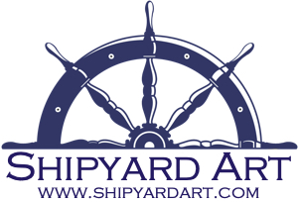

Michelle Brown
michelle@shipyardart.com
Exhibitions | 2019 – Solo Exhibit, Land of a Thousand Hills Coffee Co., Lynn MA  2019 – Galleries at LynnArts, “Imaginary Spaces & Far Out Places”  2019 – Creative Spirit, “Wild & Free,” Marblehead, MA  2019 – Salem Arts Festival, Exhibiting Artist, Old Town Hall  2019 – Galleries at LynnArts, “BodyArt”  2019 – Art Walk Marblehead, Bus Stop, Marblehead, MA  2019 – Galleries at LynnArts, Extending Ironbound Art Fair  2019 – Creative Spirit, “Play,” Marblehead, MA  2019 - Feb-Mar Exhibit, Lynch Van-Otterloo YMCA, Marblehead  2019 – Variations, Marblehead Arts Association  2019 – Creative Spirit, “Journey,” Marblehead, MA  2019 – New Member Exhibit, Marblehead Arts Association  2019 – Jan-Feb Exhibit, Lynch Van-Otterloo YMCA, Marblehead  2019 – Conception Art Show, Boston, MA  2018 - Creative Spirit, "Dream," Marblehead, MA  2018 - Winter Member Exhibit & Pieces of Eight Exhibit, Marblehead Arts Association, Marblehead, MA  2018 - Creative Spirit, "Shadow," Marblehead, MA  2018 - Creative Spirit, "Nature," Marblehead, MA  2018 - Creative Spirit, "Wonder," Marblehead, MA
Awards | 2018 – Show Favorite, Force of Nature, Creative Spirit, “Nature”  2018 – Show Favorite, Adrift, Creative Spirit, “Wonder”
Social Media | Website: www.shipyardart.com  Instagram: @shipyardart  Facebook: facebook.com/shipyardart
Affiliations | Marblehead Arts Association, Artist Member  Discover Marblehead Business Member  Galleries at LynnArts, Professional Artist Member

