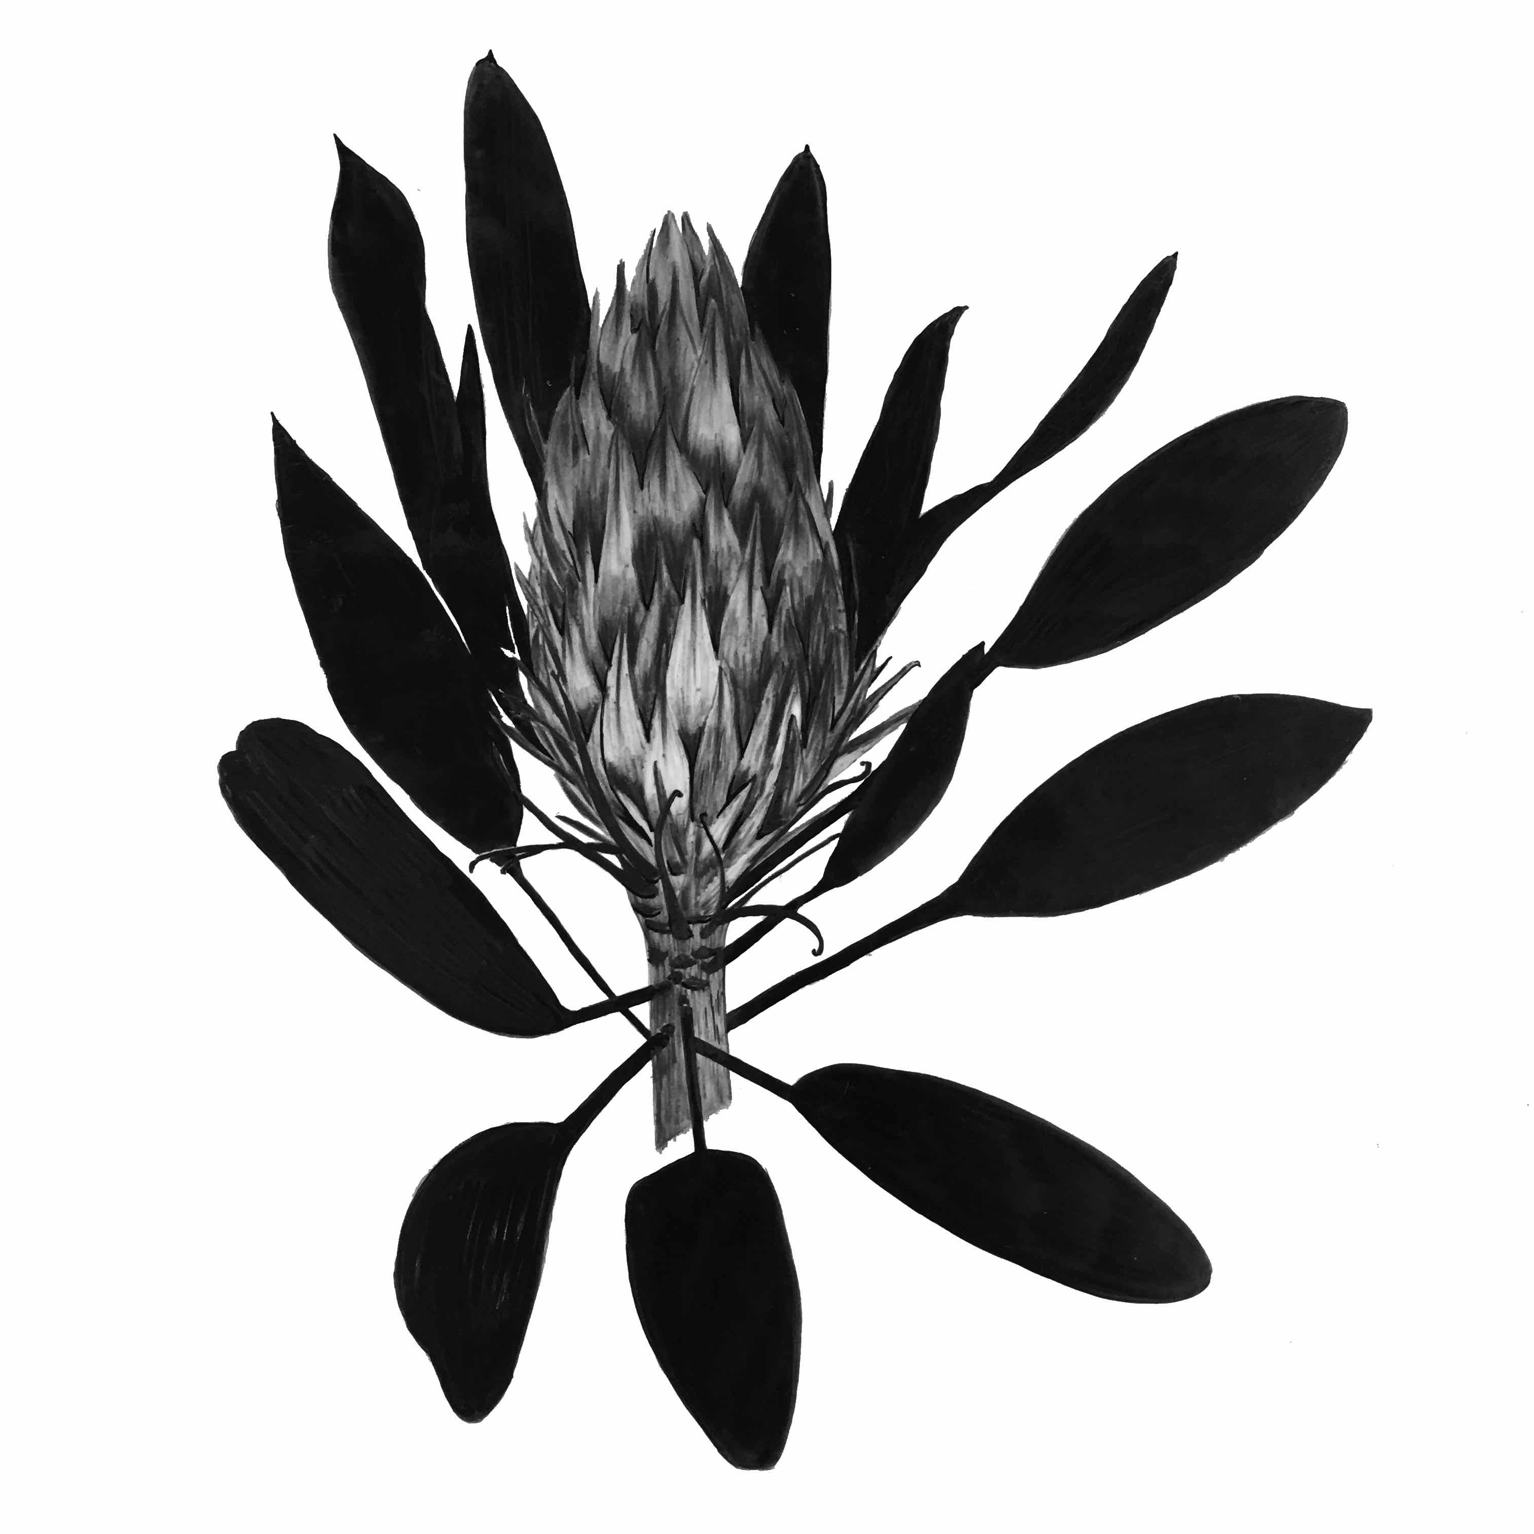
Trudy Rice  (b. 1970 AUS)  Currently living and working in Melbourne, Victoria, Australia | M 0410 596 415  trudy@trudyrice.com  www.trudyrice.com

Deeply connected to our natural world Trudy’s works on paper are created by printing many layers of monotype and solarplate etchings. With mindful observation, the initial drawings are etched in the very sun and water that her specimens are found.

Delicate textures and atmospheric depth bring Trudy’s love and empathy for the natural environment directly to the viewer. Her inspiration is collected quite close to home, from her garden and around the coastal landscape of Lorne on Victoria’s picturesque Great Ocean Road. Her studio is filled with specimens collected from the bush and sea. Clear air, gorgeous skies, beach and bush provide a never-ending palette to draw from.

Trudy enjoys teaching both children and adults in workshops within her studio as well as by invitation to other art facilities.

Her range of textile designed homewares include designer cushions, table runners and wallpaper are a transference of her art from paper to fabric. With an ethos of protecting our environment by using organic product and recycling as much as possible, it is well worth the effort to make her products locally.

Trudy has artwork in the collection of the Olivia Newton-John Cancer & Wellness Centre at the Austin Hospital and other Private Collections throughout Australia, United States of America and the United Kingdom.

Gallery Representation

Queenscliff Gallery & Workshop, 81 Hesse Street, Queenscliff, Victoria

http://qgw.com.au

Lauriston Press, Prints & Drawings, Victoria

https://lauristonpress.com.au

Counterweave Arts, Rome, Italy
https://counterweave.com/

Education
CAE, Diploma & Advanced Diploma of Visual Arts, Completed 2012

Exhibition History

SOLO Exhibitions

Oct 2018 ‘In my Garden’, Port Jackson Press Print Gallery, Collingwood

Aug 2018 ‘Gardens’ Carlisle Street Art Gallery, St Kilda

Aug 2017 ‘Coming into Spring’ Little Window of Opportunity, Port Jackson Press Print Gallery

Feb 2016 Little Window of Opportunity, Port Jackson Press Print Gallery

July 2015 OCEANUS, Port Jackson Press Print Gallery

May 2014 DRAGONS & BANKSIAS, Firestation Print Studio

Sept/Oct 2012 FRAGILITY, Firestation Print Studio, Armadale, Victoria, Australia

Selected GROUP Exhibitions & Events
Feb 2020 ‘EDITIONS 2020’ Tacit Galleries
Oct 2019 Albert Park College Art Show
Sept 2019 Sydney Contemporary, MELBOURNE STUDIOS #trudyrice #lisasewards

May 2019 HISTORIA, Queenscliff Gallery & Workshop

May 2019 Lauriston Press Gallery, Collection

April 2019 LIONS CLUB, Lorne Surf Coast
Dec-Jan 2019 ‘Lustre’ Queenscliff Gallery & Workshop
Oct 2018 Brunswick Street Gallery, Contemporary Impressions, Spring Edition
Oct 2018 Swiss by Natures, Swiss Festival, Eildon Manion, St Kilda
Oct 2018 Albert Park College Art Show
Sept 2018 Sydney Contemporary, MELBOURNE STUDIOS #trudyrice #lisasewards
Aug 2018 Surf Coast Shire Open Studio, Lorne, Victoria
July 2019 Overwintering Exhibition, State Library of Queensland
July 2018 Winter Exhibition, Port Jackson Press Print Galery
June 2018 Overwintering, Firestation Print Studio & Migaloo Press
May 2018 Counterweave Arts Gallery and Workshop, Rome, ITALY
May 2018 Firestation in Florence, Fondazione II Bisonte, Florence, Italy & Firestation Print Studio
Feb 2018 Beauty of Beast, Queenscliff Gallery & Workshop
Dec 2017 Summer Impressions, Port Jackson Press Print Gallery
Nov 2017 Imaginings, Curated by Rona Green, Neospace, Collingwood
Nov 2017 Litho, Mono, Screen & Unique State Prints, Queenscliff Gallery & Workshop
Oct 2017 Albert Park College Art Show
June 2017 ‘Tracing the Line in Contemporary Art’, PORT JACKSON PRESS PRINT GALLERY
June 2017 Counterweave Arts Gallery and Workshop, Rome, ITALY

May 2017 Graeme Altmann Gallery, Advantage Road Exhibition

March 2017 LIONS CLUB, Lorne Surf Coast

March 2017 Global Oceans, Hahndorf Academy, South Australia

Nov-Jan 2016 ‘Proof’, PORT JACKSON PRESS PRINT GALLERY

Nov-Dec 2016 QUEENSCLIFF GALLERY & WORKSHOP

July 2016 ‘Contemporary Paper’, PORT JACKSON PRESS PRINT GALLERY

March 2016 LIONS CLUB, Lorne Surf Coast

Feb 2016 Window @ PORT JACKSON PRESS PRINT GALLERY

Dec 2015 ‘WRAP UP’, PORT JACKSON PRESS PRINT GALLERY

Dec 2015 ‘Glow Exhibition’ The Framing Salon, London (curated by Marguerite Brown)

Dec 2015 SUMMER SALON 2015, Firestation Print Studio, Armadale, Victoria, Australia

Sept-Nov 2015 Gippsland Art Gallery, Print Prize

Sept 2015 Linden New Art “Postcards Show”

Print Exchange

2020 EMOTIONS, Queenscliff Gallery & Workshop

2019 HISTORIA, Queenscliff Gallery & Workshop

2017 Rona Green Print Exchange ‘Imaginings’ 66 Prints

2017 Global Oceans, Hahndorf Academy, South Australian International Print Exchange

2016 Print Council of Australia, Australia wide print exchange

2016 Firestation Print Studio & Atlanta Printmakers Studio “Deep South & Down Under” Print Exchange

2016 The Lettered Print, Queenscliff Gallery & Workshop

2014 IPE Print Exchange

2014 Impresiones Gigantes Granada, Spain Print Exchange

Teaching Experience

Jan 2020 Solarplate Etching 1:4, 1-day workshop, Queenscliff Gallery & Workshop

Sept 2019 Linocut Concertina Book 2-day workshop, Emerald Art Society, Victoria

July 2019 Solarplate Etching 1-day workshop, Firestation Print Studio

July 2019 Solarplate Etching 1:2, 1-day workshop, Queenscliff Gallery & Workshop

June 2019 Solarplate Etching 1-day workshop, Firestation Print Studio

June 2019 Solarplate Etching 2-day workshop, Firestation Print Studio

June 2019 Solarplate Etching 1:2, 1-day workshop, Queenscliff Gallery & Workshop

April 2019 Solar Plate Etching 2-day workshop, Firestation Print Studio

March 2019 Solar Plate Etching 2-day workshop, Emerald Art Society, Victoria

Feb 2019 Solarplate Etching 1:1, 1-day workshop, Queenscliff Gallery & Workshop

Jan 2019 Solarplate Etching 1:1, 1-day workshop, Queenscliff Gallery & Workshop

Dec 2018 Solarplate Etching 1:1, 1-day workshop, Queenscliff Gallery & Workshop

2018 CAE (Box Hill Institute) All Printmaking Techniques Cert III & IV

Sept 2018 Teenagers Drypoint workshop, Studio Warehouse, Port Melbourne

Aug 2018 CAE Box Hill Institute, Solarplate Etching Masterclass

June 2018 Solar Plate Etching 2-day workshop, Emerald Art Society, Victoria

Feb 2018 Solar Plate Etching 2-day workshop, Wisteria Cottage, Tamborine Mountain, Queensland

June – Nov 2017 CAE (Box Hill Institute) All Printmaking Techniques Cert IV

June 2017 CAE Box Hill Institute, Solarplate Etching Masterclass

May 2017 Solar Plate Etching (Adults) Workshop at STUDIO #Artist Proof

Curator

2009 to present Curator/Convenor Albert Park Secondary College Art Show

April 2019 Lions Club of Lorne, Art Show

March 2018 Curator Lisa Sewards Solo Exhibition ‘Thousand kisses deep’ at 45 Downstairs Gallery, Melbourne CBD

2010 - 2012 Managed and curated exhibitions at the Firestation Print Studio Gallery

2010 Managed and curated the Melbourne Fashion Incubator Gallery at Melbourne Central, CBD

Commissions
8 metre artwork for Queens Domain Apartment Lobby.
Landream Property, The International. Commissioned design of a homewares range to give to new apartment owners.

Collections
Artwork included in a unique state artist books assembled by the Firestation Print Studio, purchased by a private collector from Hardcastle, West Hobart as well as being acquired by the State Library (Victoria) and Stonnington Council Victoria.
Artwork included in a unique state artists book Firestation in Florence, acquired by the State Library (Victoria).

Work also acquired by the Olivia Newton John Cancer & Wellness Centre, Austin Hospital and various Private Collections.

Overwntering, State Library of Queensland

Recent Publications & Interviews
Media https://trudyricecollection.com/pages/media1

Australian Home Beautiful Magazine  3 Page Article  Christmas Edition  Dec 2019  Featuring images from my studio | The Financial Review 2019  Mothers Day Gift Guide  April 2019  Featured Homewares
The Age 2019  Good Weekend  April 2019  Featured Homewares | In Conversation with Laura Kirkham  Port Jackson Press Print Gallery 2018  http://portjacksonpress.com.au/news/in-conversation-with-trudy-rice
Brisbane Time  Overwintering Project  November 2018  Featured Artwork | Artists Profile with The Store by Fairfax  https://email.thestore.com.au/3ZGB-DPJN-5B429FFB5B/cr.aspx

Home Beautiful Magazine

Featured my Wallpaper and Homewares range

May 2017 Issue Page 65

Lectures/Presentation/Public Speaking/Demonstrations

June 2019 Kardinia International College, Geelong, Senior Art Department

Aug 2017 Demonstration at the Lorne Information Centre during the Otway Open Studio

Nov 2016 Live printing demonstrations at STUDIO #Artist Proof

Aug 2016 Box Hill Institute, educational film about Solar Plate Etching

June 2016 Demonstration in Collins Place for the PRINT COUNCIL OF AUSTRALIA

May 2016 Council of Adult Education, Presentation/Talk about Solar Plate Etching

April 2016 Art Town, solar plate demonstration

Jan 2011- present Artists’ Salon (Albert Park) – Trudy initiated this group to enable artists to share and critique their ideas and concepts in a supportive, confidential environment.

Awards & Selection

2017 Style Guide Winner, House & Garden Magazine( Dec issue)

2016 Best “Other Medium”, LIONS CLUB ART SHOW, Lorne Surf Coast

2015 Firestation Print Studio, Best Etching, Judged by Neil Wallace

2012 Firestation Print Studio, Best Mixed Media on Paper, Judged by Robert Clinch

2011 Firestation Print Studio, 2nd Prize Summer Salon, Judged Exhibition

Selected Prizes

2017 Selected for the Peebles Print Prize, Queenscliff Gallery

Public Artwork/Projects

2018 Florence artwork

2016 Work featured in the “BIRD” book, FPS, Acquired at the State Library of Victoria

2015 Bay Street Traders Association – Banners in Bay Street Project

2015 Waterfront Project, City of Port Phillip, ‘Art on the Fence’

2014 City of Port Phillip, Waterfront Activation Project, POSTCARDS TO PORT

2012 Property Development Analysis, Yarra Street office installation

Membership & Board appointments

Current Member of the National Association for Visual Artists (NAVA)

Current PCA – Print Council of Australia

2012 - 2015 President of the Firestation Print Studio

2011 - 2012 Secretary of the Firestation Print Studio

2010 - Current Firestation Print Studio Member, Armadale, Victoria

2010 - Current Warringah Print Studio, Sydney, NSW

Donated Works

Koala Tea Towel (all profits going to the Hamson Bay Koala Sanctuary in Kangaroo Island), Lungitude, Cancer Council, Black Cockatoo Conservation Centre, Collingwood College, Pink Lady (Breast Cancer), Lions Club of Lorne, Angelsea Flora & Fauna, Lighthouse Foundation, Care for Kids, Think Pink (Breast Cancer), Albert Park Secondary College, Albert Park Primary School, St Michaels Grammar School, Port Melbourne Primary School and The Margaret Pratt Foundation.

